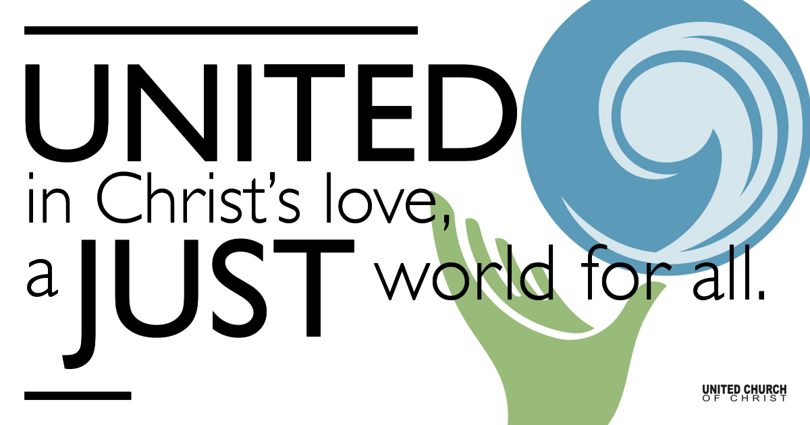

September 06, 2020

Biblical Conflict Resolution
Silent Meditation
The safety of our souls is to be wherever Jesus is. Jesus is calling us to the reign of peace and justice. Out in the turbulent water is our redemption. Out in the chaotic waters being calmed by the God who loves and cares for us. Out in the chaos of the world where the violence and hate need naming, need to be called to account, need to be changed and forgiven and yes calmed into peace.

Prelude “Morning Has Broken”

Welcome to Worship
One: Whoever you are and wherever you are on life’s journey,
ALL: We welcome you here.

Opening Comments

Ringing of the Bell

Call to Worship
God, Make us instruments of your peace.
All: Where there is hatred, let us sow love.
Where there is injury, pardon.
All: Where there is doubt, faith.
Where there is despair, hope.
All: Where there is darkness, light.
Where there is sadness, joy.
O Divine creator, Grant that we may
All: not so much seek to be consoled as to console;
To be understood as to understand;
All: To be loved as to love.
For it is in giving that we receive;
All: It is in pardoning that we are pardoned;
And it is in Dying that we are born to eternal life.

↑Opening Song “We Can Work it Out” Lennon/McCartney

Scripture Matthew 18:15-20

Reflection Biblical Conflict Resolution Rev Marijke Rossi

Children’s Time Chelsea Page

Closing song “Spirit in the Sky” Norman Greenbaum
When I die and they lay me to rest
Gonna go to the place that's the best
When I lay me down to die
Goin' up to the spirit in the sky
Goin' up to the spirit in the sky
That's where I'm gonna go when I die
When I die and they lay me to rest
Gonna go to the place that's the best

Prepare yourself you know it's a must
Gotta have a friend in Jesus
So you know that when you die
He's gonna recommend you
To the spirit in the sky
Gonna recommend you
To the spirit in the sky
That's where you're gonna go when you die
When you die and they lay you to rest
You're gonna go to the place that's the best

Never been a sinner. I never sinned
I got a friend in Jesus
So you know that when I die
He's gonna set me up with
The spirit in the sky
Oh set me up with the spirit in the sky
That's where I'm gonna go when I die
When I die and they lay me to rest
I'm gonna go to the place that's the best
Go to the place that's the best

Live Service

Call to Offering

Prayer of Dedication

Prayers of the Community
(If you would like to offer a prayer of gratitude or concern for someone or some situation please comment when you join the live service. Please use first names for security. The congregation will respond to each prayerful offering with the following words:
“Together with God, we hear your prayers.”

Pastoral Prayer

Jesus Prayer
Our Creator who is in heaven,
Hallowed be Your name,
Your reign to come, Your will be done,
On earth as it is in heaven,
Give us this day our daily bread,
And forgive us our debts as we forgive our debtors,
And lead us not into temptation, but deliver us from evil,
For Yours is the reign, the power, and glory for ever. Amen.

↑Words of Mission and Benediction

Find out More!



holladayucc.org

Or scan from your mobile device:


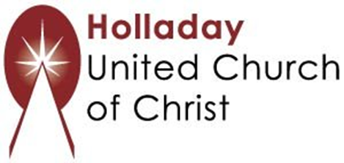
2631 East Murray-Holladay Rd
Holladay, UT 84117 801-277-2631
Rev. Marijke Rossi, Pastor
Rev. Chelsea Page, Associate Pastor
We are a Whole Earth,
Open and Affirming Congregation
Of the United Church of Christ.
Participants in Worship:
Video: Connie Nomann
Music: Twist of Faith, Children’s Chat: Chelsea Page

PRAYER REQUESTS
The following are offered for your prayers both this morning and as you pray this week at home:
· Prayers of strength and comfort for all those who live in fear of violence.
· Prayers of support and gratitude for our community of caregivers.
· Prayers of healing for all who are facing health issues

