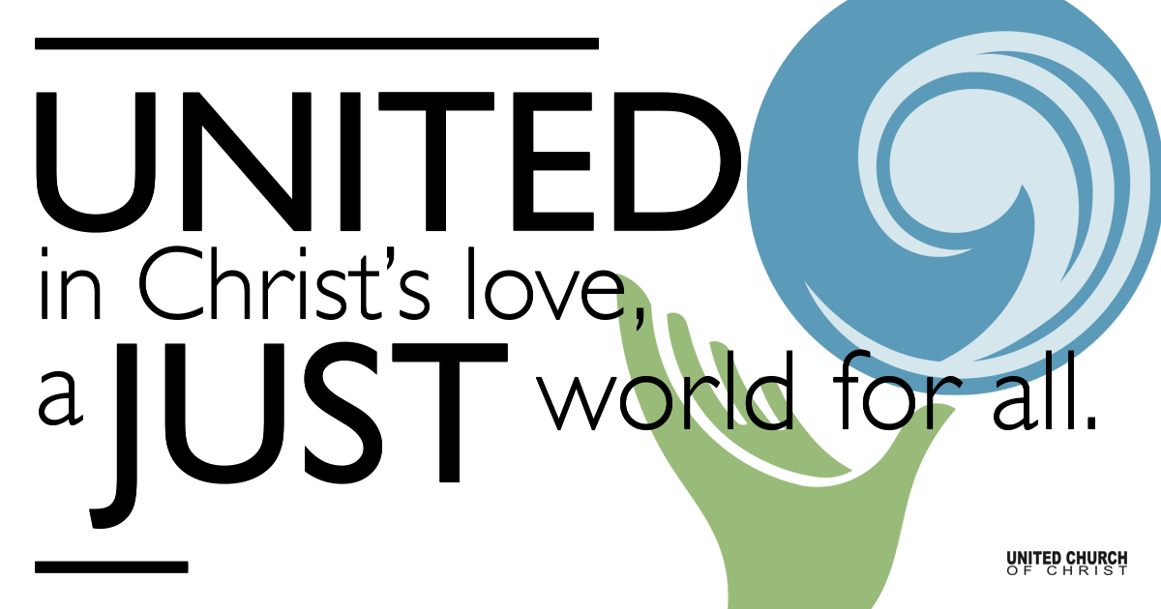

September 13, 2020

Biblical Resolution
Silent Meditation
We shall not cease from exploration
And the end of all our exploring
Will be to arrive where we started
And know the place for the first time.
~T.S. Eliot

The real voyage of discovery consists, not in seeking new landscapes, but in having new eyes. ~Marcel Proust

Organ Prelude Come Thou Fount

Welcome to Worship
One: Whoever you are and wherever you are on life’s journey,
ALL: We welcome you here.

Opening Comments

Ringing of the Bell

Call to Worship
Jim: Let us pray. Loving God, in your scripture for us today, you have provided us with the parable of the Prodigal Son.

Shesh (hands raised to indicate this is also the “All” response): The Prodigal Son is a story of homecoming.

Jim: Coming home can be scary at first.

All/Shesh: But like the young person in the story who is welcomed, how quickly our fear turns into joy!

Jim: We are entering the fall season, a time of reopening -- coming home to church and school.

All/Shesh: We hear from young people that coming back to school this year feels scary and different, but also joyful.

Jim: At this time, let us pray for our young people who have returned to school and will soon be starting Sunday School, whether online or in person.

All/Shesh: We pray for their doubt and fear to mature into caution and wisdom, and for safe togetherness to bring them much joy.

Jim: We pray most especially for our community at Holladay Preschool, for every child, teacher and parent who will be arriving to our doors tomorrow.

All/Shesh: May God bless each of them with the utmost safety, protection, health, wisdom, togetherness, and joy, as these 200 precious children come together to learn and grow. Loving God, bless this special place, where children can play together and develop intellectually, socially, emotionally, and physically. [Shesh, I took this from the preschool mission statement, feel free to edit.]

Jim: And please bless us, your community, whom you have invited to worship you with confidence and joy!

All/Shesh: Lead us home to trust and hope, relying on your loving promise to welcome us back always. Amen.

↑Opening Song Bones Maren Morris

Scripture Luke 15:11-32

Reflection “Love Your Earth Family” Rev. Chelsea Page

Children’s Time Tiffini Adams

Closing Song This Little Light of Mine

Live Service

Call to Offering

Prayer of Dedication

Prayers of the Community
If you would like to offer a prayer of gratitude or concern for someone or some situation please comment when you join the live service. Please use first names for security. The congregation will respond to each prayerful offering with the following words:
“Together with God, we hear your prayers.”

Pastoral Prayer

Jesus Prayer
Our Creator who is in heaven,
Hallowed be Your name,
Your reign to come, Your will be done,
On earth as it is in heaven,
Give us this day our daily bread,
And forgive us our debts as we forgive our debtors,
And lead us not into temptation, but deliver us from evil,
For Yours is the reign, the power, and glory for ever. Amen.

↑Words of Mission and Benediction

Find out More!



holladayucc.org

Or scan from your mobile device:


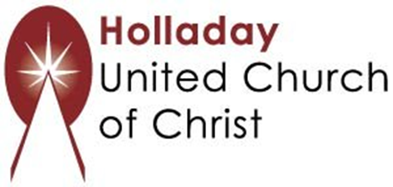
2631 East Murray-Holladay Rd
Holladay, UT 84117 801-277-2631
Rev. Marijke Rossi, Pastor
Rev. Chelsea Page, Associate Pastor
We are a Whole Earth,
Open and Affirming Congregation
Of the United Church of Christ.
Participants in Worship:
Reader: Jim and Shesh, Slides: Connie
Music: Matt Mortensen, Gabi and Shelley McCall,
Tiff Thomson (Guest Musician - friend of Eric’s from Virginia)
Children’s Chat: Tiffini Adams

PRAYER REQUESTS
The following are offered for your prayers both this morning and as you pray this week at home:
· Prayers of strength and comfort for all those who live in fear of violence.
· Prayers of support and gratitude for our community of caregivers.
· Prayers of healing for all who are facing health issues

