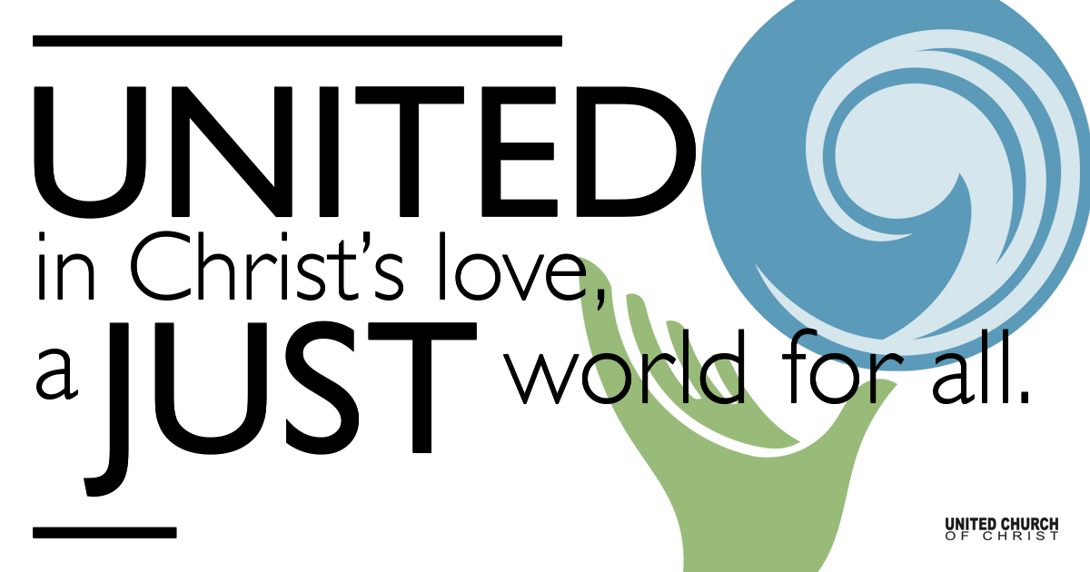

September 20, 2020

Biblical Forgiveness
Silent Meditation
Our Spiritual Journey calls us to seek and find this living God of Love in prayer, worship, spiritual reading, spiritual mentoring, compassionate service to the poor, and good friends. Let us claim the truth that we are loved and open our hearts to receive God’s overflowing love poured out for us. ~Henri J. M. Nouwen

Prelude “There is a Balm in Gilead” Matt Mortensen

Welcome to Worship
One: Whoever you are and wherever you are on life’s journey,
ALL: We welcome you here.

Opening Comments

Ringing of the Bell

Call to Worship
How many times should we forgive?
All: “Seven?” Peter asks.
Jesus replied, “Hardly.”
All: How many times should we forgive?
Jesus replies, “Try seventy times seven.”
All: We wonder how that looks like justice?
Jesus follows with a story that sounds more like justice.
All: Maybe it is like the thing we call Karma?
Let us see ourselves in the story.
All: Maybe we will deepen our understanding of forgiveness.

↑Opening Song “Forgiveness” Matthew West
It’s the hardest thing to give away and the last thing on your mind today
It always goes to those that don’t deserve
It’s the opposite of how you feel when the pain they caused is just too real
It takes everything you have just to say the word
Forgiveness
It flies in the face of all your pride it moves away the mad inside
It’s always anger’s own worst enemy
Even when the jury and the judges Say you gotta right to hold a grudge
It’s the whisper in your ear saying “Set it Free”
Forgiveness
It’ll clear the bitterness away It can even set a prisoner free
There is no end to what its power can do
So, let it go and be amazed by what you see through eyes of grace
The prisoner that it really frees is you
Forgiveness
I want to finally set it free so show me how to see what your mercy sees
Help me now to give what you gave to me
Forgiveness

Scripture Matthew 18:21-35

Reflection Biblical Forgiveness Rev. Marijke Rossi

Children’s Time Kerry Spiroff

Closing Song “Change My Heart, O God” Eddie Espinosa
Change my heart, O God, make it ever true.
Change my heart, O God, may I be like you

Chorus: You are the potter, I am the clay.
Mold me and make me, this is what I pray
Change my heart, O God, make it every true.
Change my heart O God, may I be like you.

Cleanse my soul, O God, wash it with your grace
Cleanse my soul, O God, tender your embrace.

Chorus: You are the potter, I am the clay.
Mold me and make me, this is what I pray.
Cleanse my soul, O God, wash it with your grace
Cleanse my soul, O God, tender your embrace

Live Service

Call to Offering

Prayer of Dedication

Prayers of the Community
If you would like to offer a prayer of gratitude or concern for someone or some situation please comment when you join the live service. Please use first names for security. The congregation will respond to each prayerful offering with the following words:
“Together with God, we hear your prayers.”

Pastoral Prayer

Jesus Prayer
Our Creator who is in heaven,
Hallowed be Your name,
Your reign to come, Your will be done,
On earth as it is in heaven,
Give us this day our daily bread,
And forgive us our debts as we forgive our debtors,
And lead us not into temptation, but deliver us from evil,
For Yours is the reign, the power, and glory for ever. Amen.

↑Words of Mission and Benediction

Find out More!



holladayucc.org

Or scan from your mobile device:


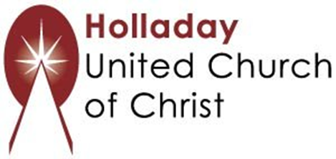
2631 East Murray-Holladay Rd
Holladay, UT 84117 801-277-2631
Rev. Marijke Rossi, Pastor
Rev. Chelsea Page, Associate Pastor
We are a Whole Earth,
Open and Affirming Congregation
Of the United Church of Christ.
Participants in Worship:
Video: Connie Nomann
Music: Marilyn and Chuck Dillard, Matt Mortensen
Children’s Chat: Kerry Spiroff

PRAYER REQUESTS
The following are offered for your prayers both this morning and as you pray this week at home:
· Prayers of strength and comfort for all those who live in fear of violence.
· Prayers of support and gratitude for our community of caregivers.
· Prayers of healing for all who are facing health issues

