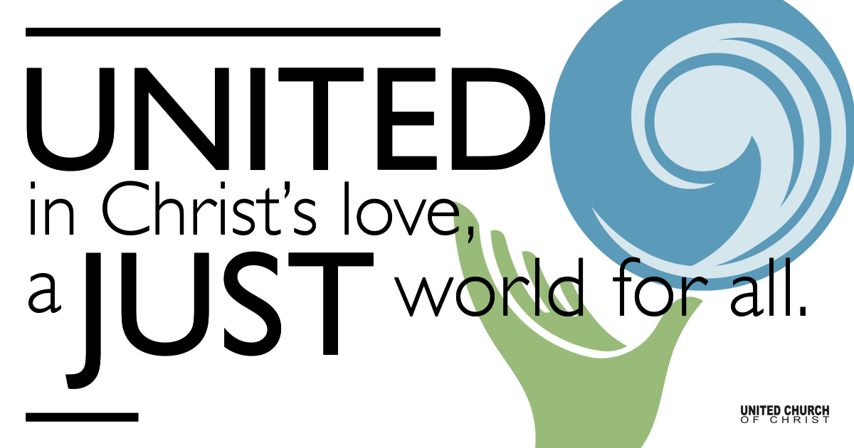

October 18, 2020

The Tricky Politics of Religion
Silent Meditation
There can be no Kingdom of God in the world without the Kingdom of God in our hearts. ~ Albert Sweitzer ~

Organ Prelude Jesus, The Very Thought of Thee

Welcome to Worship
One: Whoever you are and wherever you are on life’s journey,
ALL: We welcome you here.

Opening Comments

Ringing of the Bell

Call to Worship
One: Friends, you who are made in the image of God: we are invited to meet God face-to-face on a regular basis. But sometimes God comes to us in disguise:
ALL: A startling image of ourselves in the morning mirror.
One: The familiar smile of a family member who takes off their mask.
ALL: The needs of our neighbors, near and far.
One: The recognition of our own limitations.
ALL: Opportunities to stand up for what’s right.
One: These are revelations and insights of what God wants us to do and to be.
ALL: As we worship together, and yet apart, this morning, may we discern the call of the Holy. May we see the Loving face of God this week - not on a coin - but in the actions of those around us. Amen.

↑Opening Song Give Yourself To Love Kate Wolf
Kind friends all gathered 'round, there's something I would say:
That what brings us together here has blessed us all today.
Love has made a circle that holds us all inside.
Where strangers are as family, loneliness can't hide.
You must give yourself to love if love is what you're after;
Open up your hearts to the tears and laughter
And give yourself to love, give yourself to love.
I've walked these mountains in the rain and learned to love the wind;
I've been up before the sunrise to watch the day begin.
I've always knew I'd find you, though I never did know how;
Like sunshine on a cloudy day stand before me now.
So give yourself to love if love is what you're after;
Open up your hearts to the tears and laughter
And give yourself to love, give yourself to love.
Love is born in fire; it's planted like a seed.
Love can't give you everything, but it gives you what you need.
And love comes when you're ready, love comes when you're afraid;
It'll be your greatest teacher, the best friend you have made.
So give yourself to love if love is what you're after;
Open up your hearts to the tears and laughter
And give yourself to love, give yourself to love.
Give yourself to love if love is what you're after;
Open up your hearts to the tears and laughter
And give yourself to love, give yourself to love

Scripture Matthew 22:15-22

Reflection “The Tricky Politics of Religion” Rev. Shesh Tipton

Children’s Time Tom Sturgeon

↑Closing Song Imagine John Lennon

Live Service

Call to Offering

Prayer of Dedication

Prayers of the Community
(If you would like to offer a prayer of gratitude or concern for someone or some situation please comment when you join the live service. Please use first names for security. The congregation will respond to each prayerful offering with the following words:
“Together with God, we hear your prayers.”)

Pastoral Prayer

Jesus Prayer
Our Creator who is in heaven,
Hallowed be Your name,
Your reign come, Your will be done,
On earth as it is in heaven,
Give us this day our daily bread,
And forgive us our debts as we forgive our debtors,
And lead us not into temptation, but deliver us from evil,
For Yours is the reign, the power, and glory for ever. Amen.

↑Words of Mission and Benediction

Find out More!



holladayucc.org

Or scan from your mobile device:


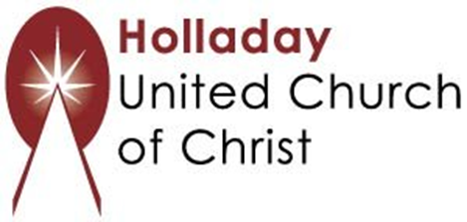
2631 East Murray-Holladay Rd
Holladay, UT 84117 801-277-2631
Rev. Marijke Rossi, Pastor
Rev. Chelsea Page, Associate Pastor
We are a Whole Earth,
Open and Affirming Congregation
Of the United Church of Christ.
Participants in Worship:
Reader: Rev. Chelsea Page, Video: Connie Nomann
Music: Kelly Martin, Cory McCann, Matt Mortensen
Children’s Chat: Tom Sturgeon

PRAYER REQUESTS
The following are offered for your prayers both this morning and as you pray this week at home:
· Prayers of strength and comfort for all those who live in fear of violence.
· Prayers of support and gratitude for our community of caregivers.
· Prayers of healing for all who are facing health issues

