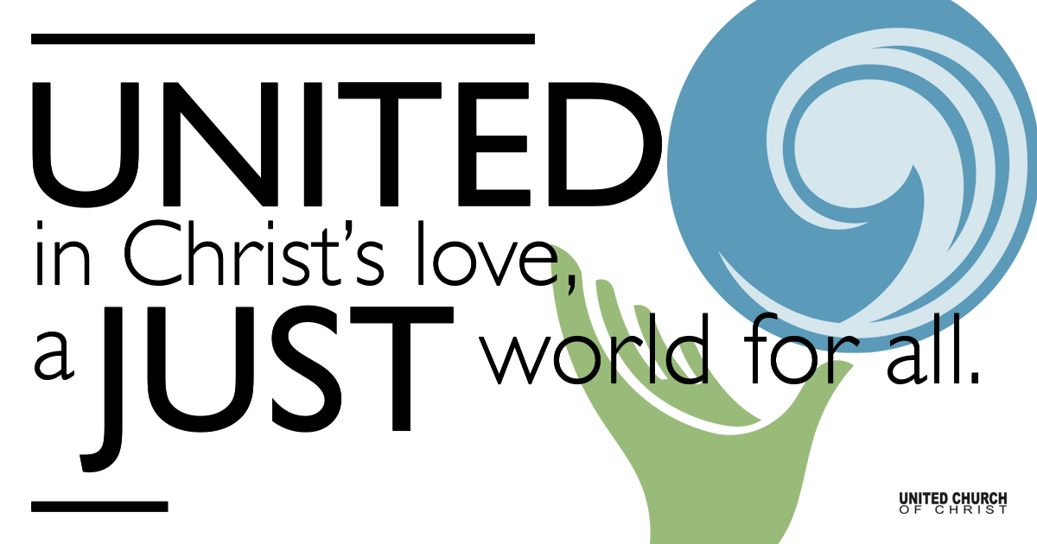

October 25, 2020

Love’s Domain
Silent Meditation
This is my prayer: that your love will flourish and that you will not only love much but well. Learn to love appropriately. You need to use your head and test your feelings so that your love is sincere and intelligent, not sentimental gush. Live a lover’s life, bountiful in fruits from the soul. Philippians: 9-10 (The Message)

Prelude “Mandy’s Waltz” Mandy Danzig

Welcome to Worship
One: Whoever you are and wherever you are on life’s journey,
ALL: We welcome you here.

Opening Comments

Ringing of the Bell

Call to Worship
One: If you were able to ask God one question and get a verbal answer, what would it be?
ALL: When will I no longer have money problems?
One: How old will I be when I die?
ALL: Will I ever have grandchildren?
One: What are the winning Lotto numbers this week?
ALL: When will I be able to buy that electric car I've been wanting?
One: How about - what makes the world work? Or, what is the greatest commandment?
ALL: Yes! Those are great questions to ask God!

One: Would you be surprised to find out that Jesus answered the greatest commandment question and the answer is all about Love?
ALL: Of course, the Holy God of Love would command us to Love God and Love one another.
One: Perhaps, due to the difficulty of loving others at times, our next question should be:
ALL: God, will you please strengthen my heart and my spirit so that I can obey your greatest commandment? I ask you in the name of Jesus. Amen.

↑Opening Song “Get Together” Jesse Colin Young
Love is but a song we sing, and fear’s the way we die
You can make the mountains ring, or make the angels cry
Know the dove is on the wing, and you need not know why.
Chorus: Come on, people now, smile on your brother.
Everybody get together; try to love one another right now.
Some will come and some will go; we shall surely pass,
When the one that left us here, returns for us, at last.
We are but a moment’s sunlight, all fading in the grass.
Chorus repeats
If you hear the song I sing, you will understand,
You hold the key to love and fear, all in your trembling hand.
Just one key unlocks them both; its there at your command.
Chorus repeats

Scripture Genesis 3:20-24

Centering Music Alla Turca Jesse Milner-Barraza

Scripture Revelation 22:1-5

Reflection “Love’s Domain” Rev. Chelsea Page

Children’s Time Steve Ritchey

↑Closing Song “We are Called” David Haas
Come! Live in the light! Shine with the joy and the love of the Lord!
We are called to be light for the kingdom, to live in the freedom of the city of God.
Refrain:We are called to act with justice, we are called to love tenderly;
We are called to serve one another, to walk humbly with God.
Come! Open your heart! Show your mercy to all those in fear!
We are called to be hope for the hopeless so all hatred and blindness will be no more.
Refrain: We are called to act with justice, we are called to love tenderly;
we are called to serve one another, to walk, humbly with God.

Live Service Rev. Marijke Rossi

Call to Offering

Prayer of Dedication

Prayers of the Community
(If you would like to offer a prayer of gratitude or concern for someone or some situation please comment when you join the live service. Please use first names for security. The congregation will respond to each prayerful offering with the following words:
“Together with God, we hear your prayers.”)

Pastoral Prayer

Jesus Prayer
Our Creator who is in heaven,
Hallowed be Your name,
Your reign come, Your will be done,
On earth as it is in heaven,
Give us this day our daily bread,
And forgive us our debts as we forgive our debtors,
And lead us not into temptation, but deliver us from evil,
For Yours is the reign, the power, and glory for ever. Amen.

↑Words of Mission and Benediction

Find out More!



holladayucc.org

Or scan from your mobile device:



2631 East Murray-Holladay Rd
Holladay, UT 84117 801-277-2631
Rev. Marijke Rossi, Pastor
Rev. Chelsea Page, Associate Pastor
We are a Whole Earth,
Open and Affirming Congregation
Of the United Church of Christ.
Participants in Worship:
Reader: Shesh Tipton, Video: Connie Nomann
Music: Marilyn and Chuck Dillard, Jim Wetzel
Children’s Chat: Steve Ritchey

PRAYER REQUESTS
The following are offered for your prayers both this morning and as you pray this week at home:
· Prayers of strength and comfort for all those who live in fear of violence.
· Prayers of support and gratitude for our community of caregivers.
· Prayers of healing for all who are facing health issues

