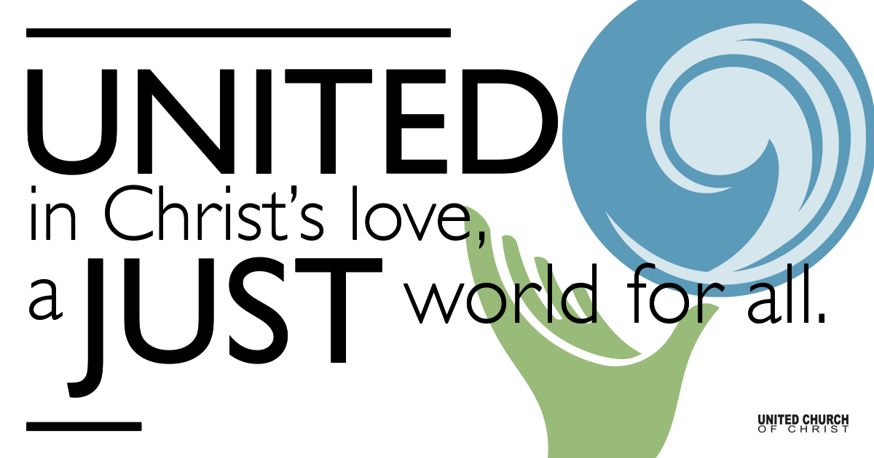

November 01, 2020

All Saints Day
Silent Meditation
I will not hesitate, I will just do what I am called to do. I will accept what I cannot control and give it over to the Divine. With every deep breath I take, I feel myself becoming more calm. I accept myself as I am and affirm that I am precious. (Adapted from mandaya.com)

“As I walked out the door toward the gate that led to my freedom, I knew if I didn’t leave my bitterness behind, I’d still be in prison.”
Nelson Mandela

Prelude “For the Beauty of the Earth” Folliott S. Pierpoint

Welcome to Worship
One: Whoever you are and wherever you are on life’s journey,
ALL: We welcome you here.

Opening Comments

Ringing of the Bell

Call to Worship
One: We are worried, nervous and anxious about what will happen on Tuesday.
All: We ask, “What will the future hold?”
One: The disciples asked Jesus, “What will happen in the Future?”
All: Our anxiety is real!
One: Jesus warns, “Don’t be swayed by doomsday deceivers.”
All: They will deceive a lot of people. Let us keep our wits about us.
One: The Spirit will work with us and in us to keep us calm and help us with the answers.
All: Love’s domain will win out in the end. We will have peace. Let us be patient. Let us work hard to be instruments of peace.

↑Opening Song “John’s Garden” Peter Mayer

Scripture Mark 13:1-12

Reflection “Election Day Thoughts” Rev. Marijke Rossi

Children’s Time Rev. Chelsea Page

↑Closing Song “Early in the Morning” Peter Paul & Mary
Well early in the morning,
About the break of day,
I ask the Lord,
"Help me find the way!"
Help me find the way
To the promised land
This lonely body
Needs a helping hand
I ask the Lord
To help me please
Find the way.
When the new day's a dawning,
I bow my head in prayer.
I pray to the Lord,
"Won't you lead me there?"
Won't you guide me safely
To the Golden Stair?
Won't you let this body
Your burden share?
I pray to the Lord,
"Won't you lead me please,
Lead me there?"
When the judgment comes
To find the world in shame
When the trumpet blows
Won't you call my name?
When the thunder rolls
And the heavens rain
When the sun turns black,
Never shine again
When the trumpet blows,
Won't you call me please,
Call my name!

Benediction Rev. Chelsea Page

Live Service

Call to Offering

Prayer of Dedication

Announcements

Communion

Prayers of the Community
(If you would like to offer a prayer of gratitude or concern for someone or some situation please comment when you join the live service. Please use first names for security. The congregation will respond to each prayerful offering with the following words:
“Together with God, we hear your prayers.”)

Pastoral Prayer

Jesus Prayer
Our Creator who is in heaven,
Hallowed be Your name,
Your reign come, Your will be done,
On earth as it is in heaven,
Give us this day our daily bread,
And forgive us our debts as we forgive our debtors,
And lead us not into temptation, but deliver us from evil,
For Yours is the reign, the power, and glory for ever. Amen.

↑Words of Mission and Benediction

Find out More!



holladayucc.org

Or scan from your mobile device:


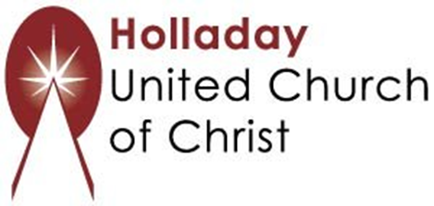
2631 East Murray-Holladay Rd
Holladay, UT 84117 801-277-2631
Rev. Marijke Rossi, Pastor
Rev. Chelsea Page, Associate Pastor
We are a Whole Earth,
Open and Affirming Congregation
Of the United Church of Christ.
Participants in Worship:
Readers: Chelsea Page and Marijke Rossi, Slides: Chelsea Page
Music: Twist of Faith, Children’s Chat: Chelsea Page

