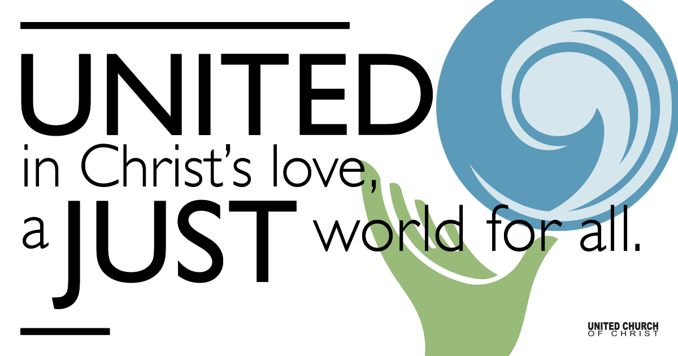

November 08, 2020

What Is the Good News?
Silent Meditation
A person waiting is someone who is present in the moment, believing that this moment is the moment. To wait with openness and trust is an enormously radical attitude toward life. ~Henri J.M. Nouwen

Prelude “God, Save the People” (Godspell) Jazz arr. J. Giordano
Guests: Flute Sonja Noykos Piano Matt Noykos

Welcome to Worship
One: Whoever you are and wherever you are on life’s journey,
ALL: We welcome you here.

Opening Comments

Ringing of the Bell

Call to Worship
One: John the Baptizer was an unusual character, even for his time.
ALL: John "appeared in the wilderness."
One: He ate locusts.
ALL: He wore a camel hair coat.
One: John claimed that the "One" coming after him would baptize them with fire - and yet, they didn't run.
ALL: He spoke of the power of Jesus, introducing him to his crowds.
One: He spoke of the power of the Holy Spirit.
ALL: He prepared people for the "Good News."
One: However, John and the crowds who followed him had to wait a bit for Jesus.
ALL: Good News is always worth waiting for.

One: Due to our experience this last week, we know what "waiting for good news" is all about.
ALL: But we don't have to wait for the power of the Holy Spirit.
One: In times of anxiety, in times of joy, in times of loss, in times of grief, and in times of elation . . .
ALL: The Holy Spirit is with us, within us, supporting us in whatever we are doing or whatever we might be waiting for.
Thank you, God. Amen.

↑Opening Song Hey, Hey, Anybody Listening? Avery-Marsh
Hey, hey, anybody listening? Hey, hey, anybody there?
Hey, hey, anybody listening? Anybody care?

1. We've got good news, good news, good news, good news. Christ the lord is to be found here, good news good news. good news, good news, let's help spread the news around here.
If I had a drum, I'd drum it, a mandolin, I'd strumm it, a hummingbird I'd humm it, everywhere, everywhere, everywhere, everywhere.

2. Come on, sing out, sing out, sing out, tell the world about his love now.
Sing out, sing out, sing out, sing out, loud and clear to all the earth now.
If I had a chime, I'd ring it, a finger symbol, ching it, we've got this song, let's sing it, everywhere , everywhere, everywhere, everywhere.

3. Come on, come on, come on, come on. Let's sing out for Mary's son here, come on come on come, on he'll bring joy for everyone here.
If I had a harp, I’d twang it, a tambourine I'd bang it, a fireman's bell, I'd clang it everywhere, everywhere, everywhere, everywhere.

Scripture Mark 1:1-11

Reflection “What is the Good News?” Rev. Marijke Rossi

Children’s Time Trent Parkhill

↑Closing Song Profetiza, Pueblo Mio (You Shall Prophesy) NCH 578
Profetiza, pueblo mío, profetiza una vez más
Que tu voz sea al eco del clamor
de los pueblos en opresión.

You shall prophesy, my people, you shall prophesy once more,
To the poor announce the coming of a new society.

Pastoral Prayer

Jesus Prayer
Our Creator who is in heaven,
Hallowed be Your name,
Your reign come, Your will be done,
On earth as it is in heaven,
Give us this day our daily bread,
And forgive us our debts as we forgive our debtors,
And lead us not into temptation, but deliver us from evil,
For Yours is the reign, the power, and glory for ever. Amen.

↑Words of Mission and Benediction

Find out More!



holladayucc.org

Or scan from your mobile device:


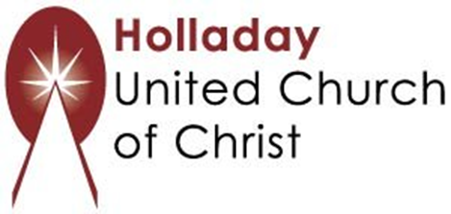
2631 East Murray-Holladay Rd
Holladay, UT 84117 801-277-2631
Rev. Marijke Rossi, Pastor
Rev. Chelsea Page, Associate Pastor
We are a Whole Earth,
Open and Affirming Congregation
Of the United Church of Christ.
Participants in Worship:
Reader: Shesh Tipton, Video: Connie Nomann
Music: Steve Ritchey & Friends, Children’s Chat: Trent Parkhill

