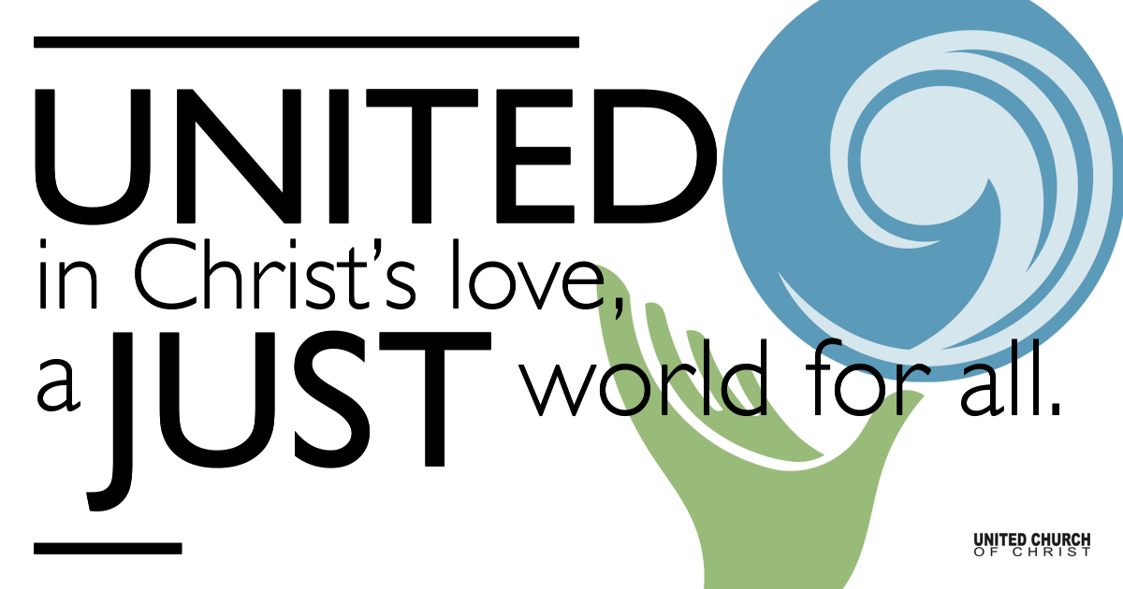

November 15, 2020

We’re All in This Together
Silent Meditation
“We are each other's harvest; we are each other's business; we are each other's magnitude and bond.” ― Gwendolyn Brooks

Organ Prelude “Sweet Hour of Prayer”

Welcome to Worship
One: Whoever you are and wherever you are on life’s journey,
ALL: We welcome you here.

Opening Comments

Ringing of the Bell

Call to Worship
(Psalm 133, Psalm 26)
One: How good and pleasant it is
ALL: when God’s people live together in unity!
One: Sing aloud a song of thanksgiving,
ALL: tell of God’s wondrous deeds.
One: We love the house where you live, O God,
ALL: the place where your glory dwells.
In the great congregation we will bless you.

↑Opening Song “Thank You” words & music by Kimball Hurd
Chuck & Marilyn Dillard

Thank you for the clear water
Thank you for the morning light
Thank for the gift of laughter
Thank you for the red, red wine
Thank you for the earth we walk on
Thank you for the starry night
Thank you for the breath returning
Thank you for all life

I know this world is filled with pain
Some people suffer every day
So how is it that I explain
I open my eyes in wonder
Every day, and say (Chorus)

I am not the one to tell this old world how to get along
I only know that peace will come
When all hate is gone (Chorus 2x)

Scripture 1 Thessalonians 1:1-10

Reflection “We’re All in This Together” Pastoral Candidate

Children’s Time Ruby Hammel

↑Closing Song "How We Love" Beth Neilson Chapman
Shesh & Jim with Tom Klassen
Life has taught me this
Every day is new
And if anything is true
All that matters
When we're through
Is how we love
Faced with what we lack
Some things fall apart
But from the ashes new dreams start
All that matters to the heart is how we love
How we love, How we love

From the smallest act of kindness
In a word, a smile, a touch
In spite of our mistakes
Chances come again
If we lose or if we win
All that matters in the end is how we love
How we love, How we love
I will not forget your kindness
When I needed it so much
Sometimes we forget
Trying to be so strong
In this world of right and wrong
All that matters when we're gone
All that mattered all along
All we have that carries on
Is how we love

Pastoral Prayer

Jesus Prayer
Our Creator who is in heaven,
Hallowed be Your name,
Your reign come, Your will be done,
On earth as it is in heaven,
Give us this day our daily bread,
And forgive us our debts as we forgive our debtors,
And lead us not into temptation, but deliver us from evil,
For Yours is the reign, the power, and glory for ever. Amen.

↑Words of Mission and Benediction

Congregational meeting

Find out More!



holladayucc.org

Or scan from your mobile device:


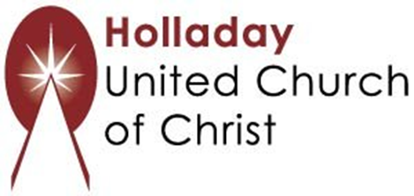
2631 East Murray-Holladay Rd
Holladay, UT 84117 801-277-2631
Rev. Marijke Rossi, Pastor
Rev. Chelsea Page, Associate Pastor
We are a Whole Earth,
Open and Affirming Congregation
Of the United Church of Christ.
Participants in Worship:
Reader: Martha Bale, Video: Connie Nomann
Music: Holy House Band, Children’s Chat: Ruby Hammel

