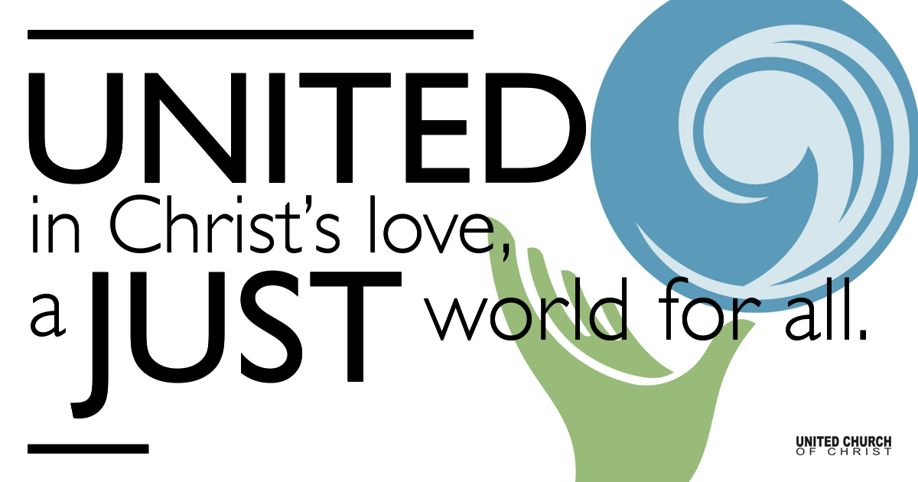

November 29, 2020

I’m Dreaming of a
Hopeful Christmas
Silent Meditation
Our hope for you is unshaken; for we know that as you share in our sufferings, so also you share in our consolation. 2 Corinthians 1:7 MSG

Prelude with Luminarias Comfort, Comfort O My People NCH #101

Comfort, comfort O my people,
Tell of peace, thus says our God;
comfort those whose hearts are shrouded,
mourning under sorrow's load.
Speak unto Jerusalem
of the peace that waits for them;
tell them that their sins I cover,
and their warfare now is over.

For the herald's voice is calling
in the desert far and near,
bidding us to make repentance,
since the realm of God is here.
O that warning cry obey!
Now prepare for God a way;
let the valleys rise in meeting,
and the hills bow down in greeting.

Straight shall be what long was crooked,
and the rougher places plain;
let your hearts be true and humble,
For Messiah’s holy reign.
For God’s glory evermore.
Shall be known o’er all the world
and all flesh shall see the token
that God’s word is never broken.

Welcome to Worship
One: Whoever you are and wherever you are on life’s journey,
ALL: We welcome you here.

Opening Comments

Ringing of the Bell

Call to Worship
One: O come, O come, Emmanuel. Bring us hope.
ALL: Hope to those who are empty-handed and heavy-hearted.
One: Hope to the ones who are ill and afraid.
ALL: Hope for your creation which has taken a beating in recent years.
One: Hope for all the People of Color who have been suffering for so long.
ALL: And, hope for your church, your community - that we may stand strong and live boldly in the face of circumstances - always “at the ready” to do your work on earth.
Amen.

Opening Song Isaiah the Prophet Has Written of Old Joy F. Patterson

Lighting of Advent Wreath at home: Light the first purple candle.
Speaker 1: This Advent we are doing lots of dreaming.
Speaker 2: The first Advent candle is a candle for Hope.
Speaker 3: We light this candle this morning with our eyes on Hope for all beings and creatures in our world.
(light candle)
ALL: We are dreaming of a Hopeful Christmas.

Scripture Mark 13:21-37 (MSG)

Reflection “I’m Dreaming of a Hopeful Christmas” Rev. Marijke Rossi

Reflection Song Lo, How A Rose ‘Er Blooming by Michael Praetorius

Children’s Time Rev. Chelsea Page

Closing Song Isaiah’s Dream (album recording) Twist of Faith

Live Service

Call to Offering

Prayer of Dedication

Prayers of the Community
(If you would like to offer a prayer of gratitude or concern for someone or some situation please comment when you join the live service. Please use first names for security. The congregation will respond to each prayerful offering with the following words:
“Together with God, we hear your prayers.”)

Pastoral Prayer

Jesus Prayer
Our Creator who is in heaven,
Hallowed be Your name,
Your reign come, Your will be done,
On earth as it is in heaven,
Give us this day our daily bread,
And forgive us our debts as we forgive our debtors,
And lead us not into temptation, but deliver us from evil,
For Yours is the reign, the power, and glory for ever. Amen.

Words of Mission and Benediction

Stay on Zoom for Bean Redeemed Coffee Hour 11-12

Find out More!



holladayucc.org

Or scan from your mobile device:


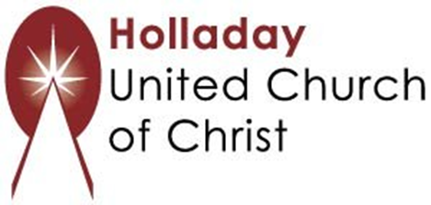
2631 East Murray-Holladay Rd
Holladay, UT 84117 801-277-2631
Rev. Marijke Rossi, Pastor
Rev. Chelsea Page, Associate Pastor
We are a Whole Earth,
Open and Affirming Congregation
Of the United Church of Christ.
Participants in Worship:
Video: Connie Nomann, Children’s Chat: Rev. Chelsea Page
Reader: Shesh Tipton, Centurier-Harris Family, Daniel & Jonathan Gellner
Music: Matt Mortensen, Chuck & Marilyn Dillard, Barb Cherrington, Twist of Faith

Upcoming Events

Dec. 6th, 4 to 6 p.m. on Zoom "Let's Talk About It: Bold Conversations on Race & Social Justice"
(A workshop with Rev. Tracey Perry at Holladay UCC)
Dec. 18th, 7 p.m. Longest Night/Blue Christmas Service on Zoom/Facebook
Dec. 20th, 1 to 2 p.m. – Drive-Thru Christmas Pageant @ the Holladay UCC parking lot

