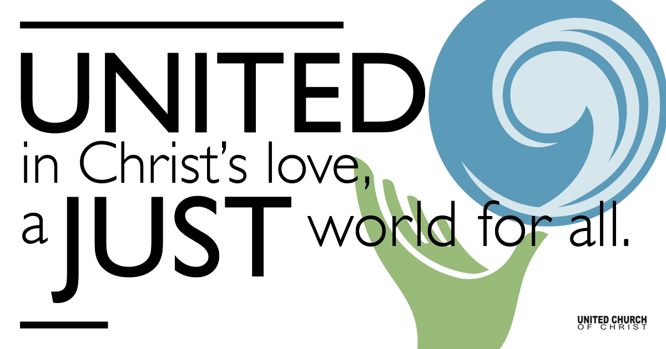

December 06, 2020

I’m Dreaming of a
Peaceful Christmas
Silent Meditation
If peace and love are not allowed to take their rightful place at the table of negotiation, then hatred and anger will produce a conflict that will continue for many years to come. It will solve nothing and thousands of innocent lives will be lost. I ask you all to pray for peace which is such an urgent priority. ~Mother Teresa

Prelude with Luminaria Watcher Tell Us of the Night NCH#103

Welcome to Worship
One: Whoever you are and wherever you are on life’s journey,
ALL: We welcome you here.

Opening Comments

Ringing of the Bell

Call to Worship
One: This second Sunday in Advent we are dreaming for Peace.
ALL: But just what does that mean?
One: It might mean an end to all war in the world.
ALL: What about in our homes? Some homes have a great deal of fighting.
One: Yes, that’s true. Our country is not exactly at peace, either. There is a lot of arguing and name calling.
ALL: What can we do about all of that? I feel powerless.
One: How about we start with ourselves, inside ourselves.
ALL: That’s a great idea. May we each pray about the Peace of God- the harmony and calmness of body, mind, and spirit that supersedes our earthly circumstances. We open ourselves, O God, to be blessed by your Holy Peace. Amen.

↑Opening Song Breath of Heaven Amy Grant/ReAwaken Productions

Lighting of Advent Wreath at home: Light the 1st & 2nd purple candles.
(light first candle)
Speaker 1: This Advent we are doing lots of dreaming.
Speaker 2: The second Advent candle is a candle for Peace.
Speaker 1: We light this candle this morning with our eyes on Peace for all beings and creatures in our world.
(light second candle)
ALL: We are dreaming of a Peaceful Christmas.

Scripture Psalm 84

Reflection “I’m Dreaming of a Peaceful Christmas” Rev. Marijke Rossi

Reflection Song Somewhere in my Memory Eric Richards
By John Williams, arr. John Hughes

Candles in the window
Shadows painting the ceiling
Gazing at the fire glow
Feeling that gingerbread feeling
Precious moments, special people
Happy faces, I can see
Somewhere in my memory
Christmas joys all around me
Living in my memory
All of the music, all of the magic
All of the family, home here with me

Children’s Time Rev. Chelsea Page

“Let us Break Bread Together on Our Knees”
Sung by Rev. Anthony Scott, Rocky Mountain Conference

Holy Communion with Rev. Erin Gilmore, Rocky Mountain Conference

↑Closing Song “Virgin Mary Had A Baby Boy” West Indian Spiritual
Shesh Tipton, Jim Wetzel, and Braden Tipton

Live Service

Call to Offering

Prayer of Dedication

Prayers of the Community
(If you would like to offer a prayer of gratitude or concern for someone or some situation please comment when you join the live service. Please use first names for security. The congregation will respond to each prayerful offering with the following words:
“Together with God, we hear your prayers.”)

Pastoral Prayer

Jesus Prayer
Our Creator who is in heaven,
Hallowed be Your name,
Your reign come, Your will be done,
On earth as it is in heaven,
Give us this day our daily bread,
And forgive us our debts as we forgive our debtors,
And lead us not into temptation, but deliver us from evil,
For Yours is the reign, the power, and glory for ever. Amen.

↑Words of Mission and Benediction

Find out More!



holladayucc.org

Or scan from your mobile device:


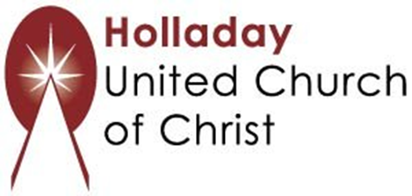
2631 East Murray-Holladay Rd
Holladay, UT 84117 801-277-2631
Rev. Marijke Rossi, Pastor
Rev. Chelsea Page, Associate Pastor
We are a Whole Earth,
Open and Affirming Congregation
Of the United Church of Christ.
Participants in Worship:
Reader: Rev. Shesh Tipton, Hera Crofts, Slides: Connie Nomann
Music: Matt Mortensen, ReAwaken Productions, Eric Richards,
Shesh Tipton, Jim Wetzel, & Braden Tipton
Children’s Chat: Rev. Chelsea Page

