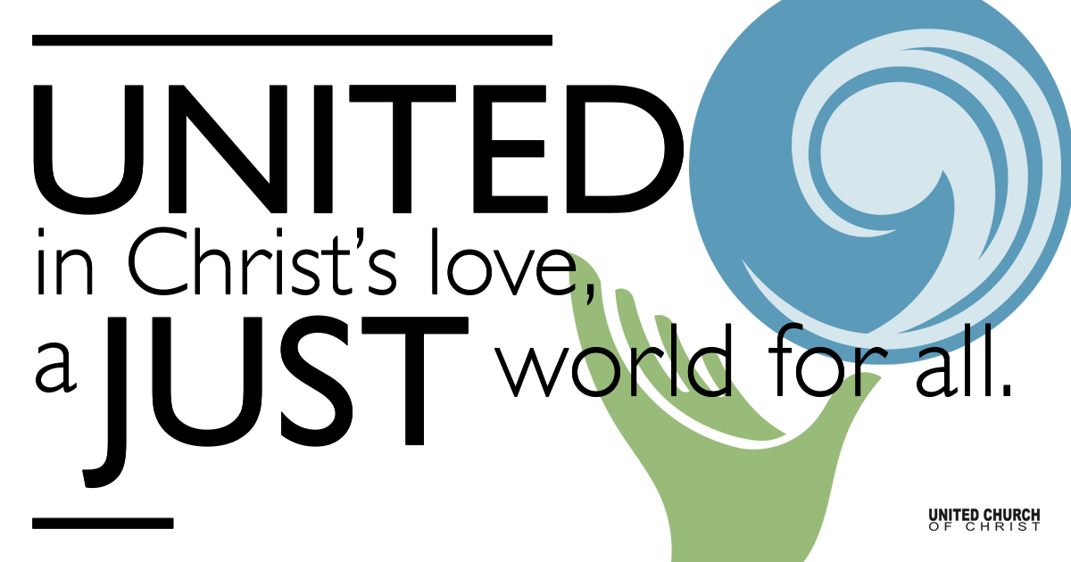

December 13, 2020

I’m Dreaming of a
Joyful Christmas
Silent Meditation
“When we speak of experiencing happiness, we need to know that there are actually two different kinds. The first is the enjoyment of pleasure through our senses. But we can also experience happiness at the deeper level through our mind, such as through love, compassion, and generosity. What characterizes happiness at this deeper level is the sense of fulfillment that you experience. While the joy of the senses is brief, the joy at this level is much longer lasting. It is true joy.”
~The Dalai Lama, The Book of Joy

Prelude with Luminaria My Heart Sings Out with Joyful Praise NCH#106

Welcome to Worship
One: Whoever you are and wherever you are on life’s journey,
ALL: We welcome you here.

Opening Comments

Ringing of the Bell

Call to Worship
One: We celebrate this particular season of Advent without the physical presence of each other - our Blessed Community
ALL: On this, our 3rd Sunday in Advent, we are invited to dream of Joy!
One: But how do we experience Joy in what seems to be these lonely times?
ALL: We are joyful as we see the color and the light of the Advent candles.
One: As we worship we can be joyful with the songs that are offered; we may merrily sing along or even dance as we hear them!
ALL: There is great joy in watching the children as they light their Advent candles.
One: And there is grateful joy as we take this time to remember the birth of the Christ-child, the one who leads us in the paths of Love and Justice.
ALL: With joy we give thanks for the life of Jesus, born over 2000 years ago. In gratitude of all that is Holy we say, Amen.

↑Opening Song Laudamus Te Vivaldi
Kelly Martin and Cory McCann
accomp. by Ton Koopman, Yo-Yo Ma & the Amsterdam Baroque Orchestra

Lighting of Advent Wreath at home:
Light the first and second purple candles, and then the pink candle.

(light the first two candles)
Speaker 1: This Advent we are doing lots of dreaming.
Speaker 2: The third Advent candle is a candle for Joy.
Speaker 3: We light this candle this morning with our eyes on Joy for all beings and creatures in our world.
(light third candle)
ALL: We are dreaming of a Joyful Christmas.

Scripture John 1:6-18

Reflection “I’m Dreaming of a Joyful Christmas” Rev. Marijke Rossi

Reflection Song Bring a Torch, Jeanette Isabella
Scott Blackhurst & Cinda Christensen
Mannheim Steamroller arr. by Chip Davis

Children’s Time Rev. Chelsea Page

↑Closing Song Mary’s Boy Child Harry Belafonte
Twist of Faith

Live Service

Call to Offering

Prayer of Dedication

Prayers of the Community
(If you would like to offer a prayer of gratitude or concern for someone or some situation please comment when you join the live service. Please use first names for security. The congregation will respond to each prayerful offering with the following words:
“Together with God, we hear your prayers.”)

Pastoral Prayer

Jesus Prayer
Our Creator who is in heaven,
Hallowed be Your name,
Your reign come, Your will be done,
On earth as it is in heaven,
Give us this day our daily bread,
And forgive us our debts as we forgive our debtors,
And lead us not into temptation, but deliver us from evil,
For Yours is the reign, the power, and glory for ever. Amen.

↑Words of Mission and Benediction

Find out More!



holladayucc.org

Or scan from your mobile device:



2631 East Murray-Holladay Rd
Holladay, UT 84117 801-277-2631
Rev. Marijke Rossi, Pastor
Rev. Chelsea Page, Associate Pastor
We are a Whole Earth,
Open and Affirming Congregation
Of the United Church of Christ.
Participants in Worship:
Reader: Centurier-Harris Family, Andrew and Ian Hanrahan
Music: Matt Mortensen, Kelly Martin, Cory McCann, Scott Blackhurst,
Cinda Christensen, and Twist of Faith
Children’s Chat: Rev. Chelsea Page, Slides: Connie Nomann

