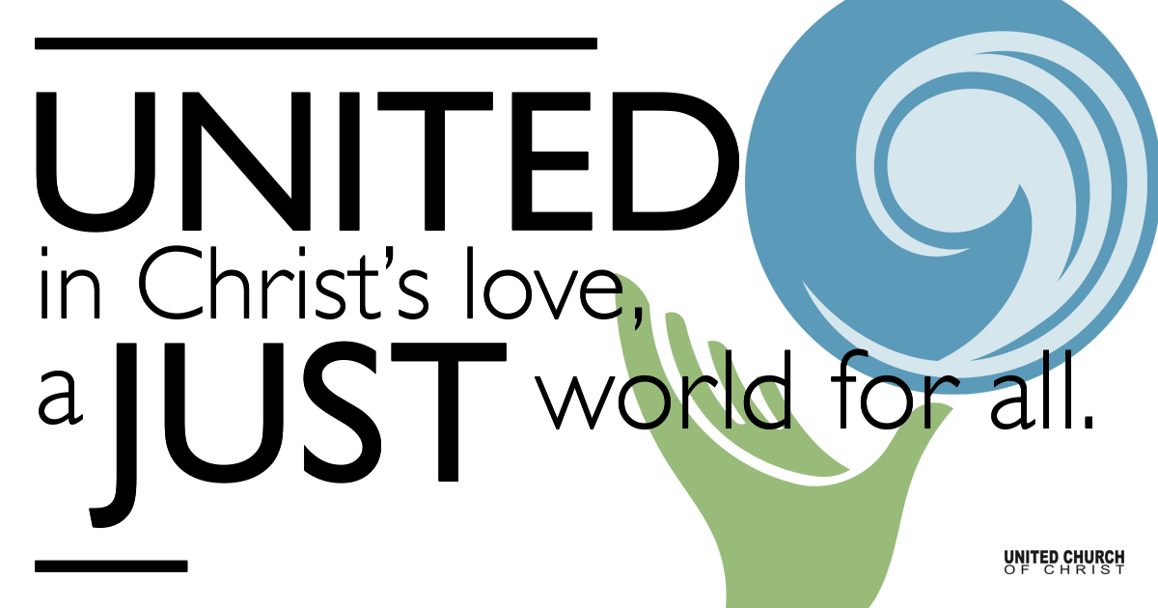

December 24, 2020

We Are Those Who Dream
Silent Meditation

The people who walked in darkness
have seen a great light.
For those who lived in a land of deep shadows—
light! sunbursts of light!
You repopulated the nation,
you expanded its joy.
Oh, they’re so glad in your presence!
Festival joy!
For a child has been born—for us!
the gift of a son—for us!
He’ll take over
the running of the world.
His names will be: Amazing Counselor,
Strong God,
Eternal Father,
Prince of Wholeness.
His ruling authority will grow,
and there’ll be no limits to the wholeness he brings.
He’ll rule from the historic David throne
over that promised kingdom.
He’ll put that kingdom on a firm footing
and keep it going
With fair dealing and right living,
beginning now and lasting always.
The zeal of God-of-the-Angel-Armies
will do all this.

Prelude I Heard the Bells on Christmas Day Henry W. Longfellow

I heard the bells on Christmas day
Their old familiar carols play
And mild and sweet their songs repeat
Of peace on earth good will to them

And in despair I bowed my head
There is no peace on earth I said
For hate is strong and mocks the song
Of peace on earth, good will to them

Then rang the bells more loud and deep
God is not dead, nor does he sleep (peace on earth, peace on earth)
The wrong shall fail, the right prevail
With peace on earth, good will to them

Welcome to Worship

One: Whoever you are and wherever you are on life’s journey,
ALL: We welcome you here.

Song “I Wonder as I Wander John Jacob Niles Bill Green and Tom Klassen

Opening Comments

Song O Come All Ye Faithful John Francis Wade
Jim Bale

Ringing of the Bell

Call to Worship
One: We have been dreaming of this night all through Advent.
ALL: This is the night to celebrate!
One: Yes, this is the night we celebrate the birth of Jesus.
ALL: Let’s observe the birth of Jesus by inviting his Love to be born in our hearts and spirits this very evening.
One: Rejoice, good friends, the Good News we have dreamed of is here!
ALL: Open our hearts to receive this blessed gift, Loving God.
ALL: Jesus is Born! Hallelujah! AMEN.

Lighting of the Advent Wreath
To Light the Advent Wreath at home:
Light all five candles, with the center white candle last.
Light the first four candles.
Speaker 1: This Christmas we are doing lots of dreaming.
Speaker 2: The center candle is a candle for Christ.
Speaker 1: We light this candle this evening with our eyes on Christ’s holiness for all beings and creatures in our world.
(light fifth candle)
ALL: We are dreaming of a Holy Christmas.

Song Christmas Wishes Wendy Parr

Children’s Christmas Pageant Video

Scripture Isaiah 9:2-7

Song Who Would Send a Baby? Mary Kay Beall Carolyn Klassen

Scripture Luke 2:1-20

Reflection “We are Those Who Dream” Rev. Marijke Rossi

Call to the Offering UCC Christmas Fund for Veterans of the Cross

Song Some Children See Him James Taylor
Kelly Martin and Cory McCann, pianist Kevin Howard

Children’s Time Rev. Chelsea Page

↑Words of Mission and Benediction

↑Closing Song Somewhere in My Silent Night Casting Crowns, performed by Allison Ottley

Find out More!
holladayucc.org



2631 East Murray-Holladay Rd
Holladay, UT 84117 801-277-2631
Rev. Marijke Rossi, Pastor
Rev. Chelsea Page, Associate Pastor
We are a Whole Earth,
Open and Affirming Congregation
Of the United Church of Christ.
Or scan from your mobile device:

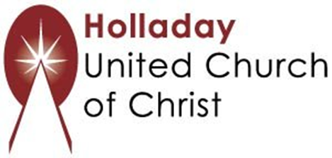

Participants in Worship:
Reader: Rev. Shesh Tipton, Zain Yousef, Aubri Kinsey Milner
Video Production: Bill Green; Children’s Chat: Rev. Chelsea Page
Music: Matt Mortensen, Bill Green, Tom and Marilyn Klassen Jim Bale, Kelly Martin, Cory McCann, Kevin Howard, Allison Ottley

