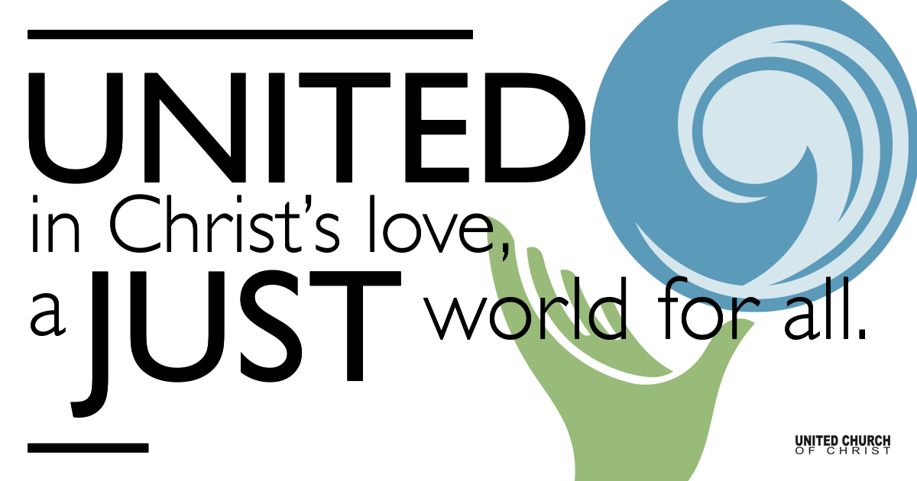

December 27, 2020

Dreaming of Our New Year
Silent Meditation
O ingenious God, I rejoice in your creation, and pray that your Spirit touch me so deeply that I will find a sense of self which makes me glad to be who I am and yet restless at being anything less than I can become.
~Rev. Ted Loder

Prelude Go Tell It On the Mountain NCH #154

Refrain:
Go tell it on the mountain,
Over the hills and ev'rywhere;
Go tell it on the mountain
That Jesus Christ is born.

1 While shepherds kept their watching
O'er silent flocks by night,
Behold, throughout the heavens
There shone a holy light. [Refrain]

2 The shepherds feared and trembled
When lo! above the earth
Rang out the angel chorus
That hailed our Savior's birth. [Refrain]

3 Down in a lowly manger
The humble Christ was born,
And God sent us salvation
That blessed Christmas morn. [Refrain]

Welcome to Worship
One: Whoever you are and wherever you are on life’s journey,
ALL: We welcome you here.

Opening Comments

Ringing of the Bell

Call to Worship

One: Make me simple enough
All: Not to be confused by disappointments,
One Make me clear enough
All: Not to mistake busyness for freedom.
One: Make me honest enough,
All: Not to expect truth to be painless.
One Make me brave enough,
All: Not to sing all my songs in private.
One: Make me compassionate enough,
All: to get in trouble.
One: Make me humble enough,
All: to admit trouble and seek help.
One: Make me joyful enough,
All: To celebrate all of it, myself and others, through Jesus Christ.
(Adapted from a Rev. Ted Loder poem)

↑Opening Song Jazz Gloria Natalie Sleeth
Steve Ritchey, Carlynn Canny, Jim Bale, Pam Ericksen, Jani Gamble

Scripture Luke 2:41-52

Reflection “Dreaming of Our New Year” Rev. Martha M. Moler

Reflection Song Mary Did You Know? Buddy Greene Shelley McCall & Eric Richards

Children’s Time Rev. Chelsea Page

↑Closing Song Better Days Johnny Rzeznik
Mona Stevens

Live Service

Call to Offering – The Christmas Fund

Prayers of the Community
(If you would like to offer a prayer of gratitude or concern for someone or some situation please comment when you join the live service. Please use first names for security. The congregation will respond to each prayerful offering with the following words:
“Together with God, we hear your prayers.”)

Pastoral Prayer

Jesus Prayer
Our Creator who is in heaven,
Hallowed be Your name,
Your reign come, Your will be done,
On earth as it is in heaven,
Give us this day our daily bread,
And forgive us our debts as we forgive our debtors,
And lead us not into temptation, but deliver us from evil,
For Yours is the reign, the power, and glory for ever. Amen.

↑Words of Mission and Benediction

Find out More!



holladayucc.org

Or scan from your mobile device:


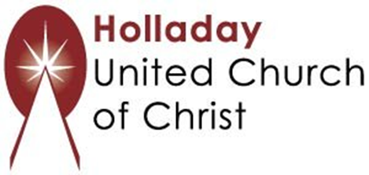
2631 East Murray-Holladay Rd
Holladay, UT 84117 801-277-2631
Rev. Marijke Rossi, Pastor
Rev. Chelsea Page, Associate Pastor
We are a Whole Earth,
Open and Affirming Congregation
Of the United Church of Christ.
Participants in Worship:
Reader: Rev. Shesh Tipton; Video Production: Connie Nomann
Music: Matt Mortensen, Jim Bale, Shelley McCall, Eric Richards, Mona Stevens
Children’s Chat: Rev. Chelsea Page

