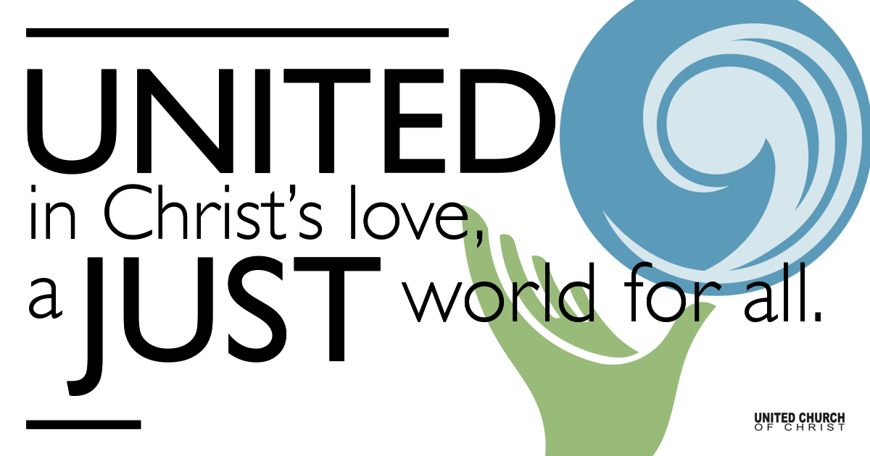

January 03, 2021

Light of the World
Meditation
Thousands of Candles can be lit from a single candle, and the life of the single candle will not be shortened. Happiness never decreases by being shared. ~Bukkyo Dendo Kyokai, The Teaching of Buddah

Prelude “Blest Be the Tie That Binds” Matt on Organ

Welcome to Worship
One: Whoever you are and wherever you are on life’s journey,
ALL: We welcome you here.

Opening Comments
Please join us for Holy Communion on Facebook Live at 11 a.m.

Ringing of the Bell

Call to Worship
One: Some years seem longer and darker than others. 2020 was one of those years.
ALL: We are longing for the light to brighten up our journeys as we move forward.
One: We need to know, has the darkness made us blind to some of the evil in the world this past year?
ALL: Have we been part of those who have hidden their heads under the blanket, ignoring the lies of the world and not challenging them?
One: So we must ask, where are the light-bearers, those who will shine a light in all those dark spaces in our world and renew our faith in Love?
ALL: What sky will now open bringing sun and rain to our eyes which have been filled with tears?
One: Will our own faith be enough to put evidence in our hands and convince us that this darkness has not made us blind? Dig down deep, each of you. See what you can find.
ALL: We need to find the faith in God's Love, the faith that discovers, once again, that Love has the power to restore our sight. May we be blessed as the Spirit's "light-bearers." Amen

↑Opening Song “Light of the World”
Paul T. Duncan/Lauren Daigle/Paul Brendon Mabury
The world waits for a miracle The heart longs for a little bit of hope
Oh come, oh come, Emmanuel A child prays for peace on Earth
And she's calling out from a sea of hurt Oh come, oh come, Emmanuel
And can you hear the angels singing Glory to the light of the world
Glory the light of the world is here
The drought breaks with the tears of a mother
A baby's cry is the sound of love Come down, come down, Emmanuel
Oh, He is the song for the suffering He is Messiah,
the Prince of Peace has come
He has come, Emmanuel Glory to the light of the world
Glory to the light of the world Glory to the light of the world
Glory to the light of the world For all who wait
For all who hunger For all who've prayed
For all who wonder Behold your King
Behold Messiah Emmanuel, Emmanuel
Glory to the light of the world Glory to the light of the world
Glory to the light of the world Behold your King
Behold Messiah Emmanuel, Emmanuel
The world waits for the miracle The heart longs for a little bit of hope
Oh come, oh come Emmanuel

Stewardship Message Dennis Bayes

Scripture John 1:1-10 Rev. Marijke Rossi

Reflection “The Light of the World” Rev. Marijke Rossi

Song of Reflection “I Believe Even When” Mark Miller Virtual Choir

Children’s Time Kerry Spiroff

↑Closing Song “Servant Song” Richard Gillard
Won’t you let me be your servant, let me be as Christ to you
Pray that I might have the grace to let you be my servant too.
We are pilgrims on a journey. We are siblings on the road
We are here to help each other walk the mile and bare the load.
I will weep when you are weeping. When you laugh, I'll laugh with you.
I will share your joys and sorrow 'till we've seen this journey through.
When we sing to God in heaven, we shall find such harmony.
Born of all we've known together of Christ's love and agony.

Live Service

Call to Offering

Prayer of Dedication

Prayers of the Community
(If you would like to offer a prayer of gratitude or concern for someone or some situation please comment when you join the live service. Please use first names for security. The congregation will respond to each prayerful offering with the following words:
“Together with God, we hear your prayers.”)

Pastoral Prayer

Jesus Prayer
Our Creator who is in heaven,
Hallowed be Your name,
Your reign come, Your will be done,
On earth as it is in heaven,
Give us this day our daily bread,
And forgive us our debts as we forgive our debtors,
And lead us not into temptation, but deliver us from evil,
For Yours is the reign, the power, and glory for ever. Amen.

↑Words of Mission and Benediction

Find out More!



holladayucc.org

Or scan from your mobile device:


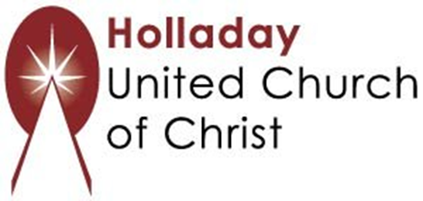
2631 East Murray-Holladay Rd
Holladay, UT 84117 801-277-2631
Rev. Marijke Rossi, Pastor
Rev. Chelsea Page, Associate Pastor
We are a Whole Earth,
Open and Affirming Congregation
Of the United Church of Christ.
Participants in Worship:
Reader: Shesh Tipton
Music: Twist of Faith, Matt Mortensen, Children’s Chat: Kerry Spiroff

