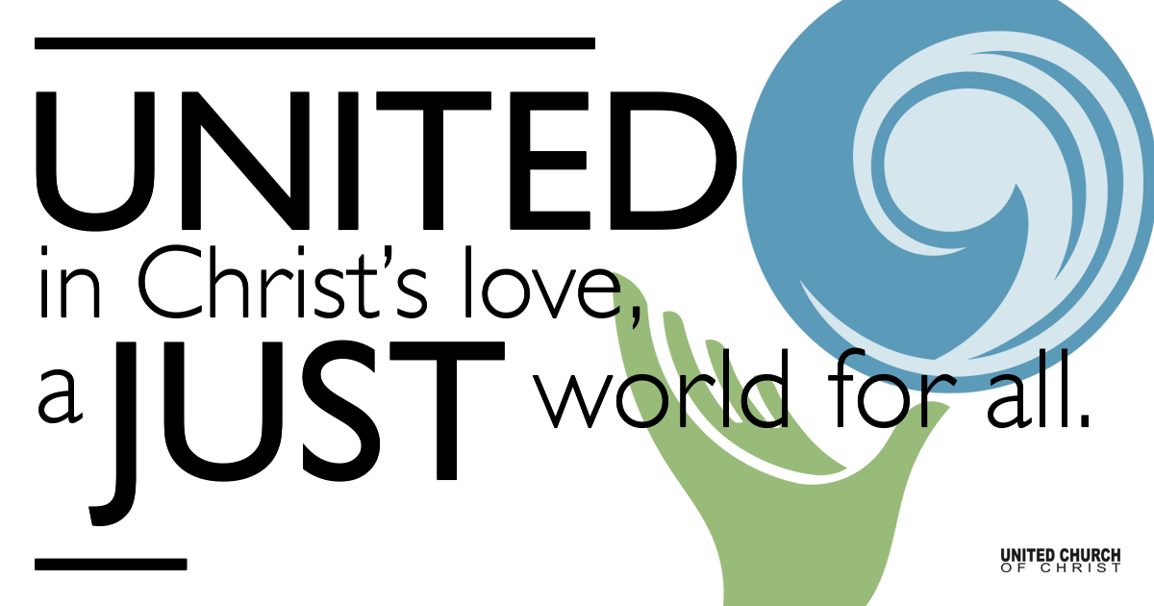

January 17, 2021

Children’s Sabbath
Silent Meditation
“The moral test of government is how that government treats those who are in the dawn of life, the children; those who are in the twilight of life, the elderly; those who are in the shadows of life; the sick, the needy and disabled.”
- Hubert Humphrey (U.S. Vice President 1965-1969)
Spoken in Washington, D.C. on November 1, 1977.

Prelude See You Again Charlie Puth
One Voice Children’s Choir

Welcome to Worship
One: Whoever you are and wherever you are on life’s journey,
ALL: We welcome you here.

Opening Comments

Ringing of the Bell

Call to Worship

One: God of the infants and toddlers
People: We worship you here.

One: God of the children, teens, and adults
People: We worship you here.

One: God who welcomes our service and gifts no matter our age
People: We worship you here.

One: God who loves all the children and bends us toward justice for them
People: We worship you here. Amen.

↑Opening Song Brave Sara Bareilles
One Voice Children’s Choir

Scripture Matthew 18:1-7 Trent Parkhill

Children’s Time Trent Parkhill

Reflection “Known and Loved” Rev. Chelsea Page

↑Closing Song Memories Maroon 5
One Voice Children’s Choir

Live Service

Call to Offering

Prayer of Dedication

Prayers of the Community
(If you would like to offer a prayer of gratitude or concern for someone or some situation please comment when you join the live service. Please use first names for security. The congregation will respond to each prayerful offering with the following words:
“Together with God, we hear your prayers.”)

Pastoral Prayer

Jesus Prayer
O Breathing Life, your Name shines everywhere!
Release a space to plant your Presence here.
Imagine your possibilities now.
Embody your desire in every light and form.
Grow through us this moment's bread and wisdom.
Untie the knots of failure binding us,
as we release the strands we hold of other's faults.
Help us not forget our Source,
yet free us from not being in the Present.
From you arises every Vision, Power and Song
from gathering to gathering. Amen
May our future actions grow from here!

↑Words of Mission and Benediction

Find out More!



holladayucc.org

Or scan from your mobile device:


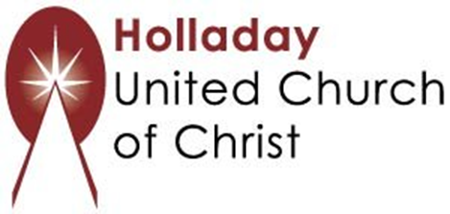
2631 East Murray-Holladay Rd
Holladay, UT 84117 801-277-2631
Rev. Marijke Rossi, Pastor
Rev. Chelsea Page, Associate Pastor
We are a Whole Earth,
Open and Affirming Congregation
Of the United Church of Christ.
Participants in Worship:
Reader: Rev. Chelsea Page, Video: Connie Nomann
Music: One Voice Children’s Choir, Children’s Chat: Trent Parkhill

PRAYER REQUESTS
The following are offered for your prayers both this morning and as you pray this week at home:
· Prayers of strength and comfort for all those who live in fear of violence.
· Prayers of support and gratitude for our community of caregivers.
· Prayers of healing for all who are facing health issues

