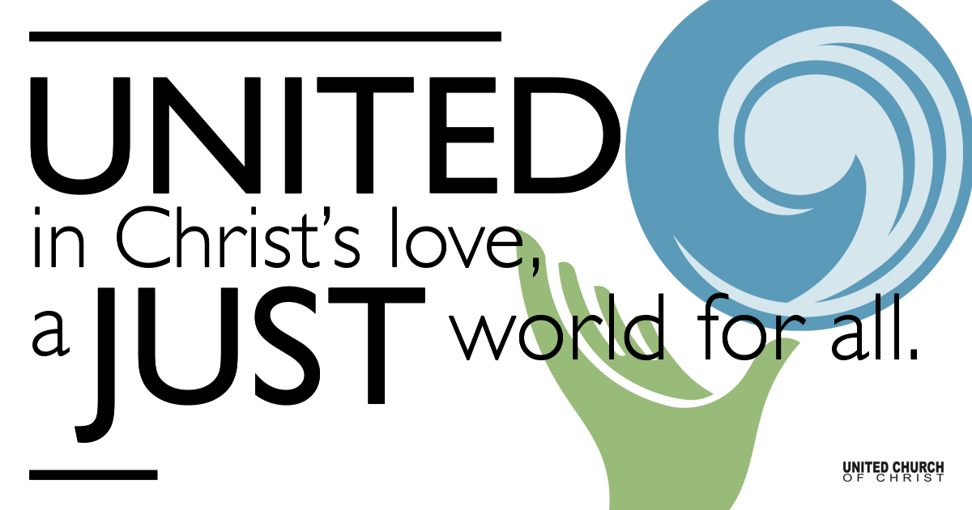

January 24, 2021

A New Slate of Characters
Silent Meditation
“Try your best to make goodness attractive. That’s one of the toughest assignments you’ll ever be given.” Fred Rogers

Prelude You Have Come Down to the Lakeshore C. Gabarain

Welcome to Worship
One: Whoever you are and wherever you are on life’s journey,
ALL: We welcome you here.

Opening Comments

Ringing of the Bell

Call to Worship
One: Let us all breathe a sigh of relief. (deep breath)
ALL: (Deep breath). Life has been difficult.
One: Hate and rancor, even violence, have permeated parts of our world.
ALL: But there is a new cast of characters that bring hope.
One: Jesus cast a net and called his disciples to follow him.
ALL: We are not perfect, but we, too, are called.
One: We are called to spread the message of Hope.
ALL: We are called to live the message of Peace.
One: We are called to bring God's message of Love to our hearts, to our homes, to our communities and to our world.
ALL: God, we are willing to be your cast of characters. Teach us what steps to take as we open our hearts to learn from you. Amen.

↑Opening Song On Eagle’s Wings Michael Joncas
You who dwell in the shelter of the Lord, who abide in God’s shadow for life, Say to the Lord: “My refuge, my Rock in whom I trust!”
And God will raise you up on eagle’s wing, bear you on the breath of dawn,
Make you to shine like the sun, and hold you in the palm of His hand.
The snare of the fowler shall never capture you, and famine will bring you no fear;
Under God’s wings your refuge and faithfulness your shield.
You need not fear the terror of the night, nor the arrow that flies by day;
Though thousands fall about you, near you it shall not come.
For to God’s angels is given a command to guard you in all of your ways;
Upon their hands they will raise you up, lest you cast your foot against a stone.

Scripture Mark 1:14-20

Reflection “A New Cast of Characters” Rev. Marijke Rossi

Children’s Time Linda Hilton

↑Closing Song Dona Nobis Pacem - Grant Us Peace

Live Service

Call to Offering

Prayer of Dedication

Prayers of the Community
(If you would like to offer a prayer of gratitude or concern for someone or some situation please comment when you join the live service. Please use first names for security. The congregation will respond to each prayerful offering with the following words:
“Together with God, we hear your prayers.”)

Pastoral Prayer

Jesus Prayer
O Breathing Life, your Name shines everywhere!
Release a space to plant your Presence here.
Imagine your possibilities now.
Embody your desire in every light and form.
Grow through us this moment's bread and wisdom.
Untie the knots of failure binding us,
as we release the strands we hold of other's faults.
Help us not forget our Source,
yet free us from not being in the Present.
From you arises every Vision, Power and Song
from gathering to gathering. Amen
May our future actions grow from here!

↑Words of Mission and Benediction

Find out More!



holladayucc.org

Or scan from your mobile device:


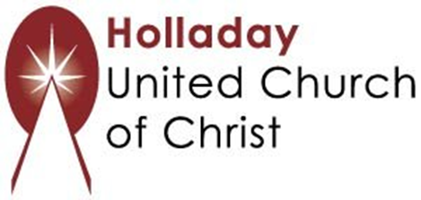
2631 East Murray-Holladay Rd
Holladay, UT 84117 801-277-2631
Rev. Marijke Rossi, Pastor
Rev. Chelsea Page, Associate Pastor
We are a Whole Earth,
Open and Affirming Congregation
Of the United Church of Christ.
Participants in Worship:
Reader: Shesh Tipton Video: Connie Nomann
Music: Matt Mortensen, Pam Erickson, Children’s Chat: Linda Hilton

PRAYER REQUESTS
The following are offered for your prayers both this morning and as you pray this week at home:
· Prayers of strength and comfort for all those who live in fear of violence.
· Prayers of support and gratitude for our community of caregivers.
· Prayers of healing for all who are facing health issues

