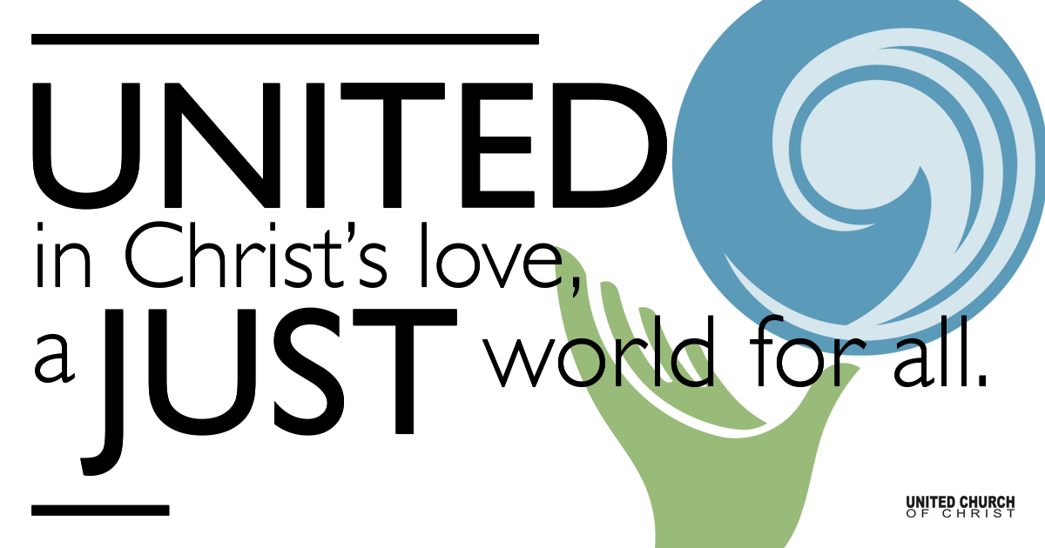

February 07, 2021

Presentation of the Child Jesus
Silent Meditation
i thank You God for most this amazing
day:for the leaping greenly spirits of trees
and a blue true dream of sky; and for everything
which is natural which is infinite which is yes
(Now the ears of my ears awake
And now the eyes of my eyes are opened)
e.e. Cummings

Prelude “Morning Has Broken” Eleanor Farjeon
Thomas Klassen Piano

Welcome to Worship
One: Whoever you are and wherever you are on life’s journey,
ALL: We welcome you here.

Opening Comments

Today is Holy Communion; please bring your elements of bread and juice to your screen. There will be no coffee hour or live prayer service today due to the Congregational Meeting at 11 a.m.

Ringing of the Bell

Call to Worship Rev. Shesh Tipton
One: Good people of the church, Lift up your eyes and see.
All: Have you not seen? Have you not heard? Our God greets us here.
One: Good servants of the Most High, Open your ears to hear.
All: Have you not seen? Have you not heard? Our God meets us here.
One: Good children of the light: Open your hearts and know what it means to delight in God.
All: For we have seen, heard and known, from the beginning to the end, Our God…is.
One: Eternal God, Creator of the universe…and then some. We call on you, you who greet us here. We give you thanks for making it possible to gather, and to ponder your eternal mysteries. Make us, creatures of this time and space, ready collaborators with your endless grace. Amen.

↑Opening Song “The Garden Song” David Mallett
Inch by inch, row by row
Gonna make this garden grow
All it takes is a rake and a hoe
And a piece of fertile ground
Inch by inch, row by row
Someone bless these seeds I sow
Someone warm them from below
Till the rain comes tumbling down
Pulling weeds and picking stones
Man is made of dreams and bones
Feel the need to grow my own
Cause the time is close at hand
Painful rain, sun and rain
Find my way in nature's chain
Tune my body and my brain
To the music from the land
Plant your rows straight and long
Temper them with prayer and song
Mother Earth will make you strong
If you give her love and care
Old crow watching hungrily
From his perch in yonder tree
In my garden I'm as free
As that feathered thief up there

Scripture Luke 2:22-40 Read by Jim Bale

Reflection “In the Springtime of Life” Rev. Chelsea Page

Communion Liturgy - Based on “A Blessing with Roots” by Jan Richardson

Preparation of the Gifts Rev. Chelsea Page

Invitation to the Table Rev. Shesh Tipton
Tug at this blessing
and you will find
it is a thing
with roots.
This is a blessing
that has gone deep
into good soil,
into the sacred dark,
into the luminous hidden.
It has been months
since the ground
gathered the seed
of this blessing
into itself,
years since the earth
enfolded it.
Sometimes
that’s how long
a blessing takes.
And the fact
that this blessing
should finally show
its first fruits
on the day
you happened by—tp
well, perhaps we shall
simply call the timing
of this ripening
a mystery
and a sweet grace.

Invocation Rev. Martha Moler

Instructions for Receiving Rev. Shesh Tipton
Take all you want
of this blessing.
Take every morsel
that you need for
the path ahead.
Let its fruits fall
into your hands;
gather them into
the basket of
your arms.
Let this blessing
be one place
where you are willing
to receive
in unmeasured portions,
to lay aside
for a moment
the way you ration
your delights.

Receiving Together Rev. Shesh Tipton

Communion Song “Give Yourself to Love” Kate Wolf
performed by Jani Gamble

Prayer after Communion Rev. Shesh Tipton
Please join me in prayer:
May you accept
this inexplicable plenitude;
allow it to give itself
to sustain you
not simply for yourself—
though on this bright day
I might be persuaded
to think that would
be enough—
but that you may
gather its seeds
into yourself
like the ground
where this blessing began
and wait
with the patience
of seasons
and of years
to bear forth
in the fullness of time
a stunning harvest,
a plenteous feast. Amen.

Children’s Time Ruby Hammel

↑Closing Song “How Can I Keep From Singing” Robert Lowry

Find out More!



holladayucc.org

Or scan from your mobile device:


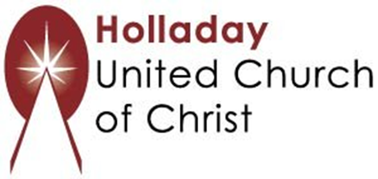
2631 East Murray-Holladay Rd
Holladay, UT 84117 801-277-2631
Rev. Marijke Rossi, Pastor
Rev. Chelsea Page, Associate Pastor
Eric Richards, Director of Music Ministry
We are a Whole Earth,
Open and Affirming Congregation
Of the United Church of Christ.
Participants in Worship:
Reader: Rev. Shesh Tipton and Jim Bale, Video: Connie Nomann
Music: Twist of Faith, Tom Klassen, Jani Gamble
Children’s Chat: Ruby Hammel

