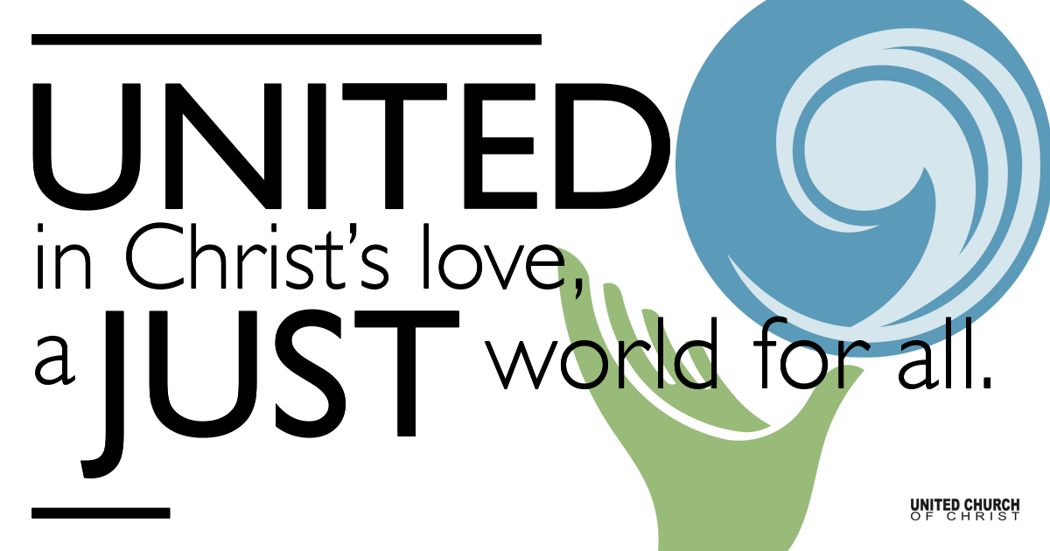

February 14, 2021

Mental Health Awareness
Silent Meditation
It’s almost Ash Wednesday
and we are on our way
to Your Way.

O Lamb of God
have mercy upon us and
keep us from all the smallness of our lives
that would take precedence over
kneeling in Jerusalem
~ Ann Weems ~

Prelude “Hello In There” John Prine

Welcome to Worship
One: Whoever you are and wherever you are on life’s journey,
ALL: We welcome you here.

Opening Comments

Ringing of the Bell

Call to Worship
One: Our church, Holladay UCC, is called to be a sanctuary.
ALL: And just how are we supposed to fulfill that calling?
One: By creating a safe space for those who feel they are in danger - mentally, physically or spiritually.
ALL: Again, how shall we fulfill that calling?
One: We've already begun doing so this morning in our welcome.

ALL: Yes, each Sunday morning we welcome everyone, no matter where they are on their journey, to join us.
One: This includes people of color and our LGBTQ community among others. However, this morning we will focus on mental health issues.
Let us go to God for help:
ALL: Holy One, we ask that you be in the minds and hearts of those who are suffering from any sort of mental health issue. We also ask your guidance for HUCC that, in your name, we will be open and willing to support all who are at risk. We ask these things in Love, Amen

↑Opening Song The Sound of Silence Paul Simon

Scripture Luke 8:26-39

Reflection “Who Could Love Me?” Rev. Martha Moler

Children’s Time Pam Erickson

↑Closing Song One Voice Barry Manilow

Just one voice, singing in the darkness
All it takes is one voice
Singing so they hear what's on your mind
And when you look around you'll find

There's more than one voice
Singing in the darkness
Joining with your one voice
Each and every note another octave
Hands are joined and fears unlocked

If only, one voice, would start it on its own
We need just one voice facing the unknown
And then that one voice would never be alone
It takes that one voice

It takes that one voice
Just one voice, singing in the darkness
All it takes is one voice
Shout it out and let it ring
Just one voice, it takes that one voice
And everyone will sing

Live Service

Call to Offering

Prayer of Dedication

Prayers of the Community
(If you would like to offer a prayer of gratitude or concern for someone or some situation please comment when you join the live service. Please use first names for security. The congregation will respond to each prayerful offering with the following words:
“Together with God, we hear your prayers.”)

Pastoral Prayer

Jesus Prayer
Our Creator who is in heaven,
Hallowed be Your name,
Your reign come, Your will be done,
On earth as it is in heaven,
Give us this day our daily bread,
And forgive us our debts as we forgive our debtors,
And lead us not into temptation, but deliver us from evil,
For Yours is the reign, the power, and glory for ever. Amen.

↑Words of Mission and Benediction

Find out More!



holladayucc.org

Or scan from your mobile device:


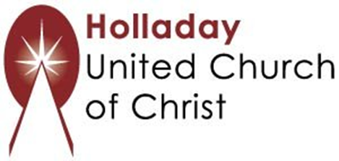
2631 East Murray-Holladay Rd
Holladay, UT 84117 801-277-2631
Rev. Marijke Rossi, Pastor
Rev. Chelsea Page, Associate Pastor
Eric Richards, Director of Music Ministry
We are a Whole Earth,
Open and Affirming Congregation
Of the United Church of Christ.
Participants in Worship:
Reader: Martha Moler, Video: Connie Nomann
Music: Kelly Martin, Cory McCann, Virtual Choir
Children’s Chat: Pam Erickson

