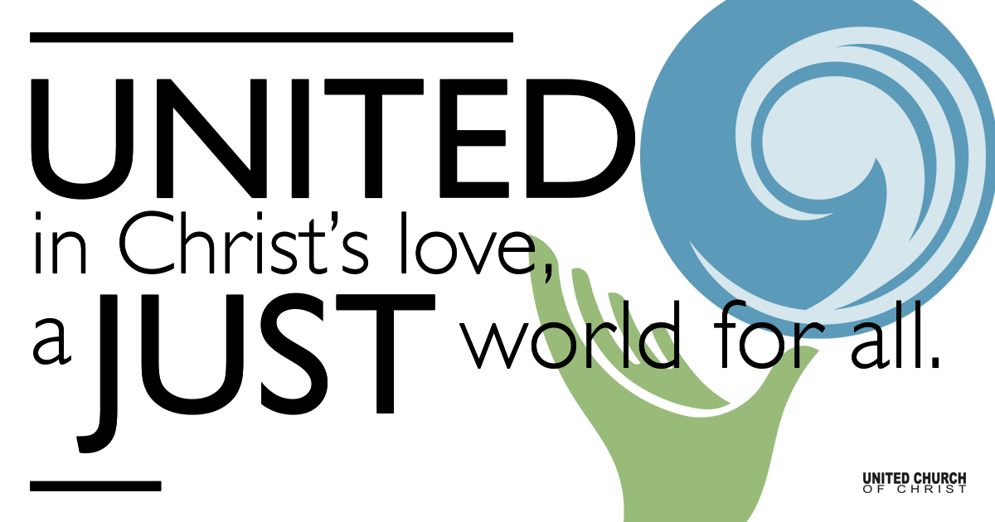

February 21, 2021

Dropped Into the Wilderness
Silent Meditation
As Jesus knew, going into the barren and uncomfortable places
isn’t about proving how holy we are, or how tough, or how brave.
It’s about letting God draw us into the place where we don’t
know everything, don’t have to know everything, indeed may be
emptied of nearly everything we think we know.
~The Painted Prayerbook~

Prelude How Great Thou Art

Welcome to Worship
One: Whoever you are and wherever you are on life’s journey,
ALL: We welcome you here.

Opening Comments

Ringing of the Bell

Call to Worship
One: On this Sunday, the first Sunday in Lent, we will be exploring the wilderness.”
ALL: But the wilderness is an uncultivated, uninhabited, and inhospitable region
One: Yes, it is. It is a place that most people choose not to be.
ALL: Jesus did not choose to be there.
One: He did not, however, the Spirit knew what was needed.
ALL: Yes, if we allow the Spirit to lead us we sometimes find ourselves in uncomfortable places as well.
One: You have just described the Lenten experience.
ALL: Spirit, I am sometimes afraid of these challenges. Please guide my way through these 40 days of transition. I trust in you. Amen

↑Opening Song “Dream God’s Dream” Bryan Sirchio
Chorus:
Dream God’s Dream! Holy Spirit help us dream of a world where there is justice and where everyone is free to build and grow and love, and to simply have enough the world will change, when we dream God’s Dream.

- I’m dreaming of a world, where the color of one’s skin will mean less than what’s within the person’s heart. A world where water’s clean and where air is safe to breathe, and every child born has enough to eat.

- I’m dreaming of the call God is offering to me, how to use my energy and my best gifts; to do the work of Christ, to say God please use my life to spread your healing love and to live your truth.

- I’m dreaming of the way that I want my life to go. I’ve got hopes and I’ve got goals I’d like to meet. I’m reaching for the stars, but I won’t forget the scars of Christ who died to show that the Dream’s for all.

Scripture Mark 1: 9-15

Reflection “Dropped Into the Wilderness” Rev. Shesh Tipton

Children’s Time Nan Sturgeon

↑Closing Song “Out in the wilderness” Jay Beech
Driven by the spirit out in the wilderness;
driven by the spirit out in the wilderness;

When the spirit says “Go,” you can’t say “no” You listen for the voice when you’re bended low; driven by the Spirit out in the wilderness
Tempted by the devil out in the wilderness; tempted by the devil out in the wilderness; though you try to be strong, it’s been so long. He whispers in your ear and you know he’s wrong;
tempted by the devil out in the wilderness.

Angels all around you out in the wilderness; angels all around you out in the wilderness; you are far from home where wild things roam, there's danger everywhere but you're not alone;
angels all around you out in the wilderness.

“You are my beloved” out in the wilderness. “You are my beloved” out in the wilderness. When you were baptized, you realized you’d heard the voice of God from the opening skies:
“You are my beloved” out in the wilderness.

Live Service

Call to Offering

Prayer of Dedication

Prayers of the Community
(If you would like to offer a prayer of gratitude or concern for someone or some situation please comment when you join the live service. Please use first names for security. The congregation will respond to each prayerful offering with the following words:
“Together with God, we hear your prayers.”)

Pastoral Prayer

Jesus Prayer
Our Creator who is in heaven,
Hallowed be Your name,
Your reign come, Your will be done,
On earth as it is in heaven,
Give us this day our daily bread,
And forgive us our debts as we forgive our debtors,
And lead us not into temptation, but deliver us from evil,
For Yours is the reign, the power, and glory for ever. Amen.

↑Words of Mission and Benediction

Find out More!



holladayucc.org

Or scan from your mobile device:


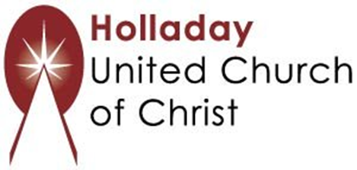
2631 East Murray-Holladay Rd
Holladay, UT 84117 801-277-2631

Rev. Chelsea Page, Associate Pastor
Eric Richards, Director of Music Ministry
We are a Whole Earth,
Open and Affirming Congregation
Of the United Church of Christ.
Participants in Worship:
Reader: Martha Moler, Video: Connie Nomann
Music: Marilyn and Chuck Dillard, Matt Mortenson
Children’s Chat: Nan Sturgeon

