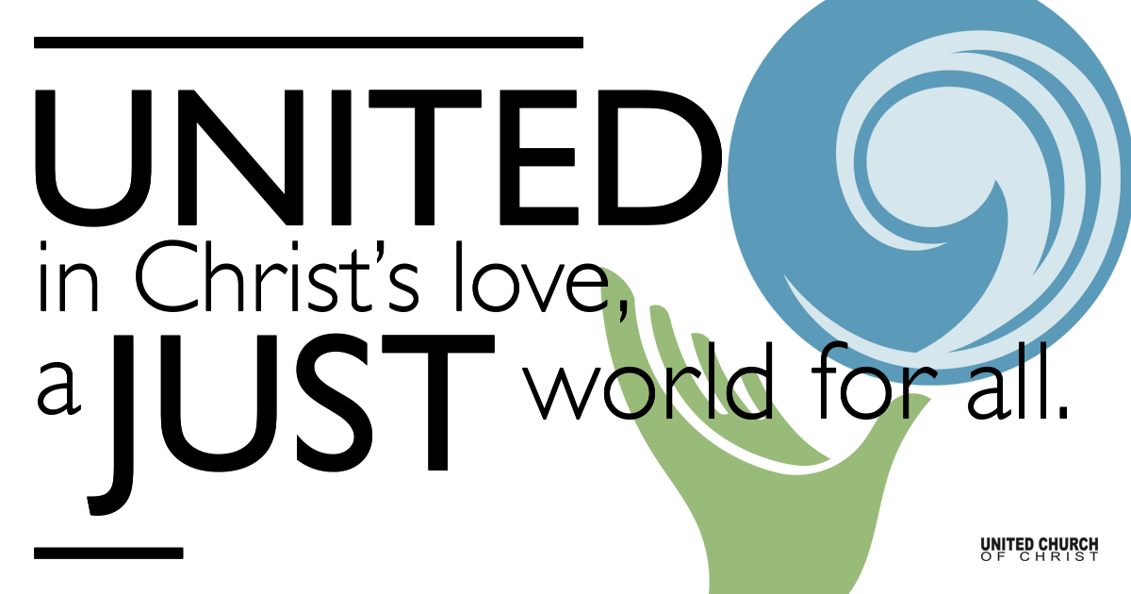

February 28, 2021

Racial Reconciliation
Silent Meditation
“The function of beauty… is to make us aware of a reality which is richer and deeper and more marvellous than anything we can dream or conceive.” ~Henry N. Wieman

Prelude "Plenty Good Room" (Spiritual) Dwight Flemming

Welcome to Worship
One: Whoever you are and wherever you are on life’s journey,
ALL: We welcome you here.

Opening Comments

Ringing of the Bell

Call to Worship
Leader: In a cycle of time that has brought tragedy and loss,
when to hear or read the news reminds us, again and again,
of our vulnerable humanity, of the violence,
so close beneath the skin in this beautiful land,
People: we are aware that there is still hostility and untruthfulness in our communal conversations, there are still families and communities and governments torn by violence that we claim not to understand.
Leader: In this cycle of time when spectacular acts of terrorism and revenge and unrecorded, smaller daily acts of discrimination and abuse accumulate and thoughtless words and actions cause pain to those we assume are invulnerable—
People: We give thanks that there are also stories of courage and love
if we look for them:
leaders and individuals in every sphere
who stand up for honesty, fairness and justice;
people in business and politics, workplaces, schools, communities
who demand and model ethical behavior,
who work by co-operation not conflict,
who speak peace to power.
All: In this beautiful land where we work and live
there are daily acts of bravery, unselfishness and kindness
which give us hope, reminding us that the Kin-dom of Heaven is here
in our hearts and actions. We give thanks that, in this special place,
in each other’s company, the way of justice is one we walk together.
(adapted from Bronwyn White)

↑Opening Song “Hush” NCH 604, Spiritual Arr. Jeffry Radford

- Hush, hush, somebody’s calling my name (3x)
Oh, my God, Oh, My God, what shall I do, what shall I do?
- Sounds like Jesus, somebody’s calling my name (3x)
- I’m so glad, trouble don’t last always (3x).

Scripture Isaiah 56: 1-8

Reflection “Six Big Ideas” Rev. Nancy Piggott, BCC

Children’s Time Chelsea Page

↑Words of Mission and Benediction
To quote from Rev Silvester Beaman who gave the benediction at Biden’s inauguration. He spoke of a future vision, saying,
“This is our benediction. That from these hallowed grounds, where slave labor built this shrine and and citadel to liberty of democracy; let us all acknowledge from the Indigenous native American; to those who recently received their citizenship; from the African American to those whose foreparents came from Europe, and every corner of the globe; from the wealthy to those struggling to make it; for every human being, regardless of their choices, that this is our country, (and) as such teach us, oh God, … to live in it, love in it, be healed in it and reconciled to one another in it.” Go in peace to love and to serve. Amen.

↑Closing Song “Lord, Help Me to Hold Out” Rev. James Cleveland
Lord, help me to hold out, until my change comes…
< solo verse: Dwight Flemming>
Lord, help me to hold out..I believe I can hold out..until my change comes.

Live Service

“Continue” by Maya Angelou

Prayers of the Community

Pastoral Prayer

Jesus Prayer
Our Creator who is in heaven,
Hallowed be Your name,
Your reign come, Your will be done,
On earth as it is in heaven,
Give us this day our daily bread,
And forgive us our debts as we forgive our debtors,
And lead us not into temptation, but deliver us from evil,
For Yours is the reign, the power, and glory for ever. Amen.

Find out More!



holladayucc.org

Or scan from your mobile device:



2631 East Murray-Holladay Rd
Holladay, UT 84117 801-277-2631
Rev. Marijke Rossi, Pastor
Rev. Chelsea Page, Associate Pastor
Eric Richards, Director of Music Ministry
We are a Whole Earth,
Open and Affirming Congregation
Of the United Church of Christ.
Participants in Worship:
Reader: Rori Piggott, Video: Connie Nomann
Music: Dwight Flemming, Steve Ritchey, Cheryl Murray, Carol Brown
Children’s Chat: Rev. Chelsea Page

