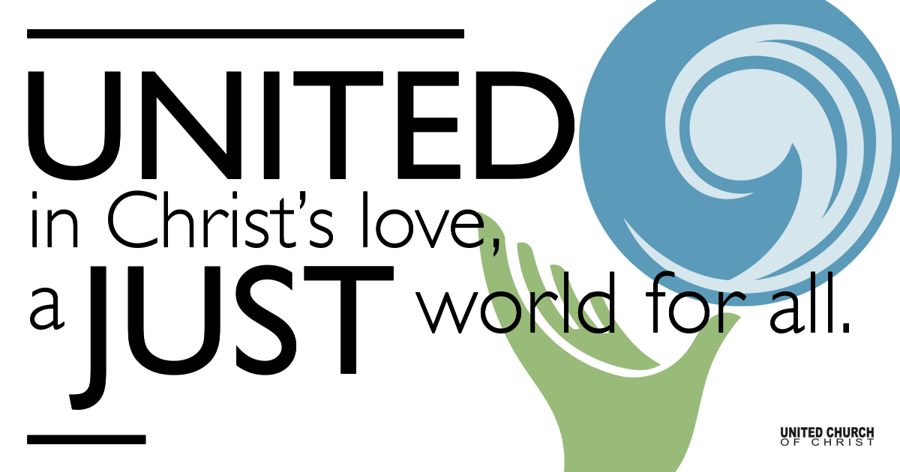

March 07, 2021

Questions and Answers
Silent Meditation
“We have all known the long loneliness, and we have found that the answer is community.” - Dorothy Day

Organ Prelude “O God of Earth and Altar” NCH#582

Welcome to Worship
One: Whoever you are and wherever you are on life’s journey,
ALL: We welcome you here.

Opening Comments

Ringing of the Bell

Call to Worship
One: We are missing our church building and we want it back!
ALL: Our sanctuary holds so much love inside.
One: It might seem that way but if we are attributing the love we feel when we are inside our "temple" to the building itself we are off-track.
ALL: Perhaps then, our sanctuary holds our community inside and we provide the Love.
One: Partly, yes. But there is more.
ALL: The Love of God lives inside as well and God's Love for us surrounds us when we are together.
One: Yes, it will be a blessing to return to the place we come together to share our Love of God, each other and the world.
ALL: We must remember, the Love of the Spirit encompasses us when we worship in our homes, on Zoom, in the mountains or at the beach. God is a God of Love and we are grateful.

↑Opening Song “Getting to Know You” Rodgers/Hammerstein
Getting to know you
Getting to know all about you
Getting to like you
Getting to hope you like me
Getting to know you
Putting it my way
But nicely
You are precisely
My cup of tea
Getting to know you
Getting to know all about you
Getting to like you
Getting to hope you like me
Getting to know you
Putting it my way
But nicely
You are precisely
My cup of tea
Getting to know you
Getting to feel free and easy
When I am with you
Getting to know what to say
Haven't you noticed
Suddenly I'm bright and breezy?
Because of all the beautiful and new
Things I'm learning about you
Day by day
Getting to know you
Getting to feel free and easy
When I am with you
Getting to know what to say
Haven't you noticed
Suddenly I'm bright and breezy?
Because of all the beautiful and new
Things I'm learning about you
Day by day

Children’s Time Bill Green

Scripture John 2:13-22

Reflection “The Answer Has Always Been Jesus” Rev. Brent Gundlah

Communion Song “Holy Now” Peter Mayer

Holy Communion Rev. Brent Gundlah

↑Closing Song “Wish You Were Here” David Gilmour

Live Service

Call to Offering

Prayer of Dedication

Prayers of the Community
(If you would like to offer a prayer of gratitude or concern for someone or some situation please comment when you join the live service. Please use first names for security. The congregation will respond to each prayerful offering with the following words:
“Together with God, we hear your prayers.”)

Pastoral Prayer

Jesus Prayer
Our Creator who is in heaven,
Hallowed be Your name,
Your reign come, Your will be done,
On earth as it is in heaven,
Give us this day our daily bread,
And forgive us our debts as we forgive our debtors,
And lead us not into temptation, but deliver us from evil,
For Yours is the reign, the power, and glory for ever. Amen.

↑Words of Mission and Benediction

Find out More!



holladayucc.org

Or scan from your mobile device:

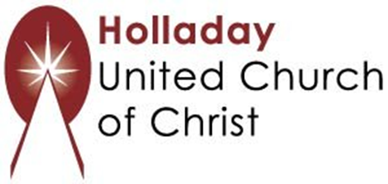
2631 East Murray-Holladay Rd
Holladay, UT 84117 801-277-2631
Rev. Brent Gundlah, Pastor
Rev. Chelsea Page, Associate Pastor
Eric Richards, Director of Music Ministry
We are a Whole Earth,
Open and Affirming Congregation
Of the United Church of Christ.
Participants in Worship:
Reader: Shesh Tipton, Video: Connie Nomann
Music: Twist of Faith, Matt Mortensen, Children’s Chat: Bill Green

