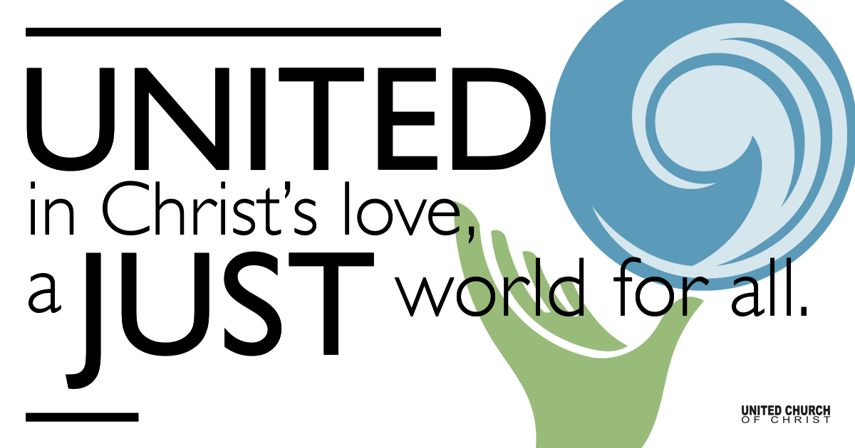

March 14, 2021

Healing
Silent Meditation: “Turn your wounds into wisdom.” - Oprah Winfrey

Prelude “What Wondrous Love Is This?” NCH #223
What wondrous love is this, O my soul, O my soul!
What wondrous love is this, O my soul!
What wondrous love is this that Christ should come in bliss
to bear the heavy cross for my soul, for my soul,
to bear the heavy cross for my soul?

To God and to the Lamb I will sing, I will sing,
to God and to the Lamb I will sing,
to God and to the Lamb who is the great I Am,
while millions join the theme, I will sing, I will sing,
while millions join the theme, I will sing.

And when from death I’m free, I’ll sing on, I’ll sing on,
and when from death I’m free, I’ll sing on!
And when from death I’m free, I’ll sing and joyful be,
and through eternity I’ll sing on, I’ll sing on,
and through eternity I’ll sing on.

Welcome to Worship
One: Whoever you are and wherever you are on life’s journey,
ALL: We welcome you here.

Opening Comments

Ringing of the Bell

Call to Worship (Psalm 107: 1-3, 17-22)
One: Give thanks to the Lord, for the Lord is good.
All: The Lord’s steadfast love endures forever.
One: The Lord redeems us from trouble.
All: The Lord gathers us in, from the east and from the west, from the north and from the south.
One: Let us give thanks for God’s mercy, for God’s wonderful works to humankind.
All: Let us offer thanksgiving sacrifices, and tell of God’s deeds with songs of joy.

↑Opening Song Fall on Me Chad Vaccarino & Ian Axel

Scripture Numbers 21:4-9 and John 3:14-21

Reflection “But It’s True” Rev. Brent Gundlah

Children’s Time Mysteries of Snakes & Health Marcus Collonge

↑Closing Song Abide With Me William Henry Monk
arr. Sally Deford

Abide with me! Fast falls the eventide;
The darkness deepens. Lord, with me abide.
When other helpers fail and comforts flee.
Help of the helpless, oh, abide with me.

I need your presence every passing hour.
What but your grace can foil the tempter’s power?
Who like yourself, my guide and stay can be?
Through cloud and sunshine, Lord, abide with me.

I fear no foe with you at hand to bless;
Ills have no weight, and tears no bitterness.
Death has no sting, the grave no victory.
I triumph still, if you abide with me.

Live Service

Call to Offering

Prayer of Dedication

Prayers of the Community
(If you would like to offer a prayer of gratitude or concern for someone or some situation please comment when you join the live service. Please use first names for security. The congregation will respond to each prayerful offering with the following words:
“Together with God, we hear your prayers.”)

Pastoral Prayer

Jesus Prayer
Our Creator who is in heaven,
Hallowed be Your name,
Your reign come, Your will be done,
On earth as it is in heaven,
Give us this day our daily bread,
And forgive us our debts as we forgive our debtors,
And lead us not into temptation, but deliver us from evil,
For Yours is the reign, the power, and glory for ever. Amen.

↑Words of Mission and Benediction

Find out More!



holladayucc.org

Or scan from your mobile device:


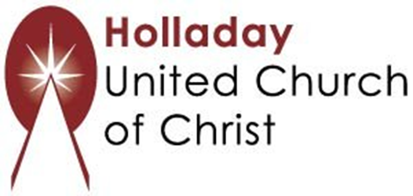
2631 East Murray-Holladay Rd
Holladay, UT 84117 801-277-2631
Rev. Brent Gundlah, Senior Pastor
Rev. Chelsea Page, Associate Pastor
Eric Richards, Director of Music Ministry
We are a Whole Earth,
Open and Affirming Congregation
Of the United Church of Christ.
Participants in Worship:
Reader: Shesh Tipton, Video: Connie Nomann
Music: Scott Blackhurst, Cinda Christensen, Matt Mortensen,
Ryan Poole, Eric Richards
Children’s Chat: Marcus Collonge

