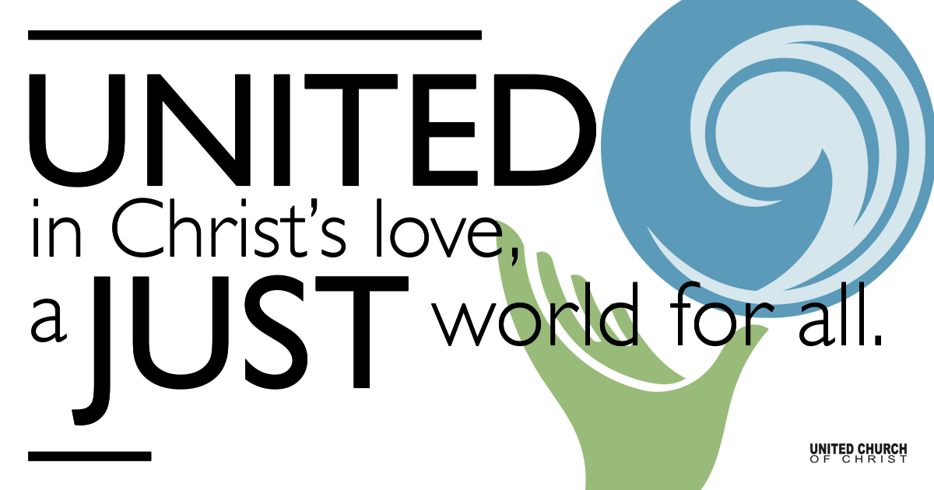

March 21, 2021

Fifth Sunday in Lent
Children’s Discipleship
Silent Meditation
“This Kingdom of God Life is not a matter of waking up each morning with a list of chores or an agenda to be tended to, left on our bedside table by the Holy Spirit for us while we slept. We wake up already immersed in a large story of creation and covenant....” — Eugene H. Peterson

Organ Prelude “Ah, Holy Jesus” NCH 218

Welcome to Worship
One: Whoever you are and wherever you are on life’s journey,
ALL: We welcome you here.

Opening Comments

Ringing of the Bell

Call to Worship Based on Psalm 119
One: How can young people keep their way pure?
All: The way we all do. By seeking to follow the way of Jesus.
One: With our whole hearts, let us seek God, and treasure God’s word in our hearts.
All: Blessed are you, O God; teach me your statutes.
One: With our lips, let us declare all the ordinances of God’s mouth.
All: I delight in the way of Jesus as much as in all riches.
One: Let us meditate on God’s precepts, and fix our eyes on God’s ways.
All: I am ready to worship God!

↑Opening Song “Surely No One Can Be Safer” NCH 487
Composer: Lina Sandell, Swedish Folk Melody

1. Surely no one can be safer than God’s children held in favor.
Not the stars so brightly burning, not the birds to nests returning

2. With the flock God is abiding, heaven’s plenty all providing,
Rich in mercy never sparing, like a father, gently caring.

3. None shall ever meet rejection, be denied God’s own protection;
has there been a friend who better knows our hopes, our fears that fetter.

4. Whether taking, whether giving, God alone remains forgiving,
And with one true purpose holy to preserve our welfare solely.

Scripture Jeremiah 31 - Selected Verses

Children’s Video on Exile - by Disciples Homeland Ministries

Children’s Chat Steve Ritchey

Children’s Song Covenant People Mona Bagasao
Steve Ritchey & Carlynn Canny

Reflection “Following Jesus All the Way Home” Rev. Chelsea Page

↑Closing Song “May the Road Rise to Meet You” Lori True
Refrain: Trad. Irish Blessing

May the road rise with you.
May the wind be at your back.
May the sun shine warm upon your face.
May the rain fall soft upon your fields.
And until we meet again, may God hold you in the hollow of God’s hand.

Live Service

Call to Offering

Prayer of Dedication

Prayers of the Community
(If you would like to offer a prayer of gratitude or concern for someone or some situation please comment when you join the live service. Please use first names for security. The congregation will respond to each prayerful offering with the following words:
“Together with God, we hear your prayers.”)

Pastoral Prayer

Jesus Prayer
Our Creator who is in heaven,
Hallowed be Your name,
Your reign come, Your will be done,
On earth as it is in heaven,
Give us this day our daily bread,
And forgive us our debts as we forgive our debtors,
And lead us not into temptation, but deliver us from evil,
For Yours is the reign, the power, and glory for ever. Amen.

↑Words of Mission and Benediction

Find out More!



holladayucc.org

Or scan from your mobile device:


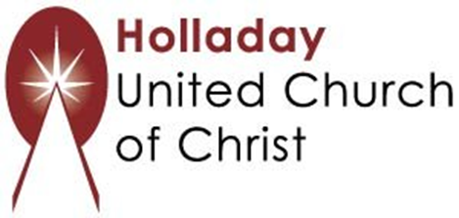
2631 East Murray-Holladay Rd
Holladay, UT 84117 801-277-2631
Rev. Brent Gundlah, Senior Pastor
Rev. Chelsea Page, Associate Pastor
Eric Richards, Director of Music Ministry
We are a Whole Earth,
Open and Affirming Congregation
Of the United Church of Christ.
Participants in Worship:
Reader: Shesh Tipton, Video: Connie Nomann
Music: Holy House Band, Children’s Chat: Steve Ritchey

