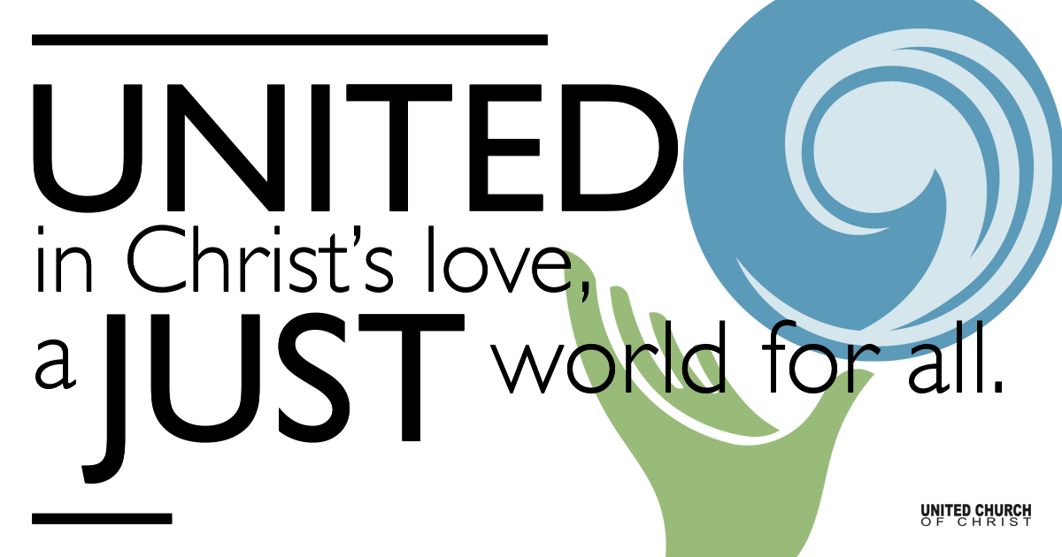

March 28, 2021

Palm Sunday
Being Christ-like
Silent Meditation “Humility is attentive patience.” - Simone Weil

Palm Parade (based on Mark 11:2-11)

Disciple 1: Attention, listen up! Let us listen attentively to Jesus. He has instructions for us on this big day.

Jesus: We are getting close to Jerusalem. Go find me a young horse to ride on for our grand entrance into the city.

Farmer: Hey! What are you doing? Why are you borrowing my little horse?

Disciple 2: Our humble Lord has need of it!

Narrator 1: Then they brought the colt to Jesus and threw their cloaks on it; and he sat on it. He rode to Jerusalem, where a large crowd of people wanted things to change. They gathered in the streets to make a way for peace.

Narrator 2: On the other side of the city, there was another procession. Pontius Pilate, governor of Judea, rode into Jerusalem with an army of horses, armored soldiers and waving banners.

Narrator 1: As Jesus entered the city, many people spread their cloaks on the road, and others spread leafy branches that they had cut in the fields. Then they all shouted:

All: “Hosanna! Blessed is the one who comes in the name of the Lord! Hosanna in the highest!”

Prelude “Hosanna, Loud Hosanna” NCH #213

Welcome to Worship
One: Whoever you are and wherever you are on life’s journey,
ALL: We welcome you here.

Opening Comments

Ringing of the Bell

Call to Worship (Psalm 118:1-2, 19-29)
One: Give thanks to God, who is good, whose mercy endures forever.
All: Open to me the gates of righteousness that I may enter into them and give thanks to God.
One: I thank you, God, that you have answered me and have become my salvation.
All: The stone that the builders rejected has become the chief cornerstone.
One: This is God’s doing; it is marvelous in our eyes.
All: God has given us light.
One: You are my God, and I will give thanks to you.
All: Let us give thanks to God, for God is good; God’s steadfast love endures forever.

↑Opening Song “Bright Morning Stars” Emmy Lou Harris
Bright morning stars are rising
Bright morning stars are rising
Bright morning stars are rising
Day is a'breaking
In my soul

Oh where are our dear fathers?
Oh where are our dear fathers?
They are down in the valley a'praying
Day is a'breaking
In my soul

Oh where are our dear mothers?
Oh where are our dear mothers?
They are gone to heaven a'shouting
Day is a'breaking
In my soul

Scripture Philippians 2:5-11

Reflection “Having the Mind of Christ” Rev. Brent Gundlah

Children’s Time Rev. Chelsea Page

↑Closing Song “Quiet Hills” Laurie Lewis
There is a darkness in these hills- I am not afraid (2x)
there is a darkness in these hills
though some may tremble, I am still
But I say hope lives in these quiet hills

There is a darkness in the land- I seek the taste of hope (2X)
There is a darkness in the land
With more sorrow than we can stand
But I say, hope lives in these quiet hills

There is a darkness in my heart- the taste of hope is sweet (2X)
There is a darkness in my heart,
But I can feel the healing start
And I say, hope lives in these quiet hills
And I say, hope lives in these quiet hills

Live Service

Call to Offering

Prayer of Dedication

Prayers of the Community
(If you would like to offer a prayer of gratitude or concern for someone or some situation please comment when you join the live service. Please use first names for security. The congregation will respond to each prayerful offering with the following words:
“Together with God, we hear your prayers.”)

Pastoral Prayer

Jesus Prayer
Our Creator who is in heaven,
Hallowed be Your name,
Your reign come, Your will be done,
On earth as it is in heaven,
Give us this day our daily bread,
And forgive us our debts as we forgive our debtors,
And lead us not into temptation, but deliver us from evil,
For Yours is the reign, the power, and glory for ever. Amen.

↑Words of Mission and Benediction

Find out More!



holladayucc.org

Or scan from your mobile device:


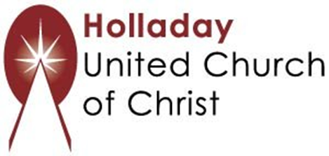
2631 East Murray-Holladay Rd
Holladay, UT 84117 801-277-2631
Rev. Brent Gundlah, Senior Pastor
Rev. Chelsea Page, Associate Pastor
Eric Richards, Director of Music Ministry
We are a Whole Earth,
Open and Affirming Congregation
Of the United Church of Christ.
Participants in Worship:
Reader: Children and Shesh Tipton, Video: Connie Nomann
Music: Jani Gamble, Allison Ottley, Mona Stevens
Children’s Chat: Rev. Chelsea Page

