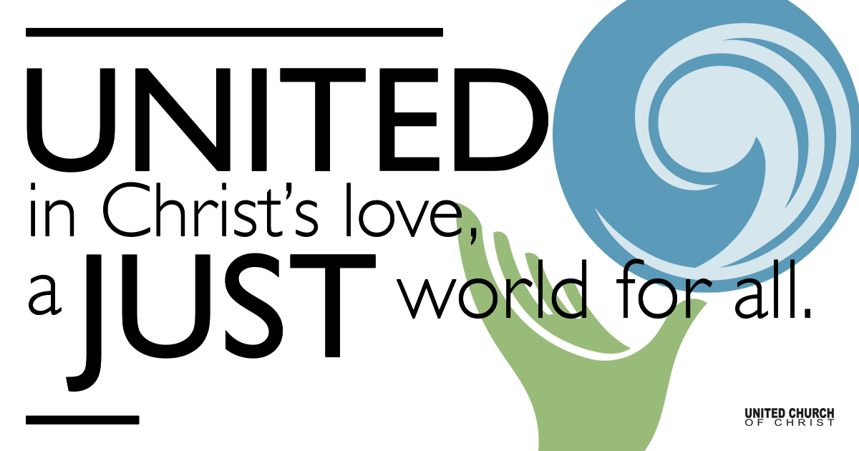

April 04, 2021

Easter Sunday

Silent Meditation
“God loves each of us as if there were only one of us” - Saint Augustine

Organ Prelude Christ The Lord is Risen Today NCH 233

Welcome to Worship
One: Whoever you are and wherever you are on life’s journey,
ALL: We welcome you here.

Ringing of the Bell and Call to Worship
One: This is the day that the Lord has made-let us rejoice and be glad in it.
All: Alleluia! Christ is risen! Christ is risen, indeed!

↑Opening Song Easter Alleluia Piano Variation on Marty Haugen

Holy Communion

Jesus Prayer
Our Creator who is in heaven,
Hallowed be Your name,
Your reign come, Your will be done,
On earth as it is in heaven,
Give us this day our daily bread,
And forgive us our debts as we forgive our debtors,
And lead us not into temptation, but deliver us from evil,
For Yours is the reign, the power, and glory for ever. Amen.

Communion Song Hope Will Rise Again Andra Moran

Scripture John 20:1-18
Early on the first day of the week, while it was still dark, Mary Magdalene came to the tomb and saw that the stone had been removed from the tomb. So she ran and went to Simon Peter and the other disciple, the one whom Jesus loved, and said to them, “They have taken the Lord out of the tomb, and we do not know where they have laid him.”

Then Peter and the other disciple set out and went toward the tomb. The two were running together, but the other disciple outran Peter and reached the tomb first. He bent down to look in and saw the linen wrappings lying there, but he did not go in.

Then Simon Peter came, following him, and went into the tomb. He saw the linen wrappings lying there, and the cloth that had been on Jesus’ head, not lying with the linen wrappings but rolled up in a place by itself.
Then the other disciple, who reached the tomb first, also went in, and he saw and believed; for as yet they did not understand the scripture, that he must rise from the dead. Then the disciples returned to their homes.

But Mary stood weeping outside the tomb.
As she wept, she bent over to look into the tomb; and she saw two angels in white, sitting where the body of Jesus had been lying, one at the head and the other at the feet. They said to her, “Woman, why are you weeping?” She said to them, “They have taken away my Lord, and I do not know where they have laid him.”

When she had said this, she turned around and saw Jesus standing there, but she did not know that it was Jesus. Jesus said to her, “Woman, why are you weeping? Whom are you looking for?”

Supposing him to be the gardener, she said to him, “Sir, if you have carried him away, tell me where you have laid him, and I will take him away.” Jesus said to her, “Mary!”
She turned and said to him in Hebrew, “Rabbouni!” (which means Teacher). Jesus said to her, “Do not hold on to me, because I have not yet ascended to the Father. But go to my brothers and say to them, ‘I am ascending to my Father and your Father, to my God and your God.’”

Mary Magdalene went and announced to the disciples, “I have seen the Lord”; and she told them that he had said these things to her.

Reflection “Just the Beginning” Rev. Brent Gundlah

↑Song of Response Beautiful Savior (Crusador’s Hymn)
Conducted by: René Clausen, arr. F. Melius Christiansen

Children’s Time Rev. Chelsea Page

↑Words of Mission and Benediction Rev. Brent Gundlah

Sending Song Hallelujah Chorus Handel
Hallelujah! For the Lord God omnipotent reigneth. The kingdom of this world is become the kingdom of our Lord, and of his Christ: And He shall reign for ever and ever. King of Kings, and Lord of Lords, Hallelujah!

Find out More!



holladayucc.org

Or scan from your mobile device:



2631 East Murray-Holladay Rd
Holladay, UT 84117 801-277-2631
Rev. Brent Gundlah, Senior Pastor
Rev. Chelsea Page, Associate Pastor
Eric Richards, Director of Music Ministry
We are a Whole Earth,
Open and Affirming Congregation
Of the United Church of Christ.
Participants in Worship:
Video: Connie Nomann
Reader: Rev. Chelsea Page and Rev. Brent Gundlah,
Music: Bill Green, Matt Mortenson, The Evergreen Choral,
Concordia Alumni Virtual Choir, Tony Freeman
(Used by permission ReAwaken Productions)
Children’s Chat: Rev. Chelsea Page

