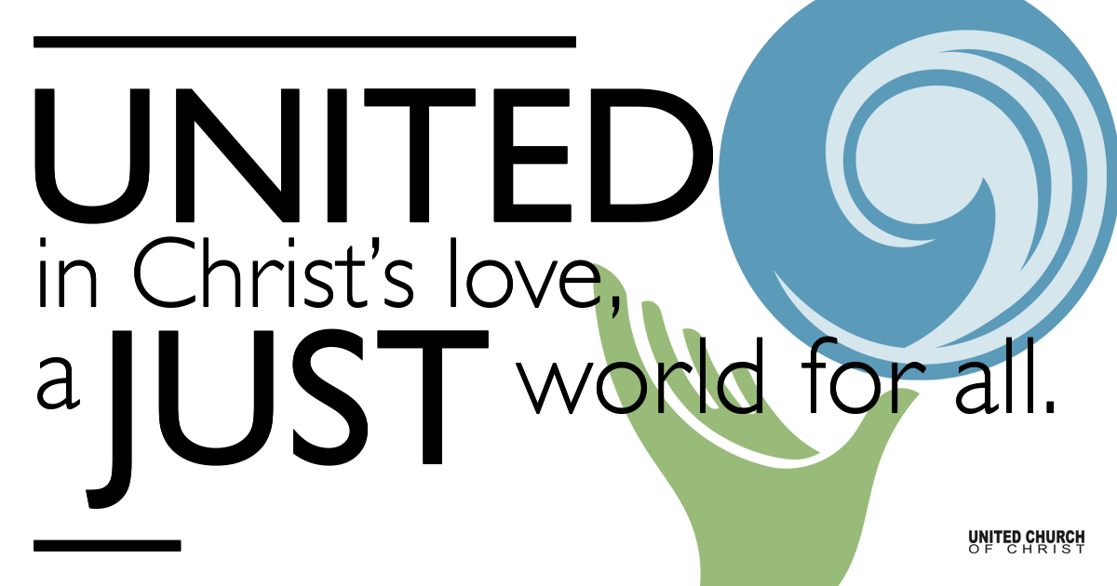

April 18, 2021

Third Sunday of Easter
Earth Day
Silent Meditation
”Eventually, all things merge into one, and a river runs through it.”
— Norman MacLean

Prelude For the Beauty of the Earth NCH 28

Welcome to Worship
One: Whoever you are and wherever you are on life’s journey,
ALL: We welcome you here.

Opening Comments

Ringing of the Bell

Call to Worship
One: It’s almost tomato season!!
ALL: HALLELUJAH!
One: With all our joy of Spring and earth, there are situations of justice we must remember. There are many who are suffering from environmental injustice.
ALL: Lord, hear our prayers for them.
One: There are those who do not have access to clean water
ALL: Lord, hear our prayers.
One: Let us remember that environmental racism endangers and harms BIPOC people.
ALL: Lord, hear our prayers for them also.
One: For our oceans that are overwhelmed by plastic pollution and, an angst we feel deeply, for our young people and future generations facing the fear of climate catastrophe.

ALL: God be their guide.
With gratitude for our earth, for green things, for water and streams, for our determined youth and for tomato season, We give you great thanks. Amen.

↑Opening Song “Blue Boat Home” Peter Mayer
Though below me I feel no motion
Standing on these mountains and plains
Far away from the rolling ocean
Still my dry land heart can say
I’ve been sailing all my life now
Never harbor nor port have I known
The wide universe is the ocean I travel,
And the Earth is my blue boat home

Sun, my sail and moon, my rudder
As I ply the starry sea
Leaning over the edge in wonder
Casting questions into the deep
Drifting here with my ship’s companions
All we kindred pilgrim souls
Making our way by the lights of the heavens
In our beautiful blue boat home

I give thanks for the waves upholding me
Hail the great winds urging me on
Greet the infinite sea before me
Sing the sky my sailor’s song
I was born upon the fathoms
Never harbor or port have I known
The wide universe is the ocean I travel
And the Earth is my blue boat home

Scripture Revelation 21:1-6

Reflection “Our Love Is Like Water” Rev. Brent Gundlah

Children’s Time HUCC Youth

↑Words of Mission and Benediction

↑Closing Song “Thank You” Kimball Hurd

Live Service on Zoom

Call to Offering

Prayer of Dedication

Prayers of the Community
(If you would like to offer a prayer of gratitude or concern for someone or some situation please comment when you join the live service. Please use first names for security. The congregation will respond to each prayerful offering with the following words:
“Together with God, we hear your prayers.”)

Pastoral Prayer

Jesus Prayer
Our Creator who is in heaven,
Hallowed be Your name,
Your reign come, Your will be done,
On earth as it is in heaven,
Give us this day our daily bread,
And forgive us our debts as we forgive our debtors,
And lead us not into temptation, but deliver us from evil,
For Yours is the reign, the power, and glory for ever. Amen.

Coffee Hour/Fellowship Time

Find out More!



holladayucc.org

Or scan from your mobile device:


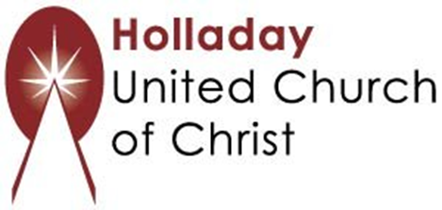
2631 East Murray-Holladay Rd
Holladay, UT 84117 801-277-2631
Rev. Brent Gundlah, Senior Pastor
Rev. Chelsea Page, Associate Pastor
Eric Richards, Director of Music Ministry
We are a Whole Earth,
Open and Affirming Congregation
Of the United Church of Christ.
Participants in Worship:
Reader: Rev. Shesh Tipton, Video: Connie Nomann
Music: Holy House Band, Children’s Chat: HUCC Youth

