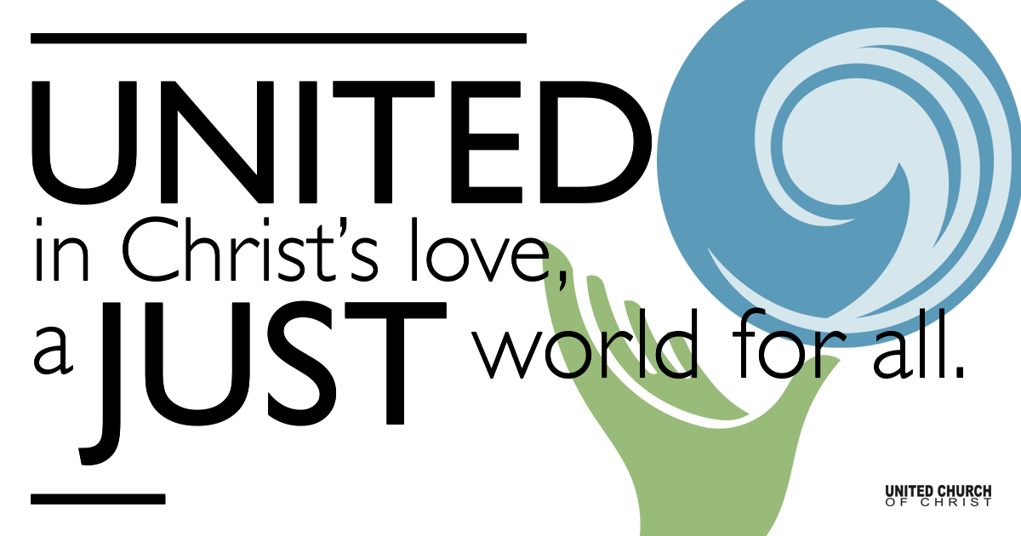

April 25, 2021

Fourth Sunday of Easter
Preschool Sunday
Silent Meditation Psalm 23 Verses 1-2
The LORD is my shepherd, I shall not want. God makes me lie down in green pastures; God leads me beside still waters; God restores my soul.

Organ Prelude NCH 593

Lift every voice and sing
Till earth and heaven ring
Ring with the harmonies of Liberty
Let our rejoicing rise
High as the listening skies
Let it resound loud as the rolling sea
Sing a song full of the faith that the harsh past has taught us
Sing a song full of the hope that the present has brought us
Facing the rising sun of our new day begun
Let us march on till victory is won

Stony the road we trod
Bitter the chastening rod
Felt in the days when hope unborn had died
Yet with a steady beat
Have not our weary feet
Come to the place for which our people sighed?
We have come over a way that with tears has been watered
We have come, treading our path through the blood of the slaughtered
Out from the gloomy past
Till now we stand at last
Where the white gleam of our bright star is cast

God of our weary years
God of our silent tears
God who has brought us thus far on the way
God, who has by your might led us into the light
Keep us forever in the path, we pray
Lest our feet stray from the places, our God, where we met Thee
Lest, our hearts drunk with the wine of the world, we forget Thee
Shadowed beneath your hand
May we forever stand
True to our God
True to our native land.

Welcome to Worship
One: Whoever you are and wherever you are on life’s journey,
ALL: We welcome you here.

Opening Comments

Ringing of the Bell

Call to Worship

One: The God of all shepherds has called us here.
All: We come today, celebrating God’s love for us.
One: The Good Shepherd walks before us to show us how to live.
All: We come today, thanking Jesus for teaching and guiding us.
One: The Shepherding Spirit moves through us, bringing us new hope.
All: We come today ready to celebrate and to praise God. AMEN.
(By Rev. Nancy Townley, United Methodist Church)

Opening Music What A Friend We Have in Jesus

Introduction by Rev. Brent Gundlah and Scripture Reading
John 10:11-15

"I am the good shepherd. The good shepherd lays down his life for the sheep.
The hired hand, who is not the shepherd and does not own the sheep, sees the wolf coming and leaves the sheep and runs away--and the wolf snatches them and scatters them.
The hired hand runs away because a hired hand does not care for the sheep.
I am the good shepherd. I know my own and my own know me, just as the Creator knows me and I know the Creator. And I lay down my life for the sheep.

Children’s Time Michelle Weeks

Reflection “Shepherding Holladay Preschool Through a Pandemic Year”
Kristi Thompson

Words of Mission and Benediction

↑Closing Song A Good Job Alicia Keys
One Voice Children’s Choir

Live Prayer Service

Our Creator who is in heaven,
Hallowed be Your name,
Your reign come, Your will be done,
On earth as it is in heaven,
Give us this day our daily bread,
And forgive us our debts as we forgive our debtors,
And lead us not into temptation, but deliver us from evil,
For Yours is the reign, the power, and glory for ever. Amen.

Find out More!



holladayucc.org

Or scan from your mobile device:


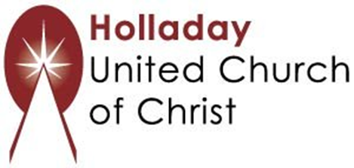
2631 East Murray-Holladay Rd
Holladay, UT 84117 801-277-2631
Rev. Brent Gundlah, Senior Pastor
Rev. Chelsea Page, Associate Pastor
Eric Richards, Director of Music Ministry
We are a Whole Earth,
Open and Affirming Congregation
Of the United Church of Christ.
Participants in Worship:
Readers: Kristi Thompson & Revs. Brent Gundlah and Chelsea Page
Music: Matt Mortensen, Nathan Drake (Reawaken Hymns),
Holladay Preschool, One Voice Children’s Choir
Children’s Chat: Michelle Weeks
Video: Connie Nomann

