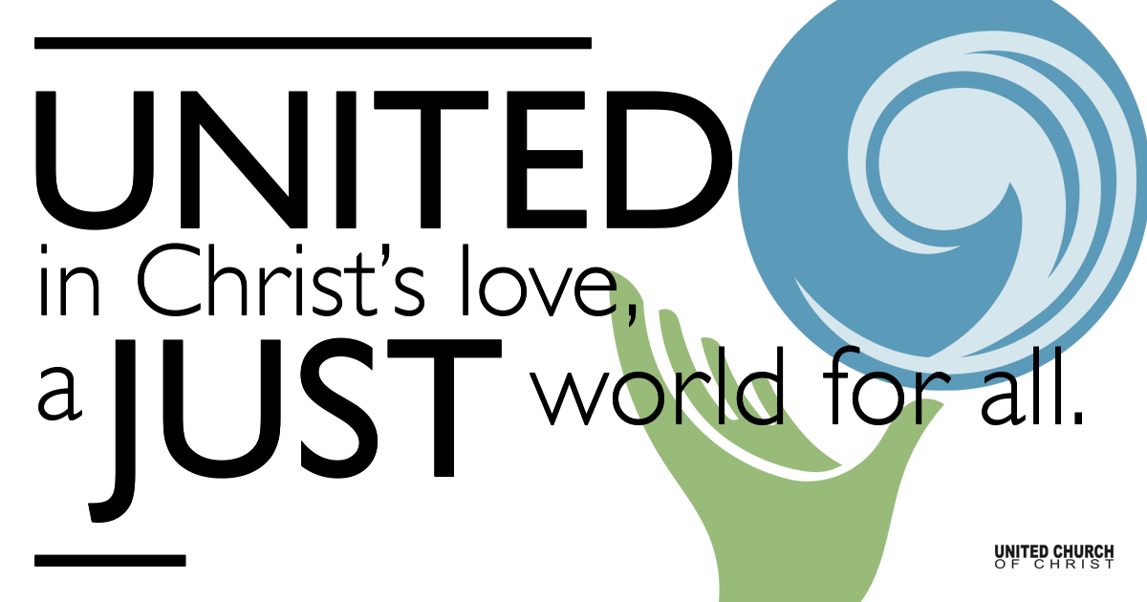

May 2, 2021

Fifth Sunday of Easter
God’s Unconditional Love
Silent Meditation
“If you’ve ever had that feeling of loneliness, of being an outsider, it never quite leaves you. You can be happy or successful or whatever, but that thing still stays within you.” ~ Tim Burton

Prelude “Come Forth, O Love Divine” NCH#289

Welcome to Worship
One: Whoever you are and wherever you are on life’s journey,
ALL: We welcome you here.

Opening Comments

Ringing of the Bell

Call to Worship
One: We have already done our regular morning reading that symbolizes one of the main tenets of HUCC but let’s repeat it, please.
ALL: Whoever you are and wherever you are on life’s journey, we welcome you here.
One: In our scripture lesson today the Spirit speaks to Phillip and directs him toward his own welcoming moment.
ALL: There is the eunuch, traveling on his own life’s journey in a chariot and questioning scripture.
One: The eunuch’s life journey was quite unique. He was chosen for a particular role in life that made him different from others.
ALL: But Phillip welcomed him into the community of Christ. Further down the road he baptized the eunuch.

One: This is an example for Holladay United Church of Christ, how to treat the stranger, the one who is different.
ALL: Whoever you are, if you are a stranger, if you are different from others in our church or our city, if your color or your sexual orientation is distinctive, God unconditionally welcomes you here. And the community of Holladay UCC, in following the example of our God, welcomes you as well. Amen.

↑Opening Song “On the Turning Away” Pink Floyd

On the turning away
From the pale and downtrodden
And the words they say
Which we won't understand
Don't accept that what's happening
Is just a case of others' suffering
Or you'll find that you're joining in
The turning away

It's a sin that somehow
Light is changing to shadow
And casting its shroud over all we have known
Unaware how the ranks have grown
Driven on by a heart of stone
We could find that we're all alone
In the dream of the proud

On the wings of the night
As the daytime is stirring
Where the speechless unite in a silent accord
Using words you will find are strange
Mesmerised as they light the flame
Feel the new wind of change
On the wings of the night

No more turning away
From the weak and the weary
No more turning away from the coldness inside
Just a world that we all must share
It's not enough just to stand and stare
Is it only a dream that there'll be
No more turning away?

Scripture Acts 8:26-40

Reflection “What’s Missing?” Rev. Brent Gundlah

Children’s Time Rev. Chelsea Page

Holy Communion Rev. Brent Gundlah

↑Words of Mission and Benediction

↑Closing Song “Come to the Feast” Christopher Grundy
They've got bars on the stained glass to keep all the blessings inside
Locks and chains on the door to guard those gold crosses they hide
But there's a man in the doorway who lives on the street
He touches the chains and they fall at his feet, and he says,
Come to the feast
There's always room for one more, and there's all you can eat
You can take some to go, gather all you can hold and then go
Go spread the feast.
She thought she was so big, she'd go without eating for days
All her bones got so frail, and her heart was just wasting away
But now she stands strong and whole at the table of grace
Tears fill the cup as the fall from her face, and she says
Come to the feast
There's always room for one more, and there's all you can eat
You can take some to go, gather all you can hold and then go
Go spread the feast.
The candles are burning, the table is spread,
A voice rings out clear like one back from the dead
Out across the battlefields, up from the slums,
Over borders and color lines the same message comes, and it says
Come to the feast
There's always room for one more, and there's all you can eat
You can take some to go, gather all you can hold and then go
Go spread the feast.
There's always room for one more, and there's all you can eat
You can take some to go, gather all you can hold and then go
Go spread the feast.

Live Service on Zoom

Call to Offering

Prayer of Dedication

Prayers of the Community
(If you would like to offer a prayer of gratitude or concern for someone or some situation please comment when you join the live service. Please use first names for security. The congregation will respond to each prayerful offering with the following words:
“Together with God, we hear your prayers.”)

Pastoral Prayer

Jesus Prayer
Our Creator who is in heaven,
Hallowed be Your name,
Your reign come, Your will be done,
On earth as it is in heaven,
Give us this day our daily bread,
And forgive us our debts as we forgive our debtors,
And lead us not into temptation, but deliver us from evil,
For Yours is the reign, the power, and glory for ever. Amen.

FELLOWSHIP COFFEE HOUR

Find out More!



holladayucc.org

Or scan from your mobile device:


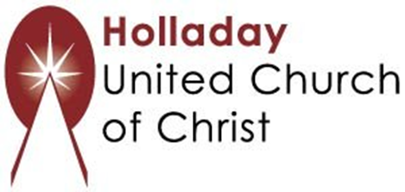
2631 East Murray-Holladay Rd
Holladay, UT 84117 801-277-2631
Rev. Brent Gundlah, Senior Pastor
Rev. Chelsea Page, Associate Pastor
Eric Richards, Director of Music Ministry
We are a Whole Earth,
Open and Affirming Congregation
Of the United Church of Christ.
Participants in Worship:
Reader: Shesh Tipton, Video: Connie Nomann
Music: Twist of Faith & Matt Mortensen
Children’s Chat: Rev. Chelsea Page

