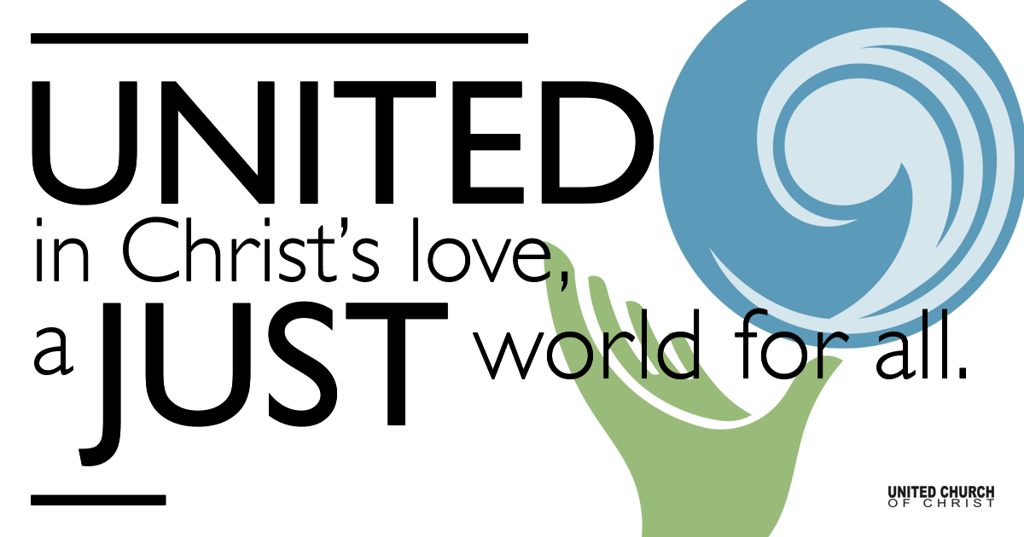

May 9, 2021

Sixth Sunday of Easter
Mother’s Day
Silent Meditation
“Sometimes the strength of motherhood is greater than natural laws.”
~Barbara Kingsolver

Prelude “Come, Let Us Join with Faithful Souls” NCH#383

Welcome to Worship

One: Whoever you are and wherever you are on life’s journey,
ALL: We welcome you here.

Opening Comments

Ringing of the Bell

Call to Worship (from re:worship)
One: We’ve come to worship God,
All: Who loved us before we were yet born,
One: Who knows us even better than we know ourselves,
All: Whose presence never leaves us,
One: And whose love for us never ceases.
All: This is our God.
Let’s worship together!

↑Opening Song Golden Harmony Kate Wolf
Holy House Four

Scripture John 15:9-17

Reflection “Love Abides” Rev. Brent Gundlah

Children’s Time Rev. Chelsea Page

↑Words of Mission and Benediction

↑Closing Song "How We Love" Beth Neilson Chapman
Shesh & Jim with Tom Klassen
Life has taught me this
Every day is new
And if anything is true
All that matters
When we're through
Is how we love
Faced with what we lack
Some things fall apart
But from the ashes new dreams start
All that matters to the heart is how we love
How we love, How we love
From the smallest act of kindness
In a word, a smile, a touch
In spite of our mistakes
Chances come again
If we lose or if we win
All that matters in the end is how we love
How we love, How we love
I will not forget your kindness
When I needed it so much
Sometimes we forget
Trying to be so strong
In this world of right and wrong
All that matters when we're gone
All that mattered all along
All we have that carries on
Is how we love

Live Service on Zoom

Call to Offering

Prayer of Dedication

Prayers of the Community
(If you would like to offer a prayer of gratitude or concern for someone or some situation please comment when you join the live service. Please use first names for security. The congregation will respond to each prayerful offering with the following words:
“Together with God, we hear your prayers.”)

Pastoral Prayer

Jesus Prayer
Our Creator who is in heaven,
Hallowed be Your name,
Your reign come, Your will be done,
On earth as it is in heaven,
Give us this day our daily bread,
And forgive us our debts as we forgive our debtors,
And lead us not into temptation, but deliver us from evil,
For Yours is the reign, the power, and glory for ever. Amen.

FELLOWSHIP COFFEE HOUR

Find out More!



holladayucc.org

Or scan from your mobile device:


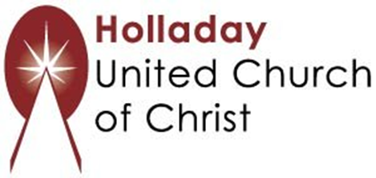
2631 East Murray-Holladay Rd
Holladay, UT 84117 801-277-2631
Rev. Brent Gundlah, Senior Pastor
Rev. Chelsea Page, Associate Pastor
Eric Richards, Director of Music Ministry
We are a Whole Earth,
Open and Affirming Congregation
Of the United Church of Christ.
Participants in Worship:
Reader: Shesh Tipton, Video: Connie Nomann
Music: Matt Mortensen, Shesh Tipton, Jim Wetzel, Marilyn & Chuck Dillard
Children’s Chat: Rev. Chelsea Page

