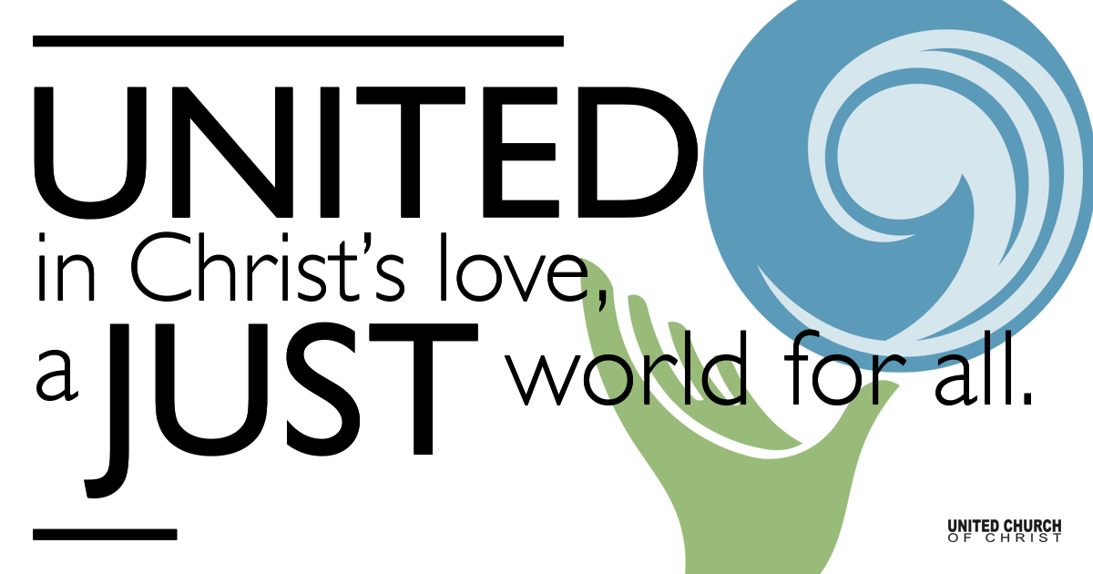

May 23, 2021

Pentecost

Silent Meditation
“When we are at our wits’ end for an answer, then the Holy Spirit can give us an answer.” - Karl Barth

Prelude Come O Spirit, With Your Sound NCH#265

Come, O Spirit, with your sound
Like a wind, quick rushing;
Come from heaven and stir our hearts,
Each disciple touching!
Mold our actions to your will,
You our service giving;
Move in our community,
Transform now our living!

Come, O Spirit, with your flame,
Leaping tongues of fire;
Come, and with your glorious light
All our thoughts inspire!
Rest upon each servant’s head
Till each one is speaking
Of our Christ, the Holy One
All the earth is seeking.

Come, O Spirit, fill your church,
Making strong our mission;
Fill your daughters and your sons
With a mighty vision,
Till the great and glorious day
When the whole creation
Sings your praise as Sovereign One,
Giver of salvation!

Welcome to Worship
One: Whoever you are and wherever you are on life’s journey,
ALL: We welcome you here.

Opening Comments

Ringing of the Bell

Call to Worship (based on Psalm 104)
One: May the glory of the Lord endure forever.
All: I will sing to the Lord as long as I live. I will sing praise to my God while I have being.
One: May my meditation be pleasing to the Lord, for in the Lord I rejoice.
All: Bless the Lord, O my soul. Praise the Lord!

↑Opening Song Burn Ellie Goulding

Scripture Acts 2:1-21

Reflection “Is There Really a Greeting Card for Every Occasion?”
Rev. Brent Gundlah

Children’s Time Trent Parkhill

↑Words of Mission and Benediction

↑Closing Song I See Fire Ed Sheeran

Live Service on Zoom

Call to Offering

Prayer of Dedication

Prayers of the Community
(If you would like to offer a prayer of gratitude or concern for someone or some situation please comment when you join the live service. Please use first names for security. The congregation will respond to each prayerful offering with the following words:
“Together with God, we hear your prayers.”)

Pastoral Prayer

Jesus Prayer
Our Creator who is in heaven,
Hallowed be Your name,
Your reign come, Your will be done,
On earth as it is in heaven,
Give us this day our daily bread,
And forgive us our debts as we forgive our debtors,
And lead us not into temptation, but deliver us from evil,
For Yours is the reign, the power, and glory for ever. Amen.

SPRING CONGREGATIONAL MEETING STARTS AT 11:00 AM

Find out More!



holladayucc.org

Or scan from your mobile device:


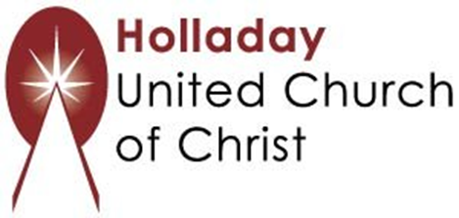
2631 East Murray-Holladay Rd
Holladay, UT 84117 801-277-2631
Rev. Brent Gundlah, Senior Pastor
Rev. Chelsea Page, Associate Pastor
Eric Richards, Director of Music Ministry
We are a Whole Earth,
Open and Affirming Congregation
Of the United Church of Christ.
Participants in Worship:
Reader: Shesh Tipton, Video: Connie Nomann
Music: Jonathan Green, Shelley McCall, Matt Mortensen
Children’s Chat: Trent Parkhill

