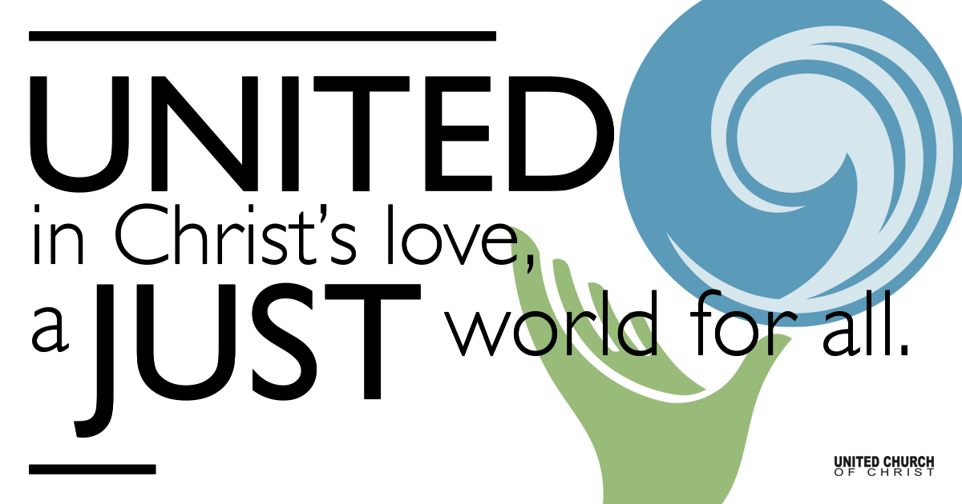

May 30, 2021

Trinity Sunday

Silent Meditation
“One love, one heart. Let’s get together and feel all right.” - Bob Marley

Prelude Holy, Holy, Holy NCH#277

Holy, holy, holy,
God the Almighty!
Early in the morning
We praise your majesty.
Holy, holy, holy!
Merciful and mighty
God in three persons
Blessed Trinity!

Holy, holy, holy!
Saints adore you truly.
Casting down their golden crowns
Around the glassy sea;
Cherubim and seraphim
Bow before you only,
From the beginning,
God eternally.

Holy, holy, holy!
God the Almighty
All your works shall praise your name
In earth and sky and sea
Holy, holy, holy!
Merciful and mighty
God in three persons
Blessed Trinity!

Welcome to Worship
One: Whoever you are and wherever you are on life’s journey,
ALL: We welcome you here.

Opening Comments

Ringing of the Bell

Call to Worship (adapted from the Presbyterian Church in Canada)
One: Holy are you, Source and Creator of all things;
All: We praise you for your gift of life.
One: Holy are you, Son and Redeemer of all things;
All: We thank you for your gift of new life.
One: Holy are you, Spirit and Sustainer of all things;
All: We come to bear witness to your truth
and worship your holy name, Ever Three and Ever One.

↑Opening Song Here I Am, Lord Daniel L. Schutte

Scripture Isaiah 6:1-8 and John 3:1-17

Reflection “How Can These Things Be?” Rev. Brent Gundlah

Children’s Time Pam Erickson

↑Words of Mission and Benediction

↑Closing Song Come, Thou Fount of Every Blessing
John Wyeth, arranged by Richard Walters

Live Service on Zoom

Call to Offering

Prayer of Dedication

Prayers of the Community
(If you would like to offer a prayer of gratitude or concern for someone or some situation please comment when you join the live service. Please use first names for security. The congregation will respond to each prayerful offering with the following words:
“Together with God, we hear your prayers.”)

Pastoral Prayer

Jesus Prayer
Our Creator who is in heaven,
Hallowed be Your name,
Your reign come, Your will be done,
On earth as it is in heaven,
Give us this day our daily bread,
And forgive us our debts as we forgive our debtors,
And lead us not into temptation, but deliver us from evil,
For Yours is the reign, the power, and glory for ever. Amen.

FELLOWSHIP COFFEE HOUR

Find out More!



holladayucc.org

Or scan from your mobile device:


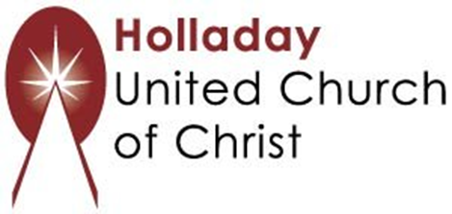
2631 East Murray-Holladay Rd
Holladay, UT 84117 801-277-2631
Rev. Brent Gundlah, Senior Pastor
Rev. Chelsea Page, Associate Pastor
Eric Richards, Director of Music Ministry
We are a Whole Earth,
Open and Affirming Congregation
Of the United Church of Christ.
Participants in Worship:
Reader: Brent Gundlah, Video: Connie Nomann
Music: Matt Mortensen, Tom and Carolyn Klassen
Children’s Chat: Pam Erickson

