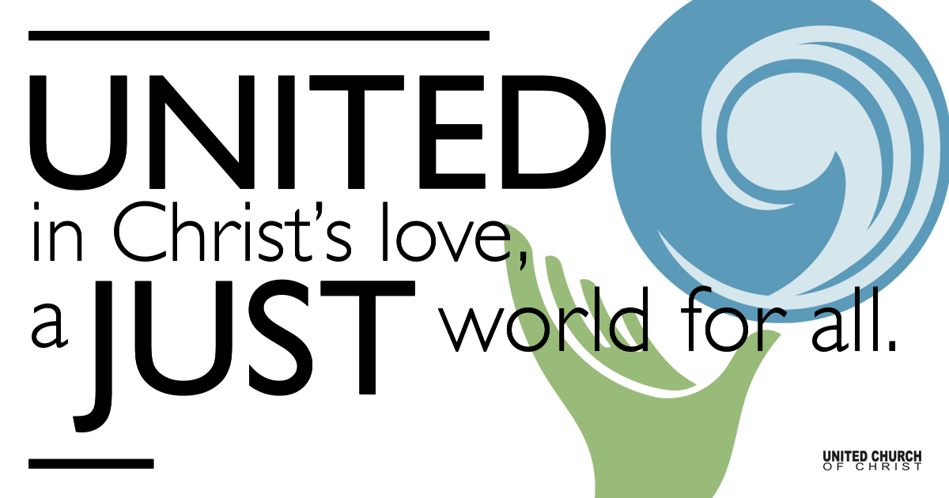

June 6, 2021

Second Sunday after Pentecost
Pride
Silent Meditation
“Now fill the world with music, love and pride.” - Lin-Manuel Miranda

Organ Prelude Blessed Assurance

Welcome to Worship
One: Whoever you are and wherever you are on life’s journey,
ALL: We welcome you here.

Opening Comments

Ringing of the Bell

Call to Worship (from The Religious Institute)
One: We are grateful for the gift of our lives and the gift of others in our lives.
All: Each of us is created with dignity and worth.
One: We are called to love each other and to do nothing to others that we would find hateful to ourselves.
All: We honor the many ways that people live and love.
One: We repent for the times when our faith traditions have named lesbian, gay, bisexual and transgender people unworthy.
All: Love does not exclude. We are all worthy.
One: We suffer when LGBT persons are oppressed, excluded and shamed by religious people who overlook the fundamental call to justice in our scriptures.
All: True justice flourishes when we can live with authenticity and integrity.
One: May we work to build a community where LGBT people are celebrated as full and equal members, recognizing their many gifts.
All: We celebrate sexual and gender diversity as a blessing that enriches us all.

↑Opening Song “The Eye” Brandi Carlile

Scripture Psalm 130 (Common English Bible)

I cry out to you from the depths, Lord —
my Lord, listen to my voice!
Let your ears pay close attention to my request for mercy!
If you kept track of sins, Lord —
my Lord, who would stand a chance?
But forgiveness is with you—
that’s why you are honored.

I hope, Lord.
My whole being hopes,
and I wait for God’s promise.
My whole being waits for my Lord—
more than the night watch waits for morning;
yes, more than the night watch waits for morning!

Israel, wait for the Lord!
Because faithful love is with the Lord;
because great redemption is with our God!
The Lord is the one who will redeem Israel
from all its sin.

Reflection “Out of the Depths” Rev. Brent Gundlah

COMMUNION

Children’s Time Pegasus Collonge

↑Words of Mission and Benediction

↑Closing Song “Closer to the Heart” RUSH

Live Service on Zoom

Call to Offering

Prayer of Dedication

Prayers of the Community
(If you would like to offer a prayer of gratitude or concern for someone or some situation please comment when you join the live service. Please use first names for security. The congregation will respond to each prayerful offering with the following words:
“Together with God, we hear your prayers.”)

Pastoral Prayer

Jesus Prayer
Our Creator who is in heaven,
Hallowed be Your name,
Your reign come, Your will be done,
On earth as it is in heaven,
Give us this day our daily bread,
And forgive us our debts as we forgive our debtors,
And lead us not into temptation, but deliver us from evil,
For Yours is the reign, the power, and glory for ever. Amen.

FELLOWSHIP COFFEE HOUR

Find out More!



holladayucc.org

Or scan from your mobile device:


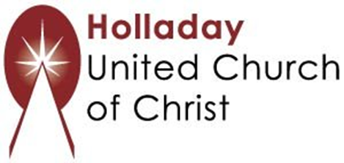
2631 East Murray-Holladay Rd
Holladay, UT 84117 801-277-2631
Rev. Brent Gundlah, Senior Pastor
Rev. Chelsea Page, Associate Pastor
Eric Richards, Director of Music Ministry
We are a Whole Earth,
Open and Affirming Congregation
Of the United Church of Christ.
Participants in Worship:
Reader: Shesh Tipton, Video: Connie Nomann
Music: Twist of Faith, Matt Mortensen, Children’s Chat: Pegasus Collonge

