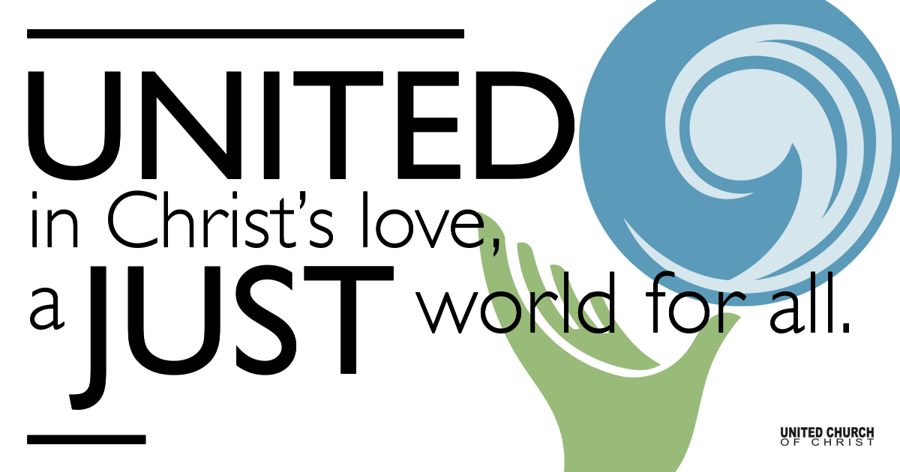

June 20, 2021
Fourth Sunday after Pentecost
Father’s Day
God of Mystery
Silent Meditation
“Dad taught me everything I know. Unfortunately, he didn’t teach me everything he knows.” Al Unser

Prelude “Let Every Christian Pray”

Welcome to Worship
One: Whoever you are and wherever you are on life’s journey,
ALL: We welcome you here.

Opening Comments

Ringing of the Bell

Call to Worship (adapted from Psalm 107:1-3, 23-32 - The Message)
One: God is so good! God’s love never runs out. All of you set free by God, tell the world!
All: God freed us from oppression, then rounded us up from all over the place, from the four winds, from the seven seas.
One: Out at sea you saw God in action. With a word God called up the wind— an ocean storm, towering waves!
All: We called out to God in our desperate condition; and God got us out in the nick of time. God quieted the wind down to a whisper, and muzzled the big waves. We were so glad when the storm died down, and God led us safely back to harbor.
One: So give thanks for God’s marvelous love, for God’s miraculous mercy.
All: Let us lift high our praises when we assemble, and shout Hallelujah!

↑Opening Song Lord of the Dance Sydney Carter

Verse 1: I danced in the morning when the world was begun.
And I danced in the moon and the stars and the sun.
And I came down from heaven and I danced on earth.
At Bethlehem I had my birth.

Chorus:
Dance then , wherever you may be. I am the Lord of the Dance, said he.
And I’ll lead you all, wherever you may be, and I’ll lead you all in the Dance said he.

Verse 2: I danced for the scribe and the Pharisee, but they would not dance and they wouldn’t follow me.
I danced for the fishermen, for James and John they came with me and the Dance went on. (Chorus)

Verse 3: I danced on the Sabbath and I cured the lame; the holy people said it was a shame. They whipped and they stripped and they hang me on high. And they left me there on a Cross to die (Chorus)

Verse 4: I danced on a Friday when the sky turned black. It’s hard to dance with the world on your back. They buried my body and they thought I’d gone
But I am the Dance and I still go on. (Chorus)

Verse 5: They cut me down and I leapt up high. I am the life that’ll never, never die. I’ll live in you if you’ll live in me- I am Lord of the Dance, said he. (Chorus)

Scripture Job 38:1-11 (Common English Bible)

Reflection “A Mystery Trip” Rev. Brent Gundlah

Children’s Time Rev. Brent Gundlah

↑Words of Mission and Benediction

↑Closing Song “We Bow Down” Twila Paris
You are Lord of creation and Lord of my life. Lord of the land and the sea.
You were Lord of the heavens before there was time, and Lord of all lords you will be.
We bow down and we worship you, Lord; we bow down and we worship you Lord; we bow down and we worship you, Lord; Lord of all lords you will be. (Repeat)

Live Service on Zoom

Call to Offering

Prayer of Dedication

Prayers of the Community
(If you would like to offer a prayer of gratitude or concern for someone or some situation please comment when you join the live service. Please use first names for security. The congregation will respond to each prayerful offering with the following words:
“Together with God, we hear your prayers.”)

Pastoral Prayer

Jesus Prayer
Our Creator who is in heaven,
Hallowed be Your name,
Your reign come, Your will be done,
On earth as it is in heaven,
Give us this day our daily bread,
And forgive us our debts as we forgive our debtors,
And lead us not into temptation, but deliver us from evil,
For Yours is the reign, the power, and glory for ever. Amen.

Find out More!



holladayucc.org

Or scan from your mobile device:


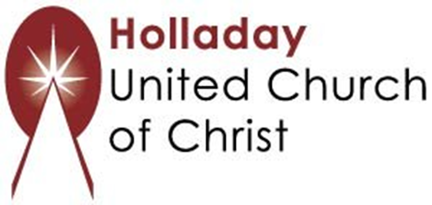
2631 East Murray-Holladay Rd
Holladay, UT 84117 801-277-2631
Rev. Brent Gundlah, Senior Pastor
Rev. Chelsea Page, Associate Pastor
Eric Richards, Director of Music Ministry
We are a Whole Earth,
Open and Affirming Congregation
Of the United Church of Christ.
Participants in Worship:
Reader: Shesh Tipton, Video: Connie Nomann
Music: Holy House, Matt Mortensen, Children’s Chat: Rev. Brent Gundah

