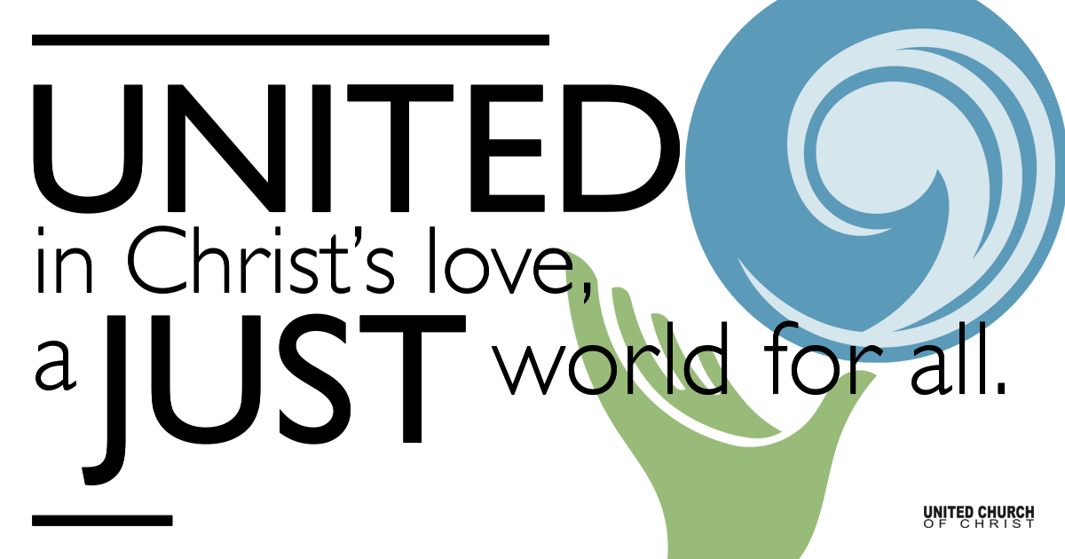

June 27, 2021

Fifth Sunday after Pentecost
Immortality
Silent Meditation
“Have you ever sensed that our soul is immortal and never dies?” - Plato

Prelude Tendrils Raynola Dominguez

Welcome to Worship
One: Whoever you are and wherever you are on life’s journey,
ALL: We welcome you here.

Opening Comments

Ringing of the Bell

Call to Worship (based on Psalm 30, responsively):
One: I will exalt you, Lord, for you lifted me out of the depths.
All: Lord my God, I called to you for help, and you healed me.
One: Sing praises to the Lord, you faithful people; praise God’s holy name.
All: To you, Lord, I called; to you I cried for mercy.
One: Hear me, Lord, and be merciful to me; Lord, be my help.
All: My heart will sing your praises and I will not be silent. Lord my God, I will praise you forever.

↑Opening Song Sky Full of Stars Coldplay
'Cause you're a sky, 'cause you're a sky full of stars
I'm gonna give you my heart
'Cause you're a sky, 'cause you're a sky full of stars
'Cause you light up the path
I don't care, go on and tear me apart
I don't care if you do, ooh
'Cause in a sky, 'cause in a sky full of stars
I think I saw you
'Cause you're a sky, 'cause you're a sky full of stars
I want to die in your arms, oh
'Cause you get lighter the more it gets dark
I'm gonna give you my heart, oh
I don't care, go on and tear me apart
I don't care if you do, oh
'Cause in a sky, 'cause in sky full of stars
I think I see you
I think I see you
'Cause you're a sky, you're a sky full of stars
Such a heavenly view
You're such a heavenly view, yeah, yeah, yeah, yeah

Scripture Wisdom of Solomon 1:13-15, 2:23-24 (Common English Bible)

God didn’t make death. God takes no delight in the ruin of anything that lives. God created everything so that it might exist. The creative forces at work in the cosmos are life-giving. There is no destructive poison in them. The underworld doesn’t rule on earth. Doing what is right means living forever.

God created humans to live forever. He made them as a perfect representation of his own unique identity. Death entered the universe only through the devil’s envy. Those who belong to the devil’s party experience death.

Reflection “What Does It Mean to Live Forever?” Rev. Brent Gundlah

Children’s Time Steve Ritchey

↑Words of Mission and Benediction

↑Closing Song Wonder Natalie Merchant

Live Service on Zoom

Call to Offering

Prayer of Dedication

Prayers of the Community
(If you would like to offer a prayer of gratitude or concern for someone or some situation please comment when you join the live service. Please use first names for security. The congregation will respond to each prayerful offering with the following words:
“Together with God, we hear your prayers.”)

Pastoral Prayer

Jesus Prayer
Our Creator who is in heaven,
Hallowed be Your name,
Your reign come, Your will be done,
On earth as it is in heaven,
Give us this day our daily bread,
And forgive us our debts as we forgive our debtors,
And lead us not into temptation, but deliver us from evil,
For Yours is the reign, the power, and glory for ever. Amen.

Covenant of Membership

FELLOWSHIP COFFEE HOUR

Find out More!



holladayucc.org

Or scan from your mobile device:


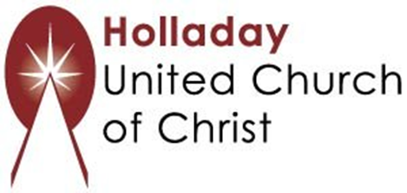
2631 East Murray-Holladay Rd
Holladay, UT 84117 801-277-2631
Rev. Brent Gundlah, Senior Pastor
Rev. Chelsea Page, Associate Pastor
Eric Richards, Director of Music Ministry
We are a Whole Earth,
Open and Affirming Congregation
Of the United Church of Christ.
Participants in Worship:
Reader: Teri Jewell, Video: Connie Nomann
Music: Raynola Dominguez, Mark Dazley
Children’s Chat: Steve Ritchey

