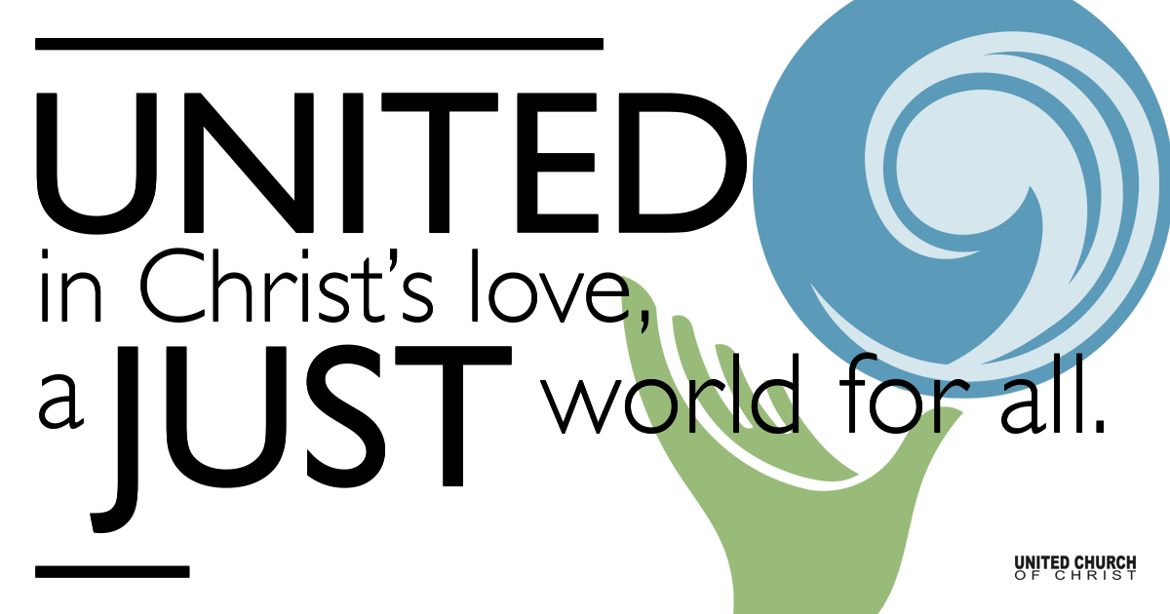

July 4, 2021

Sixth Sunday after Pentecost
Coming Home
Silent Meditation “It’s a thing to see when a boy comes home.”
John Steinbeck, The Grapes of Wrath

Prelude

Welcome to Worship
One: Whoever you are and wherever you are on life’s journey,
ALL: We welcome you here.

Opening Comments

Ringing of the Bell

Call to Worship (from UCC Worship Ways)
One: The prophets of old spoke of God’s justice, even when it was unwelcome. Who will hear their message?
All: We will listen and we will hear!
One: Responding to God’s call, Jesus traveled, preaching and teaching all who would listen. Who will hear his message?
All: We will listen and we will hear!
One: Christ sent out disciples two by two, to spread the good news in any place that would welcome them. Who will hear their message?
All: We will listen and we will hear!
One: God’s prophets are among us still, around the world and in these pews. Who will hear their message?
All: We will listen and we will hear!

↑Opening Song “I Want to Know What Love is” Mick Jones

Scripture Mark 6:1-13

He left that place and came to his hometown, and his disciples followed him. On the sabbath he began to teach in the synagogue, and many who heard him were astounded. They said, “Where did this man get all this? What is this wisdom that has been given to him? What deeds of power are being done by his hands! Is not this the carpenter, the son of Mary and brother of James and Joses and Judas and Simon, and are not his sisters here with us?” And they took offense at him. Then Jesus said to them, “Prophets are not without honor, except in their hometown, and among their own kin, and in their own house.” And he could do no deed of power there, except that he laid his hands on a few sick people and cured them. And he was amazed at their unbelief.

Then he went about among the villages teaching. He called the twelve and began to send them out two by two, and gave them authority over the unclean spirits. He ordered them to take nothing for their journey except a staff; no bread, no bag, no money in their belts; but to wear sandals and not to put on two tunics. He said to them, “Wherever you enter a house, stay there until you leave the place. If any place will not welcome you and they refuse to hear you, as you leave, shake off the dust that is on your feet as a testimony against them.” So they went out and proclaimed that all should repent. They cast out many demons, and anointed with oil many who were sick and cured them.

Reflection “Homecoming” Rev. Brent Gundlah

Communion

Children’s Time Shesh Tipton

↑Words of Mission and Benediction

↑Closing Song “This Land is Your Land” Woody Guthrie
Extra Lyrics by Bill Green

Live Service on Zoom

Call to Offering

Prayer of Dedication

Prayers of the Community
(If you would like to offer a prayer of gratitude or concern for someone or some situation please comment when you join the live service. Please use first names for security. The congregation will respond to each prayerful offering with the following words:
“Together with God, we hear your prayers.”)

Pastoral Prayer

Jesus Prayer
Our Creator who is in heaven,
Hallowed be Your name,
Your reign come, Your will be done,
On earth as it is in heaven,
Give us this day our daily bread,
And forgive us our debts as we forgive our debtors,
And lead us not into temptation, but deliver us from evil,
For Yours is the reign, the power, and glory for ever. Amen.

FELLOWSHIP COFFEE HOUR

Find out More!



holladayucc.org

Or scan from your mobile device:


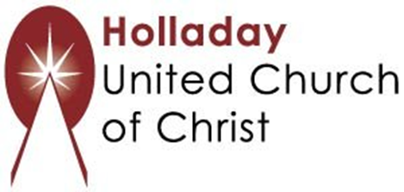
2631 East Murray-Holladay Rd
Holladay, UT 84117 801-277-2631
Rev. Brent Gundlah, Senior Pastor
Rev. Chelsea Page, Associate Pastor
Eric Richards, Director of Music Ministry
We are a Whole Earth,
Open and Affirming Congregation
Of the United Church of Christ.
Participants in Worship:
Reader: Shesh Tipton, Video: Connie Nomann
Music: Matt Mortensen, Twist of Faith, Children’s Chat: Shesh Tipton

