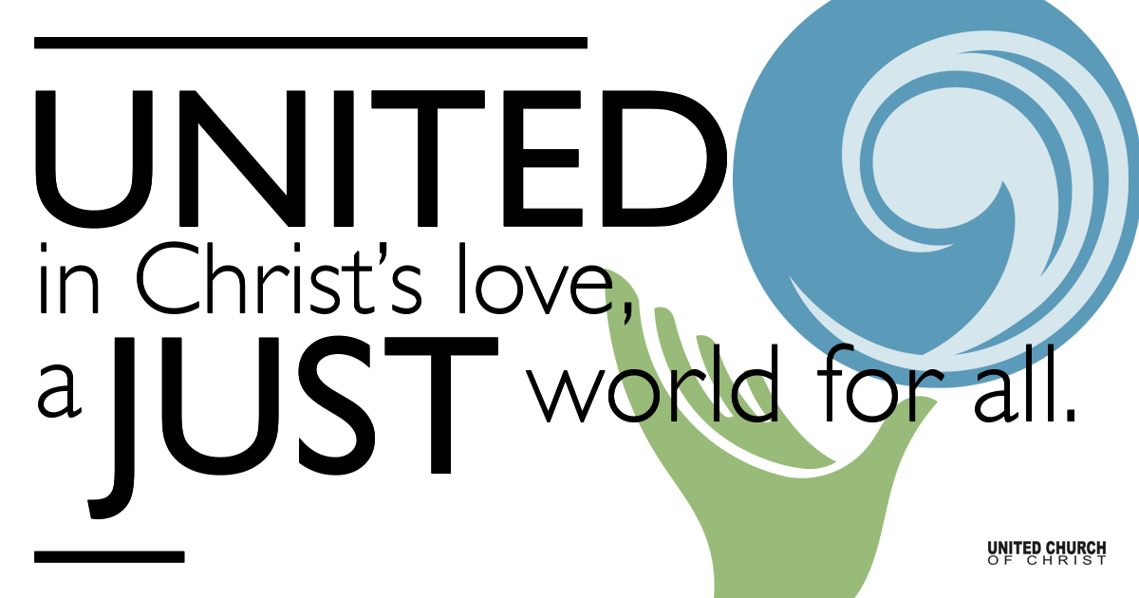

July 11, 2021

Seventh Sunday after Pentecost
Speaking Truth to Power
Silent Meditation
“Truth is the ultimate power. When the truth comes around, all the lies have to run and hide.” - Ice Cube

Prelude Don’t Hide Cory McCann

Welcome to Worship
One: Whoever you are and wherever you are on life’s journey,
ALL: We welcome you here.

Opening Comments

Ringing of the Bell

Call to Worship (based on Psalm 85:8-13):
One: Let us hear what God will speak.
All: God will speak peace to the people, to the faithful, to those who turn to God in their hearts.
One: Steadfast love and faithfulness will meet; righteousness and peace will kiss each other.
All: Faithfulness will spring up from the ground, and righteousness will look down from the sky.
One: The Lord will give what is good.
All: Let us worship God!

↑Opening Song Simply Human Morgan Taylor Reid

Scripture Amos 7:7-15
This is what he showed me: the Lord was standing beside a wall built with a plumb line, with a plumb line in his hand. And the Lord said to me, “Amos, what do you see?” And I said, “A plumb line.” Then the Lord said, “See, I am setting a plumb line in the midst of my people Israel; I will never again pass them by;
the high places of Isaac shall be made desolate, and the sanctuaries of Israel shall be laid waste, and I will rise against the house of Jeroboam with the sword.”

Then Amaziah, the priest of Bethel, sent to King Jeroboam of Israel, saying, “Amos has conspired against you in the very center of the house of Israel; the land is not able to bear all his words. For thus Amos has said, ‘Jeroboam shall die by the sword, and Israel must go into exile away from his land.’”

And Amaziah said to Amos, “O seer, go, flee away to the land of Judah, earn your bread there, and prophesy there; but never again prophesy at Bethel, for it is the king’s sanctuary, and it is a temple of the kingdom.”

Then Amos answered Amaziah, “I am no prophet, nor a prophet’s son; but I am a herdsman, and a dresser of sycamore trees, and the Lord took me from following the flock, and the Lord said to me, ‘Go, prophesy to my people Israel.’

Reflection “The House of God” Rev. Brent Gundlah

Children’s Time Linda Hilton

↑Words of Mission and Benediction

↑Closing Song Humble & Kind Tim McGraw

Live Service on Zoom

Call to Offering

Prayer of Dedication

Prayers of the Community
(If you would like to offer a prayer of gratitude or concern for someone or some situation please comment when you join the live service. Please use first names for security. The congregation will respond to each prayerful offering with the following words:
“Together with God, we hear your prayers.”)

Pastoral Prayer

Jesus Prayer
Our Creator who is in heaven,
Hallowed be Your name,
Your reign come, Your will be done,
On earth as it is in heaven,
Give us this day our daily bread,
And forgive us our debts as we forgive our debtors,
And lead us not into temptation, but deliver us from evil,
For Yours is the reign, the power, and glory for ever. Amen.

FELLOWSHIP COFFEE HOUR

Find out More!



holladayucc.org

Or scan from your mobile device:


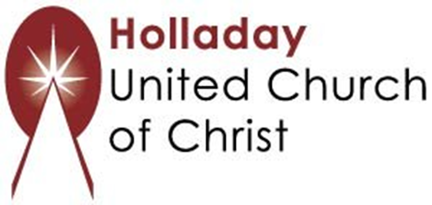
2631 East Murray-Holladay Rd
Holladay, UT 84117 801-277-2631
Rev. Brent Gundlah, Senior Pastor
Rev. Chelsea Page, Associate Pastor
Eric Richards, Director of Music Ministry
We are a Whole Earth,
Open and Affirming Congregation
Of the United Church of Christ.
Participants in Worship:
Reader: Shesh Tipton, Video: Connie Nomann
Music: Kelly Martin, Cory McCann, Children’s Chat: Linda Hilton

