~LIVESTREAMED TO YOUTUBE~
We are live streaming today’s worship service on YouTube, so we want you to know that your presence here today is your agreement and consent to being part of that recording.

~Please continue wearing your mask while in the Sanctuary~
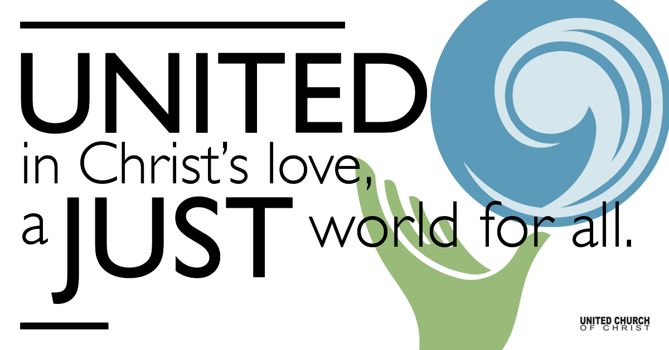

July 18, 2021

Eighth Sunday after Pentecost
So, Now What?
Silent Meditation
“My mission in life is not merely to survive, but to thrive; and to do so with some passion, some compassion, some humor, and some style.” - Maya Angelou

Prelude “No Matter” SPP #35
Chorus:
No matter who, no matter what, no matter where you are on the journey of life; you’re welcome, welcome in this place. No matter who, no matter what, no matter where you are on the journey of life; accepted, welcomed by God’s grace.

1. For we are family, meant to be, purposed for eternity. Born in love, from above, God’s community

2. And in diversity, unity, harmony for all to see; Justice and equity, God’s community.

4. The God who spoke through Christ, speaks to us; listen to our Savior’s call. Welcome home, welcome in, welcome one and all.

Welcome to Worship
One: Whoever you are and wherever you are on life’s journey,
ALL: We welcome you here.

Opening Comments and Announcements

Ringing of the Bell

Call to Worship (adapted from Ruth C. Duck, Flames of the Spirit)
One: We come to hear the story of God's faithfulness to past generations.
All: But we look to the future as well as the past.
One: The God who was with our ancestors is with us as today well.
All: Then we can go forward in hope. Whatever else fails, God remains faithful. Nothing can separate us from the love of God! Praise be to God!

↑Opening Song “Come to the Water” SPP #16
All who are thirsty for justice, all who are thirsty for peace.
All who are thirsty for peace, for justice come, come to the water of life.
All who are thirsty for mercy, all who are thirsty for love.
All who are thirsty for love, for mercy come, come to the water of life.
All who are thirsty for healing, all who are thirsty for touch.
All who are thirsty for touch, for healing come, come to the water of life.
All who are thirsty for beauty, all who are thirsty for truth.
All who are thirsty for truth, for beauty come, come to the water of life.

Children’s Chat Teri Jewell

Prayer for Illumination
Living God, as the risen Christ entered into the locked room and inspired the first disciples with the power of the Holy Spirit, may your Word inspire us to go forth from here to share the gospel with the world. Amen.

Scripture John 20:19-31

Reflection “So, Now What?” Rev. Brent Gundlah

Call to Offering/Prayer of Dedication

Prayers of the Community
(If you would like to offer a prayer of gratitude or concern for someone or some situation please use first names for security. The congregation will respond to each prayerful offering with the following words:
“Together with God, we hear your prayers.”)

Pastoral Prayer

Jesus Prayer
Our Creator who is in heaven,
Hallowed be Your name,
Your reign come, Your will be done,
On earth as it is in heaven,
Give us this day our daily bread,
And forgive us our debts as we forgive our debtors,
And lead us not into temptation, but deliver us from evil,
For Yours is the reign, the power, and glory for ever. Amen.

↑Words of Mission and Benediction

↑Closing Song “Like a Healing Stream” SPP#73
Like a healing stream in a barren desert, spirit water bringing life to dusty earth, God is trickling through our lives as in a dream unfolding promising revival and rebirth...like a healing stream
Lia a gentle rain on a thirsty garden, Spirit water come to nourish tiny seed God is bubbling through the soil to coax a new creation, yearning for an end to want and need...like a gentle rain
Like a river strong, with a restless current, spirit water rushing on to distant shore, God is carving out a channel in a new direction, calling for an end to hate and war...like a river strong.
Like a mighty sea, reaching far horizons, Spirit water with a love both deep and wide, God is working in our hearts to shape a new tomorrow: God will always challenge and provide! Like a mighty sea, like a river strong, like a gentle rain, like a healing stream.

Find out More!



holladayucc.org

Or scan from your mobile device:


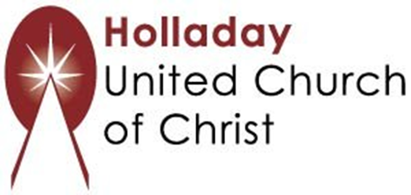
2631 East Murray-Holladay Rd
Holladay, UT 84117 801-277-2631
Rev. Brent Gundlah, Senior Pastor
Rev. Chelsea Page, Associate Pastor
Eric Richards, Director of Music Ministry
We are a Whole Earth,
Open and Affirming Congregation
Of the United Church of Christ.
Participants in Worship:
Reader: Shesh Tipton, Video: Bill Green, Slides: Steve Rossi
Music: Holy House Band, Children’s Chat: Teri Jewell

