~LIVESTREAMED TO YOUTUBE~
We are live streaming today’s worship service on YouTube, so we want you to know that your presence here today is your agreement and consent to being part of that recording.

~Please continue wearing your mask while in the Sanctuary~
~Please whisper or mouth words during responsive reading~
~Please remain seated and enjoy listening to the music~
~Offering plates will be located at the back of the Sanctuary~
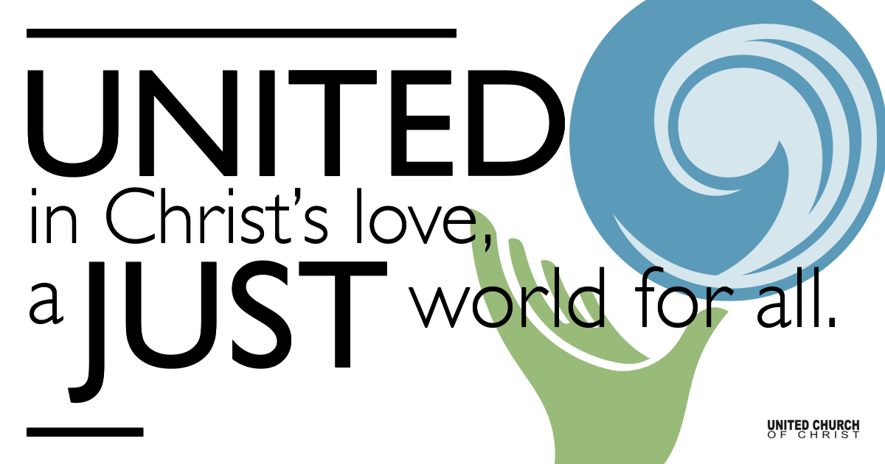

July 25, 2021

Ninth Sunday after Pentecost
The Bread of Life
Silent Meditation
“There are people in the world so hungry that God cannot appear to them except in the form of bread.” ― Mahatma Gandhi

Prelude Sweet Hour of Prayer William Walford

Welcome to Worship
One: Whoever you are and wherever you are on life’s journey,
ALL: We welcome you here.

Opening Comments and Announcements

Ringing of the Bell

Call to Worship (from UCC Worship Ways)
One: We join together as hungry eaters
to be nourished by the food that you offer us.
Many: God of sustenance, give us this day our daily bread.
One: As you care for the wheat fields that turn into bread and the vineyards that labor to produce sweet wine, tend to our bodies by feeding us what we need for healthy growth.
Many: God of abundance, give us this day our daily bread.
One: The rich crops that you have prepared are now ready to be harvested by our hands and our hearts.
Many: Holy Spirit, come! Give us this day our daily bread.

Opening Song Morning Has Broken Farjeon/Stevens

Prayer for Illumination

Scripture John 6:1-21 (Common English Bible)
After this Jesus went across the Galilee Sea (that is, the Tiberias Sea). A large crowd followed him, because they had seen the miraculous signs he had done among the sick. Jesus went up a mountain and sat there with his disciples. It was nearly time for Passover, the Jewish festival. Jesus looked up and saw the large crowd coming toward him. He asked Philip, “Where will we buy food to feed these people?” Jesus said this to test him, for he already knew what he was going to do. Philip replied, “More than a half year’s salary worth of food wouldn’t be enough for each person to have even a little bit.” One of his disciples, Andrew, Simon Peter’s brother, said, “A youth here has five barley loaves and two fish. But what good is that for a crowd like this?”
Jesus said, “Have the people sit down.” There was plenty of grass there. They sat down, about five thousand of them. Then Jesus took the bread. When he had given thanks, he distributed it to those who were sitting there. He did the same with the fish, each getting as much as they wanted. When they had plenty to eat, he said to his disciples, “Gather up the leftover pieces, so that nothing will be wasted.” So they gathered them and filled twelve baskets with the pieces of the five barley loaves that had been left over by those who had eaten. When the people saw that he had done a miraculous sign, they said, “This is truly the prophet who is coming into the world.” Jesus understood that they were about to come and force him to be their king, so he took refuge again, alone on a mountain.
When evening came, Jesus’ disciples went down to the lake. They got into a boat and were crossing the lake to Capernaum. It was already getting dark and Jesus hadn’t come to them yet. The water was getting rough because a strong wind was blowing. When the wind had driven them out for about three or four miles, they saw Jesus walking on the water. He was approaching the boat and they were afraid. He said to them, “I Am. Don’t be afraid.” Then they wanted to take him into the boat, and just then the boat reached the land where they had been heading.

Reflection “Who Jesus Is” Rev. Brent Gundlah

Children’s Chat Pam Erickson

Call to Offering/Prayer of Dedication

Prayers of the Community
(If you would like to offer a prayer of gratitude or concern for someone or some situation please use first names for security. The congregation will respond to each prayerful offering with the following words:
“Together with God, we hear your prayers.”)

Pastoral Prayer

Jesus Prayer
Our Creator who is in heaven,
Hallowed be Your name,
Your reign come, Your will be done,
On earth as it is in heaven,
Give us this day our daily bread,
And forgive us our debts as we forgive our debtors,
And lead us not into temptation, but deliver us from evil,
For Yours is the reign, the power, and glory for ever. Amen.

Words of Mission and Benediction

Closing Song How’re We Goin’ To Praise The Lord? Natalie Sleeth

Find out More!



holladayucc.org

Or scan from your mobile device:


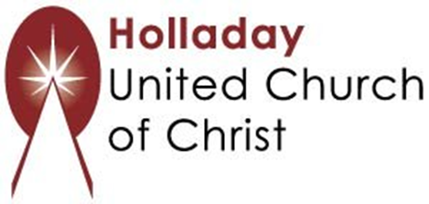
2631 East Murray-Holladay Rd
Holladay, UT 84117 801-277-2631
Rev. Brent Gundlah, Senior Pastor
Rev. Chelsea Page, Associate Pastor
Eric Richards, Director of Music Ministry
We are a Whole Earth,
Open and Affirming Congregation
Of the United Church of Christ.
Participants in Worship:
Reader: Trent Parkhill, Slides: Steve Rossi
Music: Pam Erickson, Eric Richards, Children’s Chat: Pam Erickson

PRAYER REQUESTS
The following are offered for your prayers this morning and in the days ahead:
- Prayers of strength and comfort for all those who live in fear of violence.
- Prayers of support and gratitude for our community of caregivers.
- Prayers of healing for all who are facing health issues.
- Prayers of comfort for all those in hospice care.

