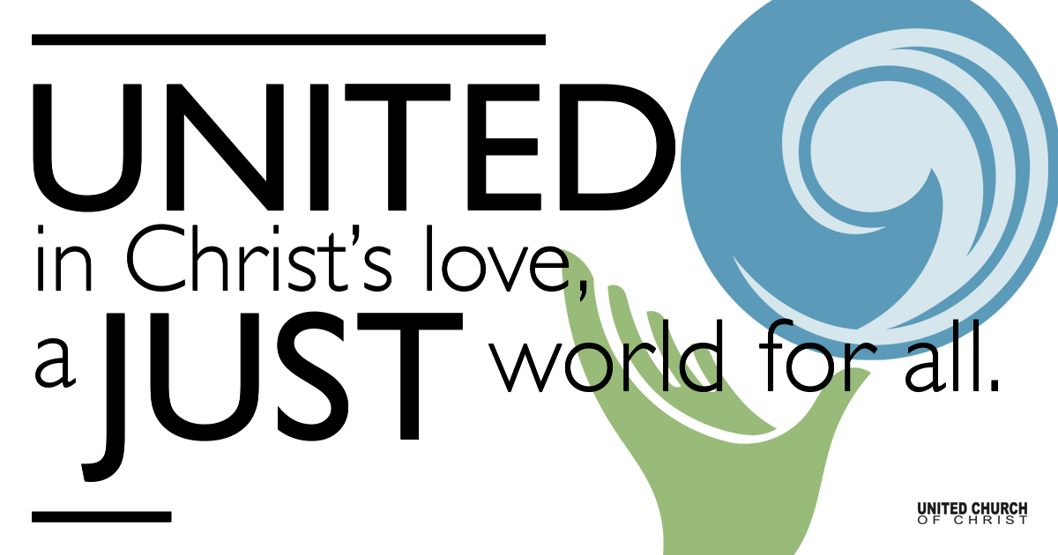

August 1, 2021

Tenth Sunday after Pentecost
Canyon Worship
~Wear a mask if you are not vaccinated~
~Speak softly during reponses and prayers~
~Sing softly or hum~
~Offering plates will be in a central location~

Silent Meditation
“One cannot be pessimistic about the West. This is the native home of hope. When it fully learns that cooperation, not rugged individualism, is the quality that most characterizes and preserves it, then it will have achieved itself and outlived its origins. Then it has a chance to create a society to match its scenery.”
~Wallace Stegner, The Sound of Mountain Water

Prelude Instrumental Bill and Jonathen Green

Welcome to Worship
One: Whoever you are and wherever you are on life’s journey,
ALL: We welcome you here.

Opening Comments

Ringing of the Bell

Call to Worship (adapted from the UCC Wisconsin Conference)
One: In the beginning, the Spirit of God moved over the waters,
All: and God said “Unbind creation and let her out!” and God declared it to be Good.
One: God said, “let there be light” and called the light “Day” and the darkness “Night.”

All: God spoke the word to call the land from the water, pulling Lake Bonneville down to the depths and raising these mountains above the waters, and in God’s eyes they were good.

One: God’s word called to life the rattlesnake and the wildflower, the potgut and the pine tree,
All: the honeybee and the wolf, the microbe and the moose, and God saw them to be good.
One: Then God spoke a final time, making creatures in the divine image: us.
All: Forming humans by holy word, to tend and steward all that God had made.
One: And God saw that it was all very good.
All: And God declared that it is all very good.
One: On the seventh day, God rested.
All: And on this seventh day, we come to worship and remember our role as God’s partners in creation.

↑Opening Song “Gathered Here” Phil Porter

Children’s Time Trent Parkhill

Scripture Psalm 104:24-34, 35b
O Lord, how manifold are your works!
In wisdom you have made them all;
the earth is full of your creatures.
Yonder is the sea, great and wide,
creeping things innumerable are there,
living things both small and great.
There go the ships,
and Leviathan that you formed to sport in it.
These all look to you
to give them their food in due season;
when you give to them, they gather it up;
when you open your hand, they are filled with good things.

When you hide your face, they are dismayed;
when you take away their breath, they die
and return to their dust.
When you send forth your spirit, they are created;
and you renew the face of the ground.
May the glory of the Lord endure forever;
may the Lord rejoice in the Lord’s works—
who looks on the earth and it trembles,
who touches the mountains and they smoke.
I will sing to the Lord as long as I live;
I will sing praise to my God while I have being.
May my meditation be pleasing to the Lord,
for I rejoice in the Lord.
Bless the Lord, O my soul. Praise the Lord!

Reflection “How Manifold Are Your Works!” Rev. Brent Gundlah

Invitation to Share/Offering Prayer

Concerns of the Community

Communion Song “Let Us Break Bread Together”

Communion

Pastoral Prayer

Jesus Prayer

↑Words of Mission and Benediction

↑Closing Song “Imago Dei” Rev. Jill Warner

FELLOWSHIP POTLUCK

Find out More!



holladayucc.org

Or scan from your mobile device:


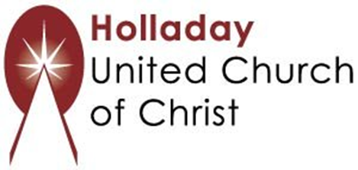
2631 East Murray-Holladay Rd
Holladay, UT 84117 801-277-2631
Rev. Brent Gundlah, Senior Pastor
Rev. Chelsea Page, Associate Pastor
Eric Richards, Director of Music Ministry
We are a Whole Earth,
Open and Affirming Congregation
Of the United Church of Christ.
Participants in Worship:
Music: Bill and Jonathen Green, Children’s Chat: Trent Parkhill

