~LIVESTREAMED TO FACEBOOK~
We are live streaming today’s worship service on Facebook, so we want you to know that your presence here today is your agreement and consent to being part of that recording.

~Please continue wearing your mask while in the Sanctuary~
~Please whisper or mouth words during responsive reading~
~Please remain seated and enjoy listening to the music~
~Offering plates will be located at the back of the Sanctuary~
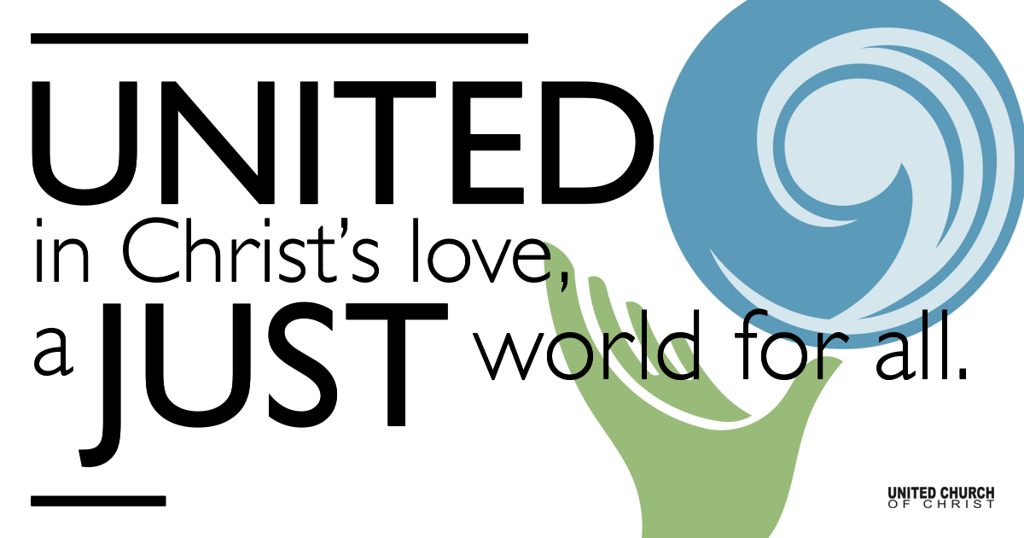

August 8, 2021

Eleventh Sunday after Pentecost
Strength for the Journey
Silent Meditation
“Life is a journey that must be traveled no matter how bad the roads and accommodations.” ― Oliver Goldsmith

Prelude “Please Be My Strength” Gungor

Welcome to Worship
One: Whoever you are and wherever you are on life’s journey,
ALL: We welcome you here.

Opening Comments

Ringing of the Bell

Call to Worship (from Psalm 34)
One: I will bless the Lord at all times.
All: The Lord’s praise shall continually be on my lips.
One: Magnify the Lord with me.
All: And let us exalt God’s name together.

↑Opening Song “Bread for The Journey” Bret Hesla

Prayer for Illumination
God of wisdom, your Word provides us with sustenance for life’s journey. May your Holy Spirit open our hearts and minds, enabling us to hear what you are saying to us today, and inspiring us to share your good news with the world. Amen.

Scripture John 6:35, 41-51
Jesus said to them, “I am the bread of life. Whoever comes to me will never be hungry, and whoever believes in me will never be thirsty. Then the Jews began to complain about him because he said, “I am the bread that came down from heaven.” They were saying, “Is not this Jesus, the son of Joseph, whose father and mother we know? How can he now say, ‘I have come down from heaven’?” Jesus answered them, “Do not complain among yourselves. No one can come to me unless drawn by the Father who sent me; and I will raise that person up on the last day. It is written in the prophets, ‘And they shall all be taught by God.’ Everyone who has heard and learned from the Father comes to me. Not that anyone has seen the Father except the one who is from God; he has seen the Father. Very truly, I tell you, whoever believes has eternal life. I am the bread of life. Your ancestors ate the manna in the wilderness, and they died. This is the bread that comes down from heaven, so that one may eat of it and not die. I am the living bread that came down from heaven. Whoever eats of this bread will live forever; and the bread that I will give for the life of the world is my flesh.”

Reflection “Strength for the Journey” Rev. Brent Gundlah

Children’s Time Ruby Hammel

Call to Offering

Prayer of Dedication

Prayers of the Community
(If you would like to offer a prayer of gratitude or concern for someone or some situation please comment when you join the live service. Please use first names for security. The congregation will respond to each prayerful offering with the following words:
“Together with God, we hear your prayers.”)

Pastoral Prayer

Jesus Prayer
Our Creator who is in heaven,
Hallowed be Your name,
Your reign come, Your will be done,
On earth as it is in heaven,
Give us this day our daily bread,
And forgive us our debts as we forgive our debtors,
And lead us not into temptation, but deliver us from evil,
For Yours is the reign, the power, and glory for ever. Amen.

↑Words of Mission and Benediction

↑Closing Song “I Want Jesus To Walk With Me” Traditional Spiritual

FELLOWSHIP COFFEE HOUR

Find out More!



holladayucc.org

Or scan from your mobile device:


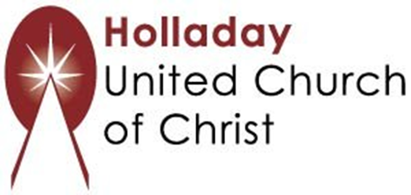
2631 East Murray-Holladay Rd
Holladay, UT 84117 801-277-2631
Rev. Brent Gundlah, Senior Pastor
Rev. Chelsea Page, Associate Pastor
Eric Richards, Director of Music Ministry
We are a Whole Earth,
Open and Affirming Congregation
Of the United Church of Christ.
Participants in Worship:
Reader: Heather Bertotti Sarin, Slides: Dale Berreth, Video: Jim Bale
Music: Jani Gamble, Eric Richards, Mark Dazley, Carl Adams
Children’s Chat: Ruby Hammel

