~LIVESTREAMED TO FACEBOOK~
We are live streaming today’s worship service on Facebook, so we want you to know that your presence here today is your agreement and consent to being part of that recording.

~Please continue wearing your mask while in the Sanctuary~
~Please whisper or mouth words during responsive reading~
~Please remain seated and enjoy listening to the music~
~Offering plates will be located at the back of the Sanctuary~
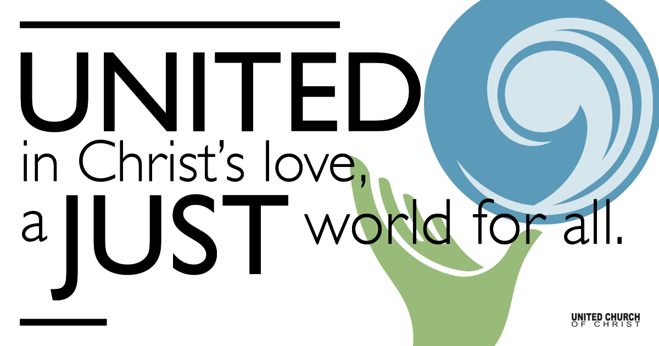

August 15, 2021

Twelfth Sunday after Pentecost
Woman Wisdom
Silent Meditation
“Knowing yourself is the beginning of all wisdom.” ― Aristotle

Prelude Simple Gifts Joseph Brackett

Welcome to Worship
One: Whoever you are and wherever you are on life’s journey,
ALL: We welcome you here.

Opening Comments

Ringing of the Bell

Call to Worship (based on Psalm 111, responsively)
One: In the company of God’s people, let us give thanks to our God.
All: Great are the works of God, full of glory and majesty.
One: God is gracious and compassionate, merciful and forgiving. God is faithful and trustworthy, just and good.
All: Come, let us worship God together. Let us praise God forever!

Opening Song Proverbs 9:1-6 Jason Silver

Prayer of Illumination

Scripture Proverbs 9:1-6
Wisdom has built her house, she has hewn her seven pillars. She has slaughtered her animals, she has mixed her wine, she has also set her table.
She has sent out her servant-girls, she calls from the highest places in the town, “You that are simple, turn in here!” To those without sense she says,
“Come, eat of my bread and drink of the wine I have mixed. Lay aside immaturity, and live, and walk in the way of insight.”

Reflection “Wisdom’s Banquet” Rev. Brent Gundlah

Children’s Chat Jim Bale

Invitation to Share/Offering Prayer

Prayers of the Community
(If you would like to offer a prayer of gratitude or concern for someone or some situation please use first names for security. The congregation will respond to each prayerful offering with the following words:
“Together with God, we hear your prayers.”)

Pastoral Prayer

Jesus Prayer
Our Creator who is in heaven,
Hallowed be Your name,
Your reign come, Your will be done,
On earth as it is in heaven,
Give us this day our daily bread,
And forgive us our debts as we forgive our debtors,
And lead us not into temptation, but deliver us from evil,
For Yours is the reign, the power, and glory for ever. Amen.

Words of Mission and Benediction

Closing Song Wisdom Song Laura Woodley Osman

FELLOWSHIP COFFEE HOUR

Find out More!



holladayucc.org

Or scan from your mobile device:


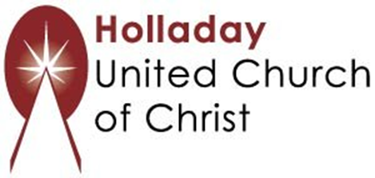
2631 East Murray-Holladay Rd
Holladay, UT 84117 801-277-2631
Rev. Brent Gundlah, Senior Pastor
Rev. Chelsea Page, Associate Pastor
Eric Richards, Director of Music Ministry
We are a Whole Earth,
Open and Affirming Congregation
Of the United Church of Christ.
Participants in Worship:
Reader: Dennis Bayes, Slides: Steve Ritchey
Music: Kelly Martin, Robb Carlson, Christopher Thomas,
Jani Gamble, Eric Richards, Children’s Chat: Jim Bale
Video: __________, Sound: ____________

