~LIVESTREAMED TO FACEBOOK~
We are live streaming today’s worship service on Facebook, so we want you to know that your presence here today is your agreement and consent to being part of that recording.

~Please continue wearing your mask while in the Sanctuary~
~Please whisper or mouth words during responsive reading~
~Please remain seated and enjoy listening to the music~
~Offering plates will be located at the back of the Sanctuary~
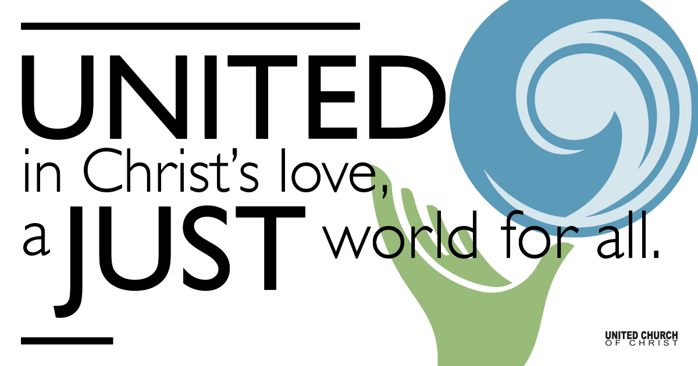

September 12, 2021

Sixteenth Sunday after Pentecost
Who is Jesus?
Silent Meditation
“When I discover who I am, I’ll be free.” - Ralph Ellison

Prelude “Trouble and Woe” Ruth Moody

Welcome to Worship
One: Whoever you are and wherever you are on life’s journey,
ALL: We welcome you here.

Opening Comments

Ringing of the Bell

Call to Worship (adapted from the Church of Scotland)
One: God of grace and mercy, we come here today to celebrate you and to ask for your presence in our lives.
All: We come to be still, we come to listen, we come to give thanks, we come to offer ourselves to you.

One: Prepare us to receive your word and lift up our spirits as we worship you together, so that when we leave this place we may feel renewed, refreshed and inspired to share the gospel with the world.

Opening Song “Shadow of Doubt” Gary Nicholson

Prayer for Illumination

Scripture Mark 8:27-38
Jesus went on with his disciples to the villages of Caesarea Philippi; and on the way he asked his disciples, “Who do people say that I am?” And they answered him, “John the Baptist; and others, Elijah; and still others, one of the prophets.” He asked them, “But who do you say that I am?” Peter answered him, “You are the Messiah.” And he sternly ordered them not to tell anyone about him.

Then he began to teach them that the Son of Man must undergo great suffering and be rejected by the elders, the chief priests, and the scribes, and be killed, and after three days rise again. He said all this quite openly. And Peter took him aside and began to rebuke him. But turning and looking at his disciples, he rebuked Peter and said, “Get behind me, Satan! For you are setting your mind not on divine things but on human things.”

He called the crowd with his disciples, and said to them, “If any want to become my followers, let them deny themselves and take up their cross and follow me. For those who want to save their life will lose it, and those who lose their life for my sake, and for the sake of the gospel, will save it. For what will it profit them to gain the whole world and forfeit their life? Indeed, what can they give in return for their life? Those who are ashamed of me and of my words in this adulterous and sinful generation, of them the Son of Man will also be ashamed when he comes in the glory of his Father with the holy angels.”

Reflection “Who Do You Say That I Am?” Rev. Brent Gundlah

Children’s Chat Jan Foutz

Call to Offering/Prayer of Dedication

Prayers of the Community
(If you would like to offer a prayer of gratitude or concern for someone or some situation please use first names for security. The congregation will respond to each prayerful offering with the following words:
“Together with God, we hear your prayers.”)

Pastoral Prayer

Jesus Prayer

Our Creator who is in heaven,
Hallowed be Your name,
Your reign come, Your will be done,
On earth as it is in heaven,
Give us this day our daily bread,
And forgive us our debts as we forgive our debtors,
And lead us not into temptation, but deliver us from evil,
For Yours is the reign, the power, and glory for ever. Amen.

Words of Mission and Benediction

Closing Song “Get Right With God” Lucinda Williams

Find out More!



holladayucc.org

Or scan from your mobile device:


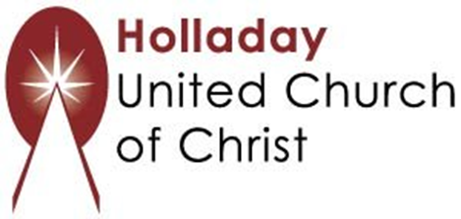
2631 East Murray-Holladay Rd
Holladay, UT 84117 801-277-2631
Rev. Brent Gundlah, Senior Pastor
Rev. Chelsea Page, Associate Pastor
Eric Richards, Director of Music Ministry
We are a Whole Earth,
Open and Affirming Congregation
Of the United Church of Christ.
Participants in Worship:
Reader: Shesh Tipton, Children’s Chat: Jan Foutz
Music: Amy Boettger, Jani Gamble, Jes Luckett, Mary Otterstrom, Mona Stevens
Slides: Roger Lamoni, Sound: Winston Gamble, Video: Jim Bale

PRAYER REQUESTS
The following are offered for your prayers this morning and in the days ahead:
- Prayers of strength and comfort for all those who live in fear of violence.
- Prayers of support and gratitude for our community of caregivers.
- Prayers of healing for all who are facing health issues
- Prayers of comfort for all those in hospice care.

