~LIVESTREAMED TO FACEBOOK~
We are live streaming today’s worship service on Facebook, so we want you to know that your presence here today is your agreement and consent to being part of that recording.

~Please continue wearing your mask while in the Sanctuary~
~Please whisper or mouth words during responsive reading~
~Please remain seated and enjoy listening to the music~
~Offering plates will be located at the back of the Sanctuary~
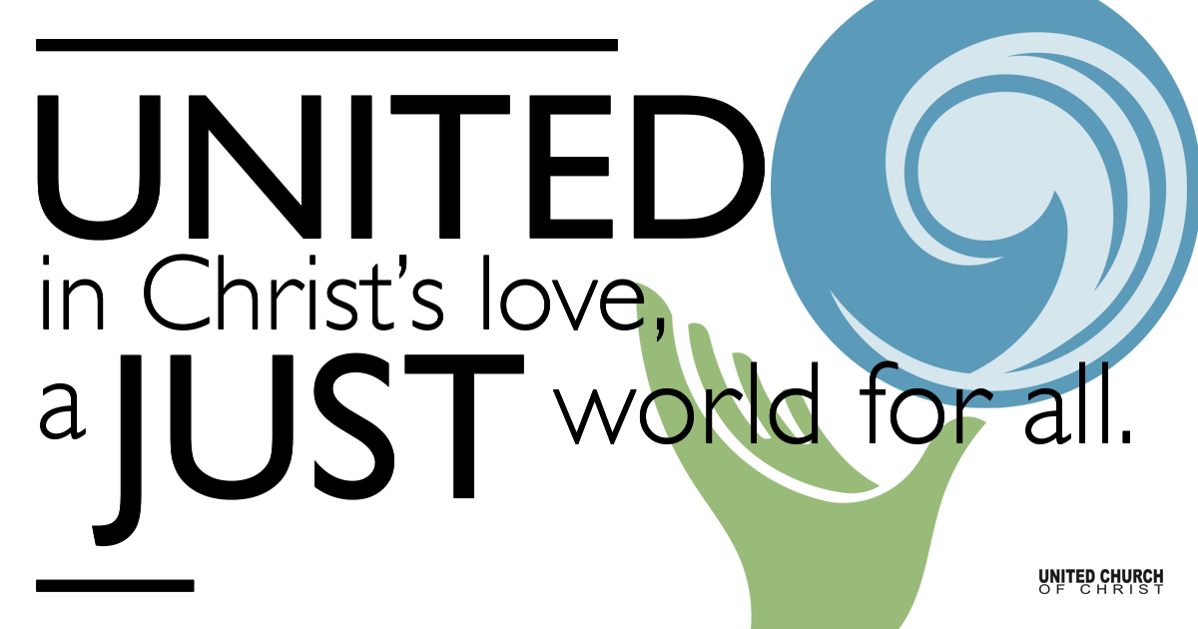

September 19, 2021

Seventeenth Sunday after Pentecost
Faith and Uncertainty
Silent Meditation
“The strongest love is the love that can demonstrate its fragility.”
Paolo Coelho

Prelude “Banner of Hope”

Welcome to Worship

One: Whoever you are and wherever you are on life’s journey,
ALL: We welcome you here.

Opening Comments

Ringing of the Bell

Call to Worship (from UCC Worship Ways)
One: Jesus challenges us in today’s gospel:
Many: Whoever wants to be first must be last of all and servant of all.
One: Then Jesus took a little child and put it among them; and taking the child in his arms, he said to them:
Many: Whoever welcomes one such child in my name welcomes me. And whoever welcomes me welcomes not me but the one who sent me.
One: We are still learning today what Jesus came to teach us two thousand years ago. To change the world we must change the way we love and welcome all children!
Many: May we learn to love all children as if they were our own!

Opening Song “God is Our Shelter & Strength”

Prayer for Illumination

Scripture Mark 9:30-37
They went on from there and passed through Galilee. He did not want anyone to know it; for he was teaching his disciples, saying to them, “The Son of Man is to be betrayed into human hands, and they will kill him, and three days after being killed, he will rise again.” But they did not understand what he was saying and were afraid to ask him.

Then they came to Capernaum; and when he was in the house he asked them, “What were you arguing about on the way?” But they were silent, for on the way they had argued with one another who was the greatest. He sat down, called the twelve, and said to them, “Whoever wants to be first must be last of all and servant of all.” Then he took a little child and put it among them; and taking it in his arms, he said to them, “Whoever welcomes one such child in my name welcomes me, and whoever welcomes me welcomes not me but the one who sent me.”

Reflection “Living with the Question of ‘Why?’” Rev. Brent Gundlah

Children’s Chat Rev. Chelsea Page

Call to Offering/Prayer of Dedication

Prayers of the Community
(If you would like to offer a prayer of gratitude or concern for someone or some situation please use first names for security. The congregation will respond to each prayerful offering with the following words:
“Together with God, we hear your prayers.”)

Pastoral Prayer

Jesus Prayer
Our Creator who is in heaven,
Hallowed be Your name,
Your reign come, Your will be done,
On earth as it is in heaven,
Give us this day our daily bread,
And forgive us our debts as we forgive our debtors,
And lead us not into temptation, but deliver us from evil,
For Yours is the reign, the power, and glory for ever. Amen.

Words of Mission and Benediction

Closing Song “I Will Be Your Friend” Guy Davis

Find out More!



holladayucc.org

Or scan from your mobile device:


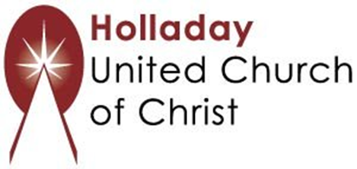
2631 East Murray-Holladay Rd
Holladay, UT 84117 801-277-2631
Rev. Brent Gundlah, Senior Pastor
Rev. Chelsea Page, Associate Pastor
Eric Richards, Director of Music Ministry
We are a Whole Earth,
Open and Affirming Congregation
Of the United Church of Christ.
Participants in Worship:
Reader: Martha Moler, Slides: Roger Lamoni, Children’s Chat: Chelsea Page
Music: Marilyn Dillard, Mark Dazley, Raynola Dominguez, Eric Richards & Christopher Thomas, Video: Jim Bale

PRAYER REQUESTS
The following are offered for your prayers this morning and in the days ahead:
- Prayers of strength and comfort for all those who live in fear of violence.
- Prayers of support and gratitude for our community of caregivers.
- Prayers of healing for all who are facing health issues
- Prayers of comfort for all those in hospice care.

