~LIVESTREAMED TO FACEBOOK~
We are live streaming today’s worship service on Facebook, so we want you to know that your presence here today is your agreement and consent to being part of that recording.

~Please continue wearing your mask while in the Sanctuary~
~Please whisper or mouth words during responsive reading~
~Please remain seated and enjoy listening to the music~
~Offering plates will be located at the back of the Sanctuary~
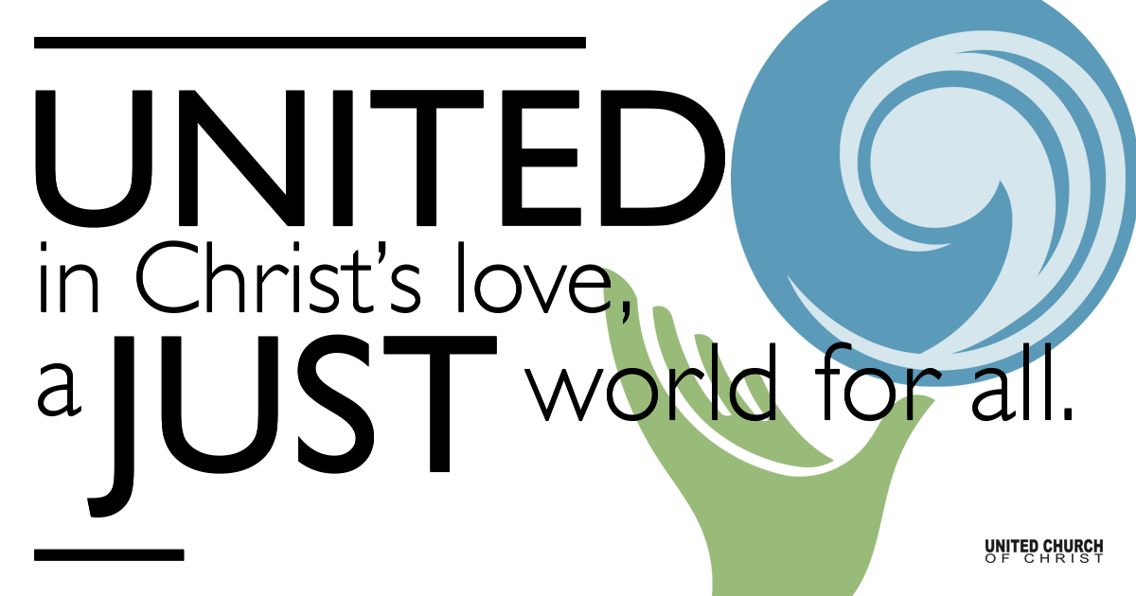

September 26, 2021

Sunday School Kickoff
Everywhere Prophets
Silent Meditation
“Whoever is not against us is for us.” - Jesus (Mark 9:40)

Prelude “Shiver Into Spark” Music & Lyrics by Mandy Lynn Danzig

Welcome to Worship Rev. Brent Gundlah
One: Whoever you are and wherever you are on life’s journey,
ALL: We welcome you here.

Community Announcements

Opening Song “That Kind of Love Goes Far” Music & Lyrics by Kate MacLeod

Entrance of Light

Ringing of the Bell

Call to Worship
One: Every day, everywhere, prophets are speaking
All: In church, at school, on the public square
One: Every day, everywhere, prophets are listening
All: To ancient voices, to new realities, to hearts’ deep desires
One: Every day, everywhere, prophets are called
All: By God, by the spirit within, by the example of Jesus
One: All are called to be prophets, because God is still speaking
All: Let us worship God!

Children’s Chat Jim Bale

Prayer for Illumination
God of wisdom, speak your Word to us through the scriptures. By your Spirit, plant your truth deep within us, so that we may follow Christ who is your Living Word. Amen.

Scripture Numbers 11:24-29

Reflection “Everywhere Prophets” Rev. Chelsea Page

Minute for Mission Faith Formation - Kate Palmer

(Please note: If you are in the sanctuary and filling out the bulletin insert signup sheet using your phone with the QR code provided, please turn off your phone wi-fi and use your own cellular data, in order to protect the Facebook livestream connection. Thank you! Bulletin inserts that are filled out hard-copy may be dropped in the offering plates at any of the sanctuary doors after the service. Thank you!)

Minute for Mission Compassionate Action - Scott Smith

Prophetic Word Cloud

WHY do you serve? What do we get out of serving the church?

(To participate live, please use your smart phone to go to www.menti.com and enter code 3475 2623. To contribute for later, please write your words on the bottom of your bulletin insert, and they will be added to a word cloud for Tidings.)

Centering Music “Amazing Grace” arr. by Mandy Lynn Danzig

Call to Offering/Prayer of Dedication Rev. Brent Gundlah

Prayers of the Community Rev. Brent Gundlah
(If you would like to offer a prayer of gratitude or concern for someone or some situation please use first names for security. The congregation will respond to each prayerful offering with the following words:
“Together with God, we hear your prayers.”)

Pastoral Prayer Rev. Brent Gundlah

Jesus Prayer
Our Creator who is in heaven,
Hallowed be Your name,
Your reign come, Your will be done,
On earth as it is in heaven,
Give us this day our daily bread,
And forgive us our debts as we forgive our debtors,
And lead us not into temptation, but deliver us from evil,
For Yours is the reign, the power, and glory for ever. Amen.

Benediction Rev. Chelsea Page

Closing Song “Stronger or Your Flame
Music and Lyrics by Randall Williams

Find out More!



holladayucc.org

Or scan from your mobile device:


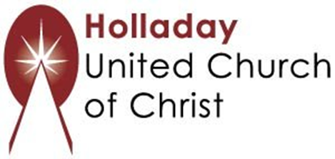
2631 East Murray-Holladay Rd
Holladay, UT 84117 801-277-2631
Rev. Brent Gundlah, Senior Pastor
Rev. Chelsea Page, Associate Pastor
Eric Richards, Director of Music Ministry
We are a Whole Earth,
Open and Affirming Congregation
Of the United Church of Christ.
Participants in Worship:
Reader: Debbie Wilkerson, Slides: Dale Berreth, Video: Jim Bale
Music: Mandy Lynn Danzig, Alisa Bolander, Children’s Chat: Jim Bale

PRAYER REQUESTS
The following are offered for your prayers this morning and in the days ahead:
- Prayers of strength and comfort for all those who live in fear of violence.
- Prayers of support and gratitude for our community of caregivers.
- Prayers of healing for all who are facing health issues
- Prayers of comfort for all those in hospice care.

