~LIVESTREAMED TO FACEBOOK~
We are live streaming today’s worship service on Facebook, so we want you to know that your presence here today is your agreement and consent to being part of that recording.

~Please continue wearing your mask while in the Sanctuary~
~Please whisper or mouth words during responsive reading~
~Please remain seated and enjoy listening to the music~
~Offering plates will be located at the back of the Sanctuary~
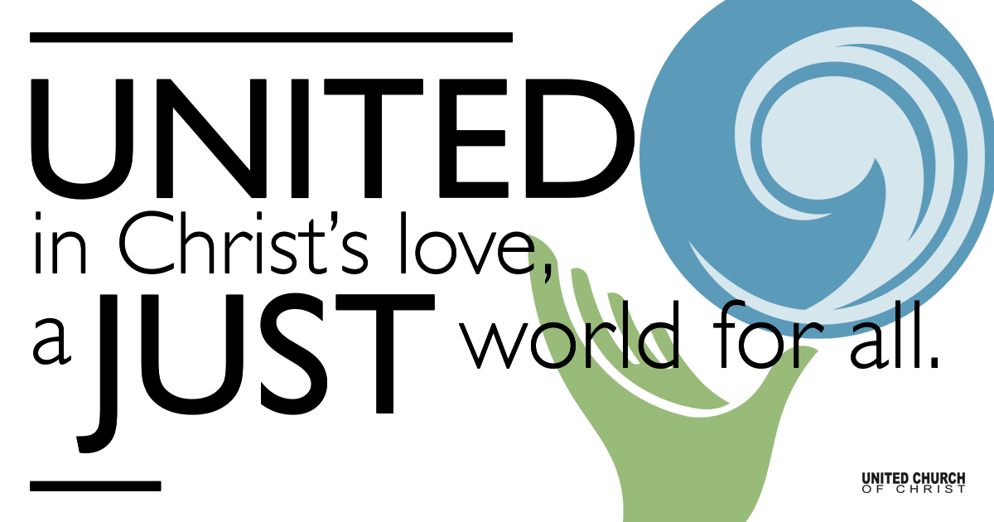

October 10, 2021

Twentieth Sunday after Pentecost
Eternal Life
Silent Meditation
“If we take eternity to mean not infinite temporal duration, but timelessness, then eternal life belongs to those who live in the present.”
~ Ludwig Wittgenstein

Prelude “Kentucky Waltz” Bill Monroe

Welcome to Worship
One: Whoever you are and wherever you are on life’s journey,
ALL: We welcome you here.

Opening Comments

Entrance of the Light & Ringing of the Bell

Call to Worship (from the Presbyterian Church in Canada):
One: God blesses us with gifts of love,
All: with relationships that bring joy and gratitude.

One: God blesses us with talents and opportunities to serve,
All: all we need for faithful living.
One: God protects us in times of danger:
All: and guards us from the time of trial.
One: So, we gather to offer thanksgiving to the Lord our God.
All: Praise be to God for all good things, now and always!

Opening Song “Black and White Rag” George Botsford

Children’s Chat & Blessing Rev. Chelsea Page
Though we gather separately, we are one community
In the sanctuary, playground or at home.
In this space and in every place, we are beloved.
We are disciples. We are leaders. We are creators.
We are thinkers. We are worshipers.
Love is the reason we are here.
God is here with us, And God is out there, too!
Go with God. Amen.

Prayer for Illumination

Scripture Mark 10:17-31, NRSV
As he was setting out on a journey, a man ran up and knelt before him, and asked him, “Good Teacher, what must I do to inherit eternal life?” Jesus said to him, “Why do you call me good? No one is good but God alone. You know the commandments: ‘You shall not murder; You shall not commit adultery; You shall not steal; You shall not bear false witness; You shall not defraud; Honor your father and mother.’” He said to him, “Teacher, I have kept all these since my youth.” Jesus, looking at him, loved him and said, “You lack one thing; go, sell what you own, and give the money to the poor, and you will have treasure in heaven; then come, follow me.” When he heard this, he was shocked and went away grieving, for he had many possessions.
Then Jesus looked around and said to his disciples, “How hard it will be for those who have wealth to enter the kingdom of God!” And the disciples were perplexed at these words. But Jesus said to them again, “Children, how hard it is to enter the kingdom of God! It is easier for a camel to go through the eye of a needle than for someone who is rich to enter the kingdom of God.” They were greatly astounded and said to one another, “Then who can be saved?” Jesus looked at them and said, “For mortals it is impossible, but not for God; for God all things are possible.”
Peter began to say to him, “Look, we have left everything and followed you.” Jesus said, “Truly I tell you, there is no one who has left house or brothers or sisters or mother or father or children or fields, for my sake and for the sake of the good news, who will not receive a hundredfold now in this age—houses, brothers and sisters, mothers and children, and fields, with persecutions—and in the age to come eternal life. But many who are first will be last, and the last will be first.”

Reflection “Don’t Just Do Something, Sit There” Rev. Brent Gundlah

Call to Offering/Prayer of Dedication

Prayers of the Community
(If you would like to offer a prayer of gratitude or concern for someone or some situation please use first names for security. The congregation will respond to each prayerful offering with the following words:
“Together with God, we hear your prayers.”)

Pastoral Prayer

Jesus Prayer
Our Creator who is in heaven,
Hallowed be Your name,
Your reign come, Your will be done,
On earth as it is in heaven,
Give us this day our daily bread,
And forgive us our debts as we forgive our debtors,
And lead us not into temptation, but deliver us from evil,
For Yours is the reign, the power, and glory for ever. Amen.

Words of Mission and Benediction

Closing Song “Wild Fiddle Rag” Howdy Forrester

Parents, please collect your child(ren) from their teachers in the playground. Thank you!

Find out More!



holladayucc.org

Or scan from your mobile device:


Welcome parents! We are glad you and your child(ren) are here. Please begin worship seated together as a family. After Children’s Chat, children will walk to Sunday School with their teachers. Classes are held outdoors and masks are required. Please pick up your child(ren) from the playground promptly after the service. We have classes for grades PK-2 and 3-6, with a Zoom option on Wednesdays for the whole family. Pastor Chelsea’s cell is (801) 573-8056.
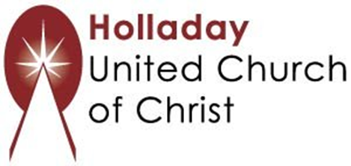
2631 East Murray-Holladay Rd
Holladay, UT 84117 801-277-2631
Rev. Brent Gundlah, Senior Pastor
Rev. Chelsea Page, Associate Pastor

We are a Whole Earth,
Open and Affirming Congregation
Of the United Church of Christ.
Participants in Worship:
Reader: Martha Moler, Children’s Chat: Rev. Chelsea Page
Sound: Carl Adams, Slides: Kyla Asmar, Video: Jim Bale
Music: Mary Louise Otterstrom & Jimmy Ingold

PRAYER REQUESTS
The following are offered for your prayers this morning and in the days ahead:
- Prayers of strength and comfort for all those who live in fear of violence.
- Prayers of support and gratitude for our community of caregivers.
- Prayers of healing for all who are facing health issues
- Prayers of comfort for all those in hospice care.

