~LIVESTREAMED TO FACEBOOK~
We are live streaming today’s worship service on Facebook, so we want you to know that your presence here today is your agreement and consent to being part of that recording.

~Please continue wearing your mask while in the Sanctuary~
~Please whisper or mouth words during responsive reading~
~Please remain seated and enjoy listening to the music~
~Offering plates will be located at the back of the Sanctuary~
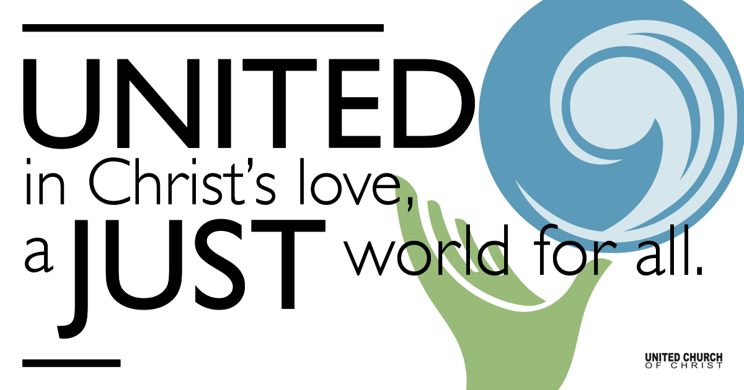

October 17, 2021

Twenty-first Sunday after Pentecost
Children’s Justice Sabbath
Silent Meditation
“Everybody can be great, because anybody can serve. You don’t have to have a college degree to serve. You don’t have to make your subject and verb agree to serve. You only need a heart full of grace. A soul generated by love.” - Martin Luther King, Jr.

Prelude “Come Sweet Justice” Louis Gilio

Welcome to Worship
One: Whoever you are and wherever you are on life’s journey,
ALL: We welcome you here.

Opening Comments

Entrance of Light & Ringing of the Bell

Call to Worship
One: We gather this morning as God’s people to worship God,
All: In confidence that God hears our hurts and hopes before they are even on our lips.
One: God calls us, as God’s partners, to help children,
All: With a passion for justice and hearts full of love.
One: Come, let us worship God on this Children’s Sabbath day.

Opening Song “Children of God” James F.D. Martin

Children’s Chat and Blessing Pam Erickson
Though we gather separately, we are one community
In the sanctuary, playground or at home.
In this space and in every place, we are beloved.
We are disciples. We are leaders. We are creators.
We are thinkers. We are worshipers.
Love is the reason we are here.
God is here with us, And God is out there, too!
Go with God. Amen.

Prayer for Illumination

Scripture Job 38:34-39:4 & 39:14-16
Do you know the ordinances of the heavens?
Can you establish their rule on the earth?
Can you lift up your voice to the clouds,
so that a flood of waters may cover you?
Can you send forth lightnings, so that they may go
and say to you, ‘Here we are’?
Who has put wisdom in the inward parts,
or given understanding to the mind?
Who has the wisdom to number the clouds?
Or who can tilt the waterskins of the heavens,
when the dust runs into a mass
and the clods cling together?
Can you hunt the prey for the lion,
or satisfy the appetite of the young lions,
when they crouch in their dens,
or lie in wait in their covert?
Who provides for the raven its prey,
when its young ones cry to God,
and wander about for lack of food?
Do you know when the mountain goats give birth?
Do you observe the calving of the deer?
Can you number the months that they fulfill,
and do you know the time when they give birth,
when they crouch to give birth to their offspring,
and are delivered of their young?
Their young ones become strong, they grow up in the open;
they go forth, and do not return to them….
The ostrich leaves its eggs to the earth,
and lets them be warmed on the ground,
forgetting that a foot may crush them,
and that a wild animal may trample them.
It deals cruelly with its young, as if they were not its own.

Reflection “What Child Is This?” Rev. Chelsea Page

Moment for Mission

Call to Offering/Prayer of Dedication
Prayers of the Community
(If you would like to offer a prayer of gratitude or concern for someone or some situation please use first names for security. The congregation will respond to each prayerful offering with the following words:
“Together with God, we hear your prayers.”)

Pastoral Prayer
Lord, listen to your children praying.

Jesus Prayer

Words of Mission and Benediction

Closing Song “Guide My Feet” NCH #497

Parents, please collect your child(ren) from their teachers in the playground. Thank you!

Find out More!



holladayucc.org

Or scan from your mobile device:


Welcome parents! We are glad you and your child(ren) are here. Please begin worship seated together as a family. After Children’s Chat, children will walk to Sunday School with their teachers. Classes are held outdoors and masks are required. Please pick up your child(ren) from the playground promptly after the service. We have classes for grades PK-2 and 3-6, with a Zoom option on Wednesdays for the whole family. Pastor Chelsea’s cell is (801) 573-8056.
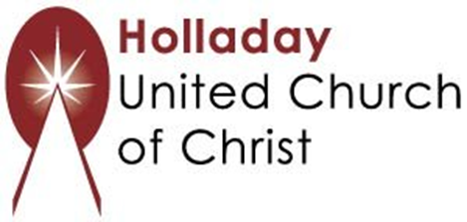
2631 East Murray-Holladay Rd
Holladay, UT 84117 801-277-2631
Rev. Brent Gundlah, Senior Pastor
Rev. Chelsea Page, Associate Pastor

We are a Whole Earth,
Open and Affirming Congregation
Of the United Church of Christ.
Participants in Worship:
Reader: Heather Bertotti Sarin, Slides: Dale Berreth, Video: Jim Bale
Music: Holy House Band, Children’s Chat: Pam Erickson

PRAYER REQUESTS
The following are offered for your prayers this morning and in the days ahead:
- Prayers of strength and comfort for all those who live in fear of violence.
- Prayers of support and gratitude for our community of caregivers.
- Prayers of healing for all who are facing health issues
- Prayers of comfort for all those in hospice care.

