~LIVESTREAMED TO FACEBOOK~
We are live streaming today’s worship service on Facebook, so we want you to know that your presence here today is your agreement and consent to being part of that recording.

~Please continue wearing your mask while in the Sanctuary~
~Please whisper or mouth words during responsive reading~
~Please remain seated and enjoy listening to the music~
~Offering plates will be located at the back of the Sanctuary~
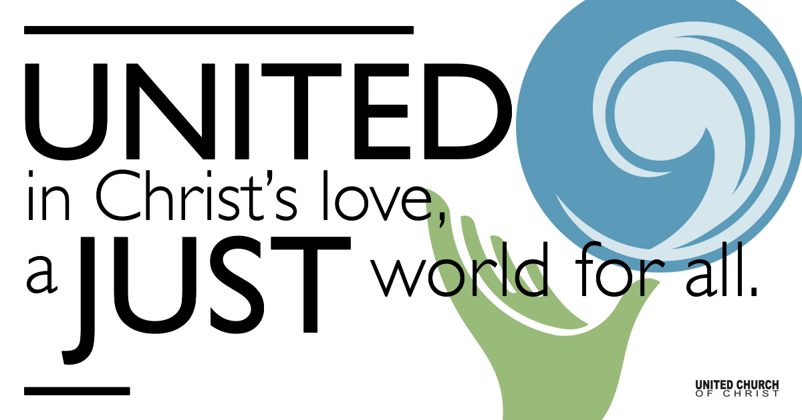

October 24, 2021

Twenty-second Sunday after Pentecost
Unhappy Endings
Silent Meditation
“And in real life endings aren’t always neat, whether they’re happy endings, or whether they’re sad endings.” - Stephen King

Prelude “I’m Gonna Walk It With You” Brian Claflin, Ellie Grace

Welcome to Worship
One: Whoever you are and wherever you are on life’s journey,
ALL: We welcome you here.

Opening Comments

Entrance of Light & Ringing of the Bell

Call to Worship
(Psalm 91, adapted from the Feasting on the Word Worship Companion)
One: God is our dwelling place,
All: a home of peace and plenty.
One: God is our dwelling place,
All: a refuge when trouble is near.
One: God is our dwelling place,
All: a temple that will stand forever.

Opening Song “Heavy” Zach & Dani Green, Jesse Baker,
Andrew Hubright, Brian Seligman

Children’s Chat & Blessing Rev. Chelsea Page
Though we gather separately, we are one community
In the sanctuary, playground or at home.
In this space and in every place, we are beloved.
We are disciples. We are leaders. We are creators.
We are thinkers. We are worshipers.
Love is the reason we are here.
God is here with us, And God is out there, too!
Go with God. Amen.

Prayer for Illumination

Scripture Job 42:1-6, 10-17
Then Job answered the Lord:
“I know that you can do all things, and that no purpose of yours can be thwarted. ‘Who is this that hides counsel without knowledge?’ Therefore I have uttered what I did not understand, things too wonderful for me, which I did not know. ‘Hear, and I will speak; I will question you, and you declare to me.’ I had heard of you by the hearing of the ear, but now my eye sees you; therefore I despise myself, and repent in dust and ashes.”
And the Lord restored the fortunes of Job when he had prayed for his friends; and the Lord gave Job twice as much as he had before. Then there came to him all his brothers and sisters and all who had known him before, and they ate bread with him in his house; they showed him sympathy and comforted him for all the evil that the Lord had brought upon him; and each of them gave him a piece of money and a gold ring.
The Lord blessed the latter days of Job more than his beginning; and he had fourteen thousand sheep, six thousand camels, a thousand yoke of oxen, and a thousand donkeys. He also had seven sons and three daughters. He named the first Jemimah, the second Keziah, and the third Keren-happuch. In all the land there were no women so beautiful as Job’s daughters; and their father gave them an inheritance along with their brothers. After this Job lived one hundred and forty years, and saw his children, and his children’s children, four generations. And Job died, old and full of days.

Reflection “Unhappy Endings” Rev. Brent Gundlah

Call to Offering/Prayer of Dedication

Prayers of the Community
(If you would like to offer a prayer of gratitude or concern for someone or some situation please use first names for security. The congregation will respond to each prayerful offering with the following words:
“Together with God, we hear your prayers.”)

Pastoral Prayer

Jesus Prayer
Our Creator who is in heaven,
Hallowed be Your name,
Your reign come, Your will be done,
On earth as it is in heaven,
Give us this day our daily bread,
And forgive us our debts as we forgive our debtors,
And lead us not into temptation, but deliver us from evil,
For Yours is the reign, the power, and glory for ever. Amen.

Words of Mission and Benediction

Closing Song “From This Valley” John Paul White, Joy Williams,
& Phil Madeira

Parents, please collect your child(ren) from their teachers in the playground. Thank you!

Find out More!



holladayucc.org

Or scan from your mobile device:


Welcome parents! We are glad you and your child(ren) are here. Please begin worship seated together as a family. After Children’s Chat, children will walk to Sunday School with their teachers. Classes are held outdoors and masks are required. Please pick up your child(ren) from the playground promptly after the service. We have classes for grades PK-2 and 3-6, with a Zoom option on Wednesdays for the whole family. Pastor Chelsea’s cell is (801) 573-8056.
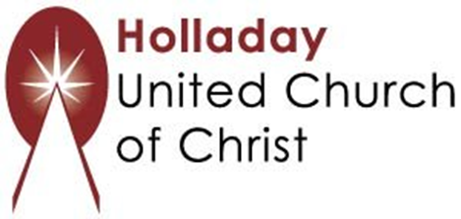
2631 East Murray-Holladay Rd
Holladay, UT 84117 801-277-2631
Rev. Brent Gundlah, Senior Pastor
Rev. Chelsea Page, Associate Pastor

We are a Creation Justice,
Open and Affirming Congregation
of the United Church of Christ.
Participants in Worship:
Reader: Heather Bertotti Sarin, Slides: Dale Berreth, Video: Jim Bale
Music: Eric Richards, Mark Dazley, Raynola Dominguez, Marilyn and Chuck Dillard, Christopher Thomas, Children’s Chat: Pam Erickson

PRAYER REQUESTS
The following are offered for your prayers this morning and in the days ahead:
- Prayers of strength and comfort for all those who live in fear of violence.
- Prayers of support and gratitude for our community of caregivers.
- Prayers of healing for all who are facing health issues
- Prayers of comfort for all those in hospice care.

