~LIVESTREAMED TO FACEBOOK~
We are live streaming today’s worship service on Facebook, so we want you to know that your presence here today is your agreement and consent to being part of that recording.

~Please continue wearing your mask while in the Sanctuary~
~Please whisper or mouth words during responsive reading~
~Please remain seated and enjoy listening to the music~
~Offering plates will be located at the back of the Sanctuary~

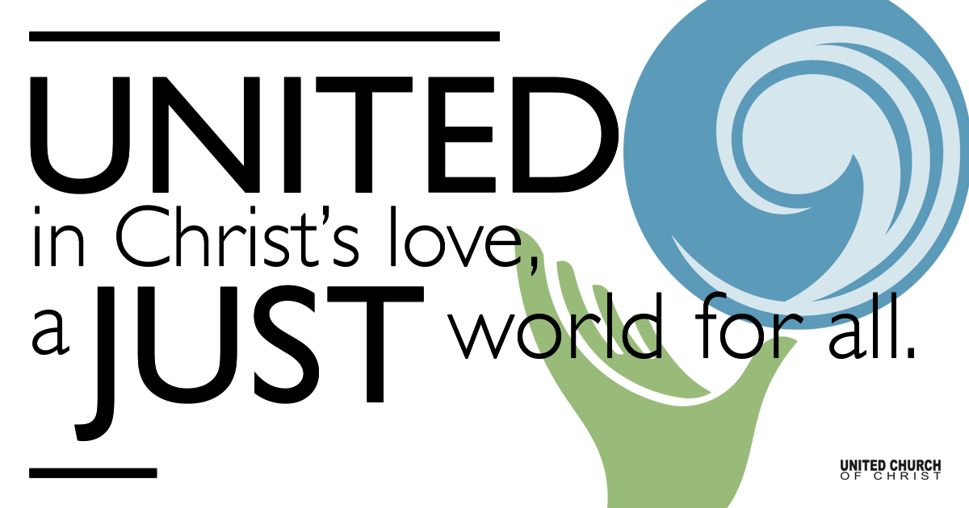
Silent Meditation

October 31, 2021

Twenty-third Sunday after Pentecost
Remembering Christ
“In the Spirit which draws us into honest engagement with one another, including those who may be very different from us in various ways, God calls us to wake up and learn how to love and respect one another, period.” ~Carter Heyward

Prelude “Apocalypse Lullaby” Annabelle Chvostek

Welcome to Worship
One: Whoever you are and wherever you are on life’s journey,
ALL: We welcome you here.

Opening Comments

Entrance of Light & Ringing of the Bell

Call to Worship (from UCC Worship Ways)
One: Hear, O people of God: our God is one.
Hear the commandments of our God.
All: First, love your God with all your heart,
and with all your soul,
and with all your mind,
and with all your strength.
One: Hear, O people of God: Our God is one.
Recite the commandments to your children
and hold them in your hearts.
All: Second, love your neighbor as yourself.
There is no commandment greater than these calls to love. Amen.

Opening Song “One Voice” Ruth Moody

Children’s Chat & Blessing Ruby Hammel
Though we gather separately, we are one community
In the sanctuary, playground or at home.
In this space and in every place, we are here
to learn, create, and wonder.
Love is the reason we are here.
God is here with us, And God is out there, too!
Go with God. Amen.

Prayer for Illumination

Scripture Deuteronomy 6:1-9, NRSV
Now this is the commandment—the statutes and the ordinances—that the Lord your God charged me to teach you to observe in the land that you are about to cross into and occupy, so that you and your children and your children’s children may fear the Lord your God all the days of your life, and keep all his decrees and his commandments that I am commanding you, so that your days may be long. Hear therefore, O Israel, and observe them diligently, so that it may go well with you, and so that you may multiply greatly in a land flowing with milk and honey, as the Lord, the God of your ancestors, has promised you.

Hear, O Israel: The Lord is our God, the Lord alone. You shall love the Lord your God with all your heart, and with all your soul, and with all your might. Keep these words that I am commanding you today in your heart. Recite them to your children and talk about them when you are at home and when you are away, when you lie down and when you rise. Bind them as a sign on your hand, fix them as an emblem on your forehead, and write them on the doorposts of your house and on your gates.

Reflection “Remembering” Rev. Brent Gundlah

Call to Offering/Prayer of Dedication

Prayers of the Community
(If you would like to offer a prayer of gratitude or concern for someone or some situation please use first names for security. The congregation will respond to each prayerful offering with the following words:
“Together with God, we hear your prayers.”)

Pastoral Prayer

Jesus Prayer
Our Creator who is in heaven,
Hallowed be Your name,
Your reign come, Your will be done,
On earth as it is in heaven,
Give us this day our daily bread,
And forgive us our debts as we forgive our debtors,
And lead us not into temptation, but deliver us from evil,
For Yours is the reign, the power, and glory for ever. Amen.

Words of Mission and Benediction

Closing Song “I Hear Them All” David Rawlins, Ketch Secor

Parents, please collect your child(ren) from their teachers in the playground. Thank you!

Find out More!



holladayucc.org

Scan to Give & Connect with Us


Welcome parents! We are glad you and your child(ren) are here. Please begin worship seated together as a family. After Children’s Chat, children will walk to Sunday School with their teachers. Classes are held outdoors and masks are required. Please pick up your child(ren) from the playground promptly after the service. We have classes for grades PK-2 and 3-6, with a Zoom option on Wednesdays for the whole family. Pastor Chelsea’s cell is (801) 573-8056.
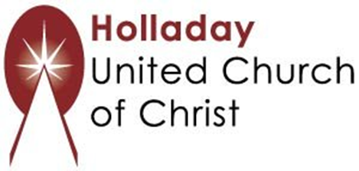
2631 East Murray-Holladay Rd
Holladay, UT 84117 801-277-2631
Rev. Brent Gundlah, Senior Pastor
Rev. Chelsea Page, Associate Pastor

We are a Creation Justice,
Open and Affirming Congregation
of the United Church of Christ.
Participants in Worship:
Reader: Esther Manning, Slides: Martha Bale, Video: Jim Bale
Music: Jani Gamble, Allison Ottley, Mona Stevens
Children’s Chat: Ruby Hammel

PRAYER REQUESTS
The following are offered for your prayers this morning and in the days ahead:
- Prayers of strength and comfort for all those who live in fear of violence.
- Prayers of support and gratitude for our community of caregivers.
- Prayers of healing for all who are facing health issues
- Prayers of comfort for all those in hospice care.

