~LIVESTREAMED TO FACEBOOK~
We are live streaming today’s worship service on Facebook, so we want you to know that your presence here today is your agreement and consent to being part of that recording.

~Please continue wearing your mask while in the Sanctuary~
~Please whisper or mouth words during responsive reading~
~Please remain seated and enjoy listening to the music~
~Offering plates will be located at the back of the Sanctuary~

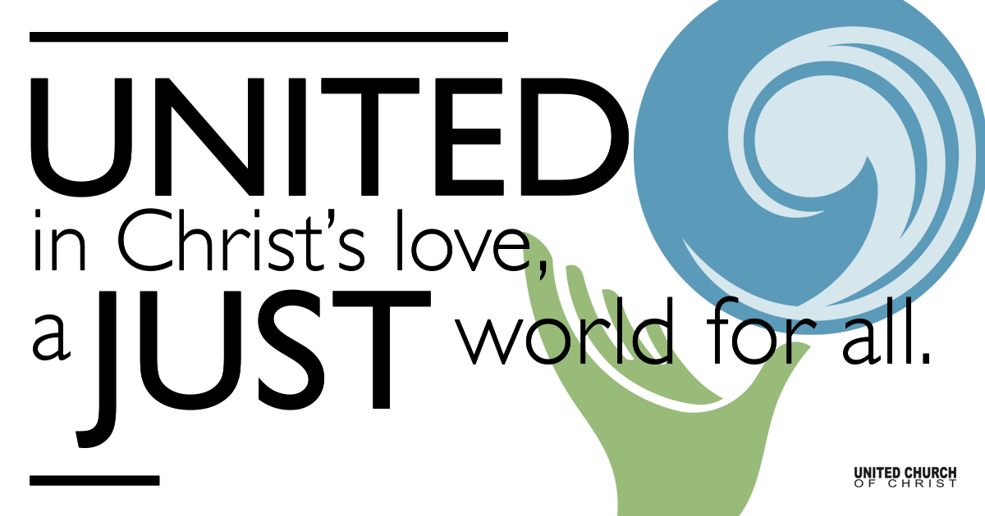
Silent Meditation

November 7, 2021

Twenty-fourth Sunday after Pentecost
Hospitality & Communion
Jesus said, “In my Abba’s house there are many dwelling places. If it were not so, would I have told you that I go to prepare a place for you?” - John 14:2

Prelude “Crowded Table” Brandi Carlile, Lori McKenna, Natalie Hemby

Welcome to Worship
One: Whoever you are and wherever you are on life’s journey,
ALL: We welcome you here.

Opening Comments

Entrance of Light & Ringing of the Bell

Call to Worship (Psalm 146)
One: Happy are those whose hope is in Adonai their God,
who made heaven and earth, the sea, and all that is in them;
All: Who keeps faith forever;
who executes justice for the oppressed;
who gives food to the hungry.
One: God sets the prisoners free,
All: Lifts up those who are bowed down,
One: Watches over the strangers,
All: Upholds the orphan and the widow.
One: God will reign forever, for all generations.
All: Praise be to God!

Opening Song “All Are Welcome” Marty Haugen

Children’s Chat & Blessing
Though we gather separately, we are one community
In the sanctuary, playground or at home.
In this space and in every place,
we are here to learn, create, and wonder.
Love is the reason we are here.
God is here with us, And God is out there, too!
Go with God. Amen.

Prayer for Illumination
God of wisdom, speak your Word to us through the scriptures. By your Spirit, plant your truth deep within us, so that we may follow Christ who is your Living Word. Amen.

Scripture 1 Kings 17:8-16
Then the word of the Lord came to Elijah, saying, "Go now to Zarephath, which belongs to Sidon, and live there; for I have commanded a widow there to feed you." So he set out and went to Zarephath. When he came to the gate of the town, a widow was there gathering sticks; he called to her and said, "Bring me a little water in a vessel, so that I may drink." As she was going to bring it, he called to her and said, "Bring me a morsel of bread in your hand." But she said, "As Adonai your God lives, I have nothing baked, only a handful of flour in a jar, and a little oil in a jug; I am now gathering a couple of sticks, so that I may go home and prepare it for myself and my child, that we may eat it, and die." Elijah said to her, "Do not be afraid; go and do as you have said; but first make me a little cake of it and bring it to me, and afterwards make something for yourself and your child. For thus says Adonai the God of Israel: The jar of flour will not be emptied and the jug of oil will not fail until the day that the Lord sends rain on the earth." She went and did as Elijah said, so that she as well as he and her household ate for many days. The jar of meal was not emptied, neither did the jug of oil fail, according to the word of the Lord that God spoke by Elijah.

Reflection “Meeting at God’s Table” Rev. Chelsea Page

Season of Stewardship Ruby Ostermann

Call to Offering/Prayer of Dedication

Prayers of the Community
(If you would like to offer a prayer of gratitude or concern for someone or some situation please use first names for security. The congregation will respond to each prayerful offering with the following words:
“Together with God, we hear your prayers.”)

Pastoral Prayer

Communion Song “Come Gather in This Special Place” Phil Porter

Holy Communion

Jesus Prayer/Lord’s Prayer (in your own words)

Words of Mission and Benediction

Closing Song “May the Light of Love” David Roth

Parents, please collect your child(ren) from their teachers in the playground. Thank you!

Find out More!



holladayucc.org

Scan to Give & Connect with Us


Welcome parents! We are glad you and your child(ren) are here. Please begin worship seated together as a family. After Children’s Chat, children will walk to Sunday School with their teachers. Classes are held outdoors and masks are required. Please pick up your child(ren) from the playground promptly after the service. We have classes for grades PK-2 and 3-6, with a Zoom option on Wednesdays for the whole family. Pastor Chelsea’s cell is (801) 573-8056.
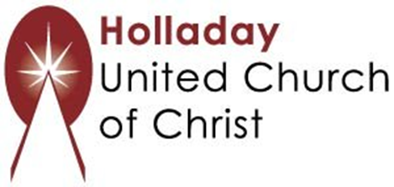
2631 East Murray-Holladay Rd
Holladay, UT 84117 801-277-2631
Rev. Brent Gundlah, Senior Pastor
Rev. Chelsea Page, Associate Pastor

We are a Creation Justice,
Open and Affirming Congregation
of the United Church of Christ.
Participants in Worship:
Reader: Dennis Bayes, Slides: Gary P Duran
Video and Sound: Jim Bale and Winston Gamble
Music: Carl Adams, Mark Dazley, Jani Gamble, Jon Green, Tom Klassen, Shelley McCall, Children’s Chat: Chris Osburn

PRAYER REQUESTS
The following are offered for your prayers this morning and in the days ahead:
- Prayers of strength and comfort for all those who live in fear of violence.
- Prayers of support and gratitude for our community of caregivers.
- Prayers of healing for all who are facing health issues
- Prayers of comfort for all those in hospice care.

