~LIVESTREAMED TO FACEBOOK~
We are live streaming today’s worship service on Facebook, so we want you to know that your presence here today is your agreement and consent to being part of that recording.

~Please continue wearing your mask while in the Sanctuary~
~Please whisper or mouth words during responsive reading~
~Please remain seated and enjoy listening to the music~
~Offering plates will be located at the back of the Sanctuary~

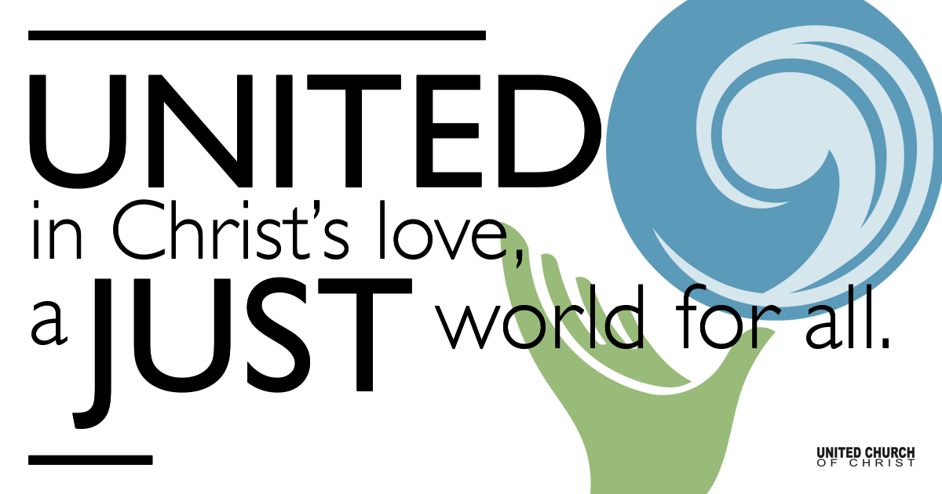
Silent Meditation

November 14, 2021

Twenty-fifth Sunday after Pentecost
Signs
“A great deal of intelligence can be invested in ignorance when the need for illusion is deep.” - Saul Bellow

Prelude “Humoresque” Dvorak

Welcome to Worship
One: Whoever you are and wherever you are on life’s journey,
ALL: We welcome you here.

Opening Comments

Entrance of Light & Ringing of the Bell

Call to Worship (Hebrews 10:19-22, adapted from re:worship)
One: We gather together to worship,
knowing that God is already here among us;
Knowing that there is nothing that can separate us from God’s presence.
All: Wherever we are, wherever we go, God is near.
One: So let us enter into this service of worship with confidence and hope.
All: We know that God meets us here, and blesses us with love.

Opening Song “Gavotte, Partita 3” Johann Sebastian Bach

Children’s Chat & Blessing Trent Parkhill
Though we gather separately, we are one community
In the sanctuary, playground or at home.
In this space and in every place,
we are here to learn, create, and wonder.
Love is the reason we are here.
God is here with us, And God is out there, too!
Go with God. Amen.

Prayer for Illumination
God of grace and wisdom, as we hear your Word read and proclaimed today, help us and guide us so that we might not only understand it but also live it. This we pray in Jesus’s name. Amen.

Scripture Mark 13:1-8, NRSV

As he came out of the temple, one of his disciples said to him, “Look, Teacher, what large stones and what large buildings!” Then Jesus asked him, “Do you see these great buildings? Not one stone will be left here upon another; all will be thrown down.”

When he was sitting on the Mount of Olives opposite the temple, Peter, James, John, and Andrew asked him privately, “Tell us, when will this be, and what will be the sign that all these things are about to be accomplished?” Then Jesus began to say to them, “Beware that no one leads you astray. Many will come in my name and say, ‘I am he!’ and they will lead many astray. When you hear of wars and rumors of wars, do not be alarmed; this must take place, but the end is still to come. For nation will rise against nation, and kingdom against kingdom; there will be earthquakes in various places; there will be famines. This is but the beginning of the birth pangs.

Reflection “Signs, Signs, Everywhere There’s Signs” Rev. Brent Gundlah

Season of Stewardship Martha Moler

Call to Offering/Prayer of Dedication

Prayers of the Community
(If you would like to offer a prayer of gratitude or concern for someone or some situation please use first names for security. The congregation will respond to each prayerful offering with the following words:
“Together with God, we hear your prayers.”)

Pastoral Prayer

Jesus Prayer
Our Creator who is in heaven,
Hallowed be Your name,
Your reign come, Your will be done,
On earth as it is in heaven,
Give us this day our daily bread,
And forgive us our debts as we forgive our debtors,
And lead us not into temptation, but deliver us from evil,
For Yours is the reign, the power, and glory for ever. Amen.

Words of Mission and Benediction

Closing Song “Ashokan Farewell” Jay Ungar

Parents, please collect your child(ren) from their teachers in the nursery. Thank you!

Find out More!



holladayucc.org

Scan to Give & Connect with Us


Welcome parents! We are glad you and your child(ren) are here. Please begin worship seated together as a family. After Children’s Chat, children will walk to Sunday School with their teachers. Classes are held outdoors and masks are required. Please pick up your child(ren) from the playground promptly after the service. We have classes for grades PK-2 and 3-6, with a Zoom option on Wednesdays for the whole family. Pastor Chelsea’s cell is (801) 573-8056.
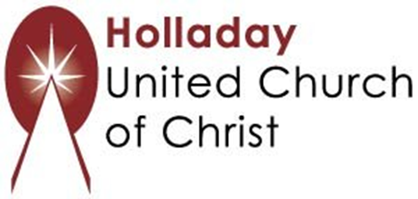
2631 East Murray-Holladay Rd
Holladay, UT 84117 801-277-2631
Rev. Brent Gundlah, Senior Pastor
Rev. Chelsea Page, Associate Pastor

We are a Creation Justice,
Open and Affirming Congregation
of the United Church of Christ.
Participants in Worship:
Reader: Tom Sturgeon, Children’s Chat: Trent Parkhill
Slides: Dale Berreth, Video: ______________, Sound: Chuck Dillard
Music: MaCall Potter (violinist)

PRAYER REQUESTS
The following are offered for your prayers this morning and in the days ahead:
- Prayers of strength and comfort for all those who live in fear of violence.
- Prayers of support and gratitude for our community of caregivers.
- Prayers of healing for all who are facing health issues
- Prayers of comfort for all those in hospice care.

